Pest risk assessment for the European Community:

plant health: a comparative approach with case studies

WP3
Description and evaluation of risk reduction options (RRO)

Ca. Phytoplasma pyri
(Pear Decline Phytoplasma)
September 2011

Authors:
Steffek¹, Robert; Follak¹, Swen
Karadjova², Olia; Ventsislavov², Ventsislav; Krumov², Vladimir
¹ AGES, Austrian Agency for Health and Food Safety; Vienna, Austria
² PPI, Plant Protection Institute, Kostinbrod, Bulgaria

Reviews:
Verhoeven³, Ko; Potting³, Roel
Pfeilstetter⁴ Ernst
³PPS, Plant Protection Service, Wageningen, The Netherlands
⁴JKI, Julius Kühn Institut, Braunschweig, Germany

Comments on specific questions were provided by:
Mouttet, Raphaelle (ANSES, France) on risk reduction options
Sauvion, Nicolas (INRA, Montpellier, France) on vector biology
Description of risk reduction options (RRO)
Pear decline phytoplasma

A. Introduction
Pear decline phytoplasma (Ca. Phytoplasma pyri) is currently listed as a quarantine pest in the EU (European-Council-Directive, 2000/29/EC). It is widespread in the risk assessment area and present in 15 of the 27 EU countries, including the largest pear production areas in Europe (for details and references refer to Annex 2 and 3 of the risk assessment). It is not reported to occur in Portugal, Belgium, Denmark, Latvia, Lithuania, Estonia, Sweden, Luxembourg, Cyprus and Malta (in Finland and Ireland pear is not produced).
A pest risk assessment was conducted within the framework of EFSA project CFP/EFSA/PLH/2009/01: Pest risk assessment for the European Community plant health - a comparative approach with case studies ("Prima phacie") to evaluate the plant health risk associated with Candidatus Phytoplasma pyri (Pear Decline phytoplasma). The risk assessment concludes that Ca. P. pyri is a native pest, which is very widespread in the EU; hence, it doesn’t qualify as quarantine pest. However, in regions within the endangered area where the disease and the vector are abundant, there is a high risk that the phytoplasma is associated with plants at the place of production. In such cases the intended use of the plants is affected.
Consequently, risk reduction options are elaborated to reduce the risk of Ca. P. pyri spreading in infested planting material

B. Risk Reduction options (RRO's)
The principal approach to reduce the risk of Pear decline entering new areas is the use of healthy propagating material in combination with the control of the psyllid vectors, which are present wherever pear is produced.
For the principal pathway "Plants for planting of pear (Pyrus sp.) and quince (Cydonia oblonga), (including grafted plants, rootstocks, graftwood and budwood)" different risk reduction options are being considered and discussed below. Several of them may be appropriate to manage Pear decline.
At first RRO's were evaluated with respect to their effectiveness, reproducibility and practical application.
Secondly, for the most reliable risk reduction options, the effect on the level of risk is assessed using the 5 different risk assessment methods. In addition, their technical feasibility and limitations of their application are being discussed.
As first step the following measures are considered:
- Visual inspection
- Specified testing
- Specified treatment
- Removal of parts of plants
- Use of specified cultivars
- Specified growing conditions
- Vector control
- Certification scheme
- Pest free place of production / pest free area

- Visual inspection
1.1. Inspection of consignments
ISPM No.23 describes procedures for the visual inspection of consignments of plants at import and export.
Symptoms of Pear decline phytoplasma are visually not detectable on consignments (plants during dormancy and graftwood, independent of the time of year). Hence, visual inspection of consignments at import or export is very unlikely to detect phytoplasma infections.

1.2. Nursery inspections
Visual inspection at the place of production is one of the current requirements for the introduction and movement of plants for planting as specified in Annex IV of the Council Directive 2000/29/EC: "… plants at the place of production and in its immediate vicinity, which have shown symptoms giving rise to the suspicion of contamination by Pear decline mycoplasm, have been rogued out at that place within the last three complete cycles of vegetation” (European-Council-Directive, 2000/29/EC).
The use of visual inspections as a phytosanitary measure requires the presence of visually detectable symptoms of the pest of concern. Pear decline phytoplasma causes no specific symptoms, which are completely reliable in visual diagnosis. Non-specific symptoms of an infection are widespread, including premature foliar reddening (appearing in the year that the infection has started or was introduced via vectors), leaf curl, premature leaf drop, poor fruit development and growth suppression (OEPP/EPPO, 2006).
In recent years (2007-2010) Pear decline was notified according to Article 16 of Directive 2000/29/EC, after symptoms of the disease where found during nursery inspections in four different member states (CIRCA database, 2010).
Nevertheless, identification of infected trees by visual inspections in nurseries may be impeded by the following factors:
  - non-specific symptoms may be confused with abiotic factors (water logging, root damage, graft incompatibility, ring barking caused by feeding animals and some fungal, viral, or bacterial diseases),
  - trees respond differently upon infection and some may fail to develop symptoms,
  - infections that were introduced through psyllid vectors in the weeks prior to the inspection may not be detected,
  - psyllid vectors may infest plants late in the season (after inspection)

CONCLUSION: visual inspection does allow the detection by symptoms. However, symptoms may be confused and are therefore not completely reliable, specified testing for confirmation may be required. Moreover, the lack of symptoms cannot fully be relied on as proof that trees are not infected.

- Specified testing
(Can the pest be reliably detected by testing?)
Sensitive and specific molecular techniques are available (OEPP/EPPO, 2006). As the presence of symptoms does not give sufficient evidence for identification, PCR testing is strongly recommended (and used) for confirmation of an infection. Testing of pre-basic plants and nuclear stock is a suitable measure to ensure that the initial material used for propagation is free of Pear decline phytoplasma.
However, although diagnostic methods are sensitive and specific, testing is impeded if reliable sampling methods are not available. It is crucial to determine the optimal time (late season) and material (phloem) of sampling. Due to the irregular distribution of the phytoplasmas in the phloem, samples should consist of multiple sub samples. Therefore, testing is quite laborious and costly (e.g. in consignments traded during dormancy). Consequently, testing of nursery plants will have to be performed at random, implying a risk that some infected plants will not be detected because they were not included in the samples.
CONCLUSION: Sensitive PCR tests are available and should be applied in the production of nuclear and propagation stock plants and in nurseries producing fruit trees in case of any suspicion. However, testing for the presence of latent infections will have to be performed at random, with multiple sub-samples.

- Specified treatment
As phytoplasmas are wall-less bacteria, most antibiotics (such as penicillin) are not effective (Weintraub, 2010). Old publications report a positive effect of Oxytetracyclins infusions to control Pear decline [(McIntyre et al., 1978), (McIntyre et al., 1979); (Nyland and Moller, 1973), (Nyland, 1975)], but the use of Oxytetracyclins in food crops is not permitted. Moreover, symptom remission is usually temporary, as tetracycline only persists in plants for 1–4 months (Weintraub, 2010). Consequently, specific chemical treatments that effectively destroy the phytoplasma in the grafted plant are not available.
Hot water treatment is based on the fact that dormant plant organs can withstand higher temperatures than those their respective pathogens can survive for a given time (Agrios, 1997). Dipping dormant woody grafts over a specified time period into hot water of specified temperature is successfully used to eliminate the phytoplasma and/or the eggs of the vector of European Stone Fruit Yellows and Grapevine Flavescence dorée [e.g. (Mannini, 2007) (Krizan et al., 2008)]. However, the temperature and time to which the planting material is exposed to hot water, which guarantee a high efficacy and a low degree of damage to the plant, has to be tested. Currently such techniques are not known to be available for Pear decline phytoplasma, therefore hot water treatments cannot be recommended.
Thermotherapy (heat treatments) has been applied to eliminate phytoplasmas from tissue culture [(Bertaccini et al., 2004), (Laimer et al., 2006)]. Moreover, it can be used to obtain plants free of viruses and phytoplasmas (Fridlund, 1989; OEPP/EPPO, 2000; Laimer, 2003). During thermotherapy, meristem cultures were kept for 15-20 days in an environmental growth chamber at 36°C-38°C, to eliminate stone fruit pathogens, including ESFY (Laimer et al., 2006). Protocols were validated for survival rates of shoots and plants and on their effectiveness elimination of Pear decline phytoplasma ((Laimer da Camara Machado, 2003; Laimer, 2003). This technique is applied in practice to eliminate the phytoplasma from candidate and nuclear stock plant material.
CONCLUSION: Hot water treatment of grafted plants is assumed to be effective, but currently not applied in pome fruit nursery production. Thermotherapy is used as an efficient measure to ensure pest freedom of pre-basic plants.

- Removal of specific parts of plants
(Does the pest occur only on certain parts of the plant or plant products (e.g. bark, flowers), which can be removed without modifying the intrinsic nature of the consignment?)
Phytoplasmas move in the phloem of infested plants, they overwinter in the roots of susceptible rootstocks, where functional sieve tubes are present throughout the year. The elimination of the phytoplasmas from the aerial parts of the trees is explained by the degeneration of phloem sieve tubes during the winter months. From the roots the stem is recolonized in the following spring [(Schaper and Seemüller, 1984), (Seemüller et al., 1984), (Babini et al., 2008)].
Seemuller et al., 1984 found that the transmission rate from scions taken from infested donor trees between May and December was in average 80%. In February, the transmissibility declined sharply, in March there was no successful transmission. The same authors found that for plants which were moved into a cold room in October and kept there until scions were taken for grafting, the transmission rate was very low and intact phloem sieve tubes (allowing the survival of the phytoplasma) were only present in a few cell layers adjacent to the cambial zone. Similar results were obtained in the UK. Vegetative buds from Pear decline-infected shoots were grafted either on 2-year-old quince or 2-year-old pear seedlings in August. In addition, no transmission by grafting infected shoots in the dormant season (Davies et al., 1992) was observed. Recently, this results were confirmed in Emilia-Romagna (Babini et al., 2008)
However, under Mediterranean conditions of north-eastern Spain, (Errea et al., 2002) and (Garcia-Chapa et al., 2003) report of a successful transmission of the phytoplasma through bud grafts in winter.
CONCLUSION: Grafting (during dormancy) reduces the risk of the phytoplasma being associated with the pathway at origin. In areas where Pear decline is present, a measure prohibiting the propagation of pear (to Pyrus rootstocks) in summer would reduce the risk of long distance spread of Pear decline phytoplasma. However, this measure may not be fully reliable in all parts of the risk assessment area.

- Use of specified cultivars
(Can infestation of the commodity be reliably prevented by growing resistant cultivars?)
Clonal rootstocks of Cydonia oblonga (quince) are predominantly used in European pear production. Quince is only poorly colonized by the phytoplasma (Seemüller et al., 1986) and pear trees grafted on quince rootstocks are little affected by Pear decline, as the phytoplasma occurs in a very low titre in the rootstock, which has a negative effect on the recolonization of the aerial parts in spring, resulting in no or mild symptoms (Seemüller et al., 1986). The poor host suitability of quince has been confirmed by other authors (Davies et. al, 1992). However, in Italy differences in the rootstock colonization of pears grafted on different clonal quince rootstocks (Quince A < Quince C and Quince BA29 < Quince CTS212) were observed (Poggi Pollini et al., 1995).
Limited winter hardiness and lime-induced chlorosis of quince rootstocks are restricting their use in areas that suffer severe winters or have predominantly calciferous soils.
CONCLUSION: in a systems approach the use of quince rootstocks in combination with an efficient vector management, is an efficient way of controlling Pear decline. However, quince rootstocks do not guarantee the pest freedom of the plant. Therefore, it is not considered as a phytosanitary measure.

- Specified growing conditions.
Can infestation of the commodity be reliably prevented by growing the crop in specified conditions (e.g. protected conditions such as screened greenhouses, physical isolation, etc.)?
Complete physical protection may be used to prevent infections by the psyllid vectors. However, physical isolation (in insect-proof greenhouse or screenhouse) is only effective, if the plants originate from mother plants that have been tested and found free of Pear decline phytoplasma and in combination with visual inspections confirming absence of psyllid vectors and Pear decline symptoms.
Although technical feasible, production under insect-proof conditions may be too cost-intensive for nurseries producing fruit trees and may therefore be more applicable in the previous steps of multiplication (the production of nuclear stock and propagation stock).

- Vector control
Ca. Phytoplasma pyri is transmitted by Cacopsylla pyri and Cacopsylla pyricola. Both vectors are of palearctic origin and widespread in the European Union, particularly C. pyri (for details and references refer to question 1.18 risk assessment, method 2). No evidence was found that vectors are present in Lithuania (31 ha pear production), Luxembourg (8 ha) and Ireland (no pear production). As both Lithuania and Luxembourg are surrounded by countries where vector species occur, it is very likely that vectors are present throughout the pear producing countries of the EU.
The disease severity is clearly correlated with the incidence of the vector in the orchard, which reinfects trees early in the season, way before aerial parts are recolonized from overwintering phytoplasmas in the roots. (for references see risk assessment). It was shown that previously infected trees recovered if they were protected from psyllid reinfection. These results were obtained for infested pear grafted on quince rootstocks (Seemuller and Schaper, 1986; Davies et al, 1992) and on seedling stock of P. pyrifolia (Westwood and Cameron, 1978) and emphasize the important role of the pear psyllids in the epidemiology and impact of the disease.
Pear psyllids are pests themselves, the nymphs feed on buds, leaves and shoots causing wilting, distortions and premature leaf drop. Therefore, it is good plant protection practice to apply measures like balanced fertilization, removal of water sprouts and suckers, monitoring of psyllid population to determine insecticide applications and good spray coverage (OEPP/EPPO, 2005). Insecticides to control psyllids in a pear orchard are applied and effective. However, in many European countries psyllids developed resistance to insecticides, particularly in insecticides of the organophosphates and pyrethroids and with insect growth regulators (for references refer to the risk assessment). In areas where low insecticide efficacy hampers the psyllid control, alternative control mechanisms are used to control the vector.

- Certification scheme
8.1. Legal basis
Council Directive 2008/90/EC of 29 September 2008 applies to the marketing of fruit plant propagation material and fruit plants, including plants of pear (Pyrus spp.) and quince (Cydonia oblonga). Article 3 specifies that propagating material may only be marketed as either pre-basic, basic, certified or CAC (Conformitas Agraria Communitatis) material (European-Council-Directive, 2008). More detailed plant health requirements are specified in Commission Directive 93/48/EEC, concerning the production of pre-basic, basic and certified material Article 7 refers to "…national schemes of certification; provided that they comply, as far as possible, with existing international schemes of certification" (European-Commission-Directive, 1993).
8.2. EPPO certification scheme
The EPPO certification scheme is intended to be used by national authorities to "… design systems of production of healthy plants for planting, for the inspection of such plants for certification and for the issue of certificates" (OEPP/EPPO, 1999) and thereby forms the basis for any national certification scheme. It gives details on the selection, growth and maintenance of the plant material in the different stages of the certification process:
    - Candidate nuclear stock material should be tested for the presence of Pear decline phytoplasma or else be heat treated. They should be maintained under conditions ensuring freedom from reinfection by psyllid vectors (vector-proof houses), visually inspected several times each year for symptoms of Pear decline and retested at least once during the useful life of the plants.
    - Propagation stock should be multiplied from nuclear stock in as few steps as possible and budded/grafted on rootstocks of equivalent certification status. The propagation stock should be kept isolated from potential sources of infection, inspected each year for pear decline symptoms and retested (in areas where Pear decline is prevalent).
    - For the production of certified fruit trees, the scion material should be grafted/budded onto rootstocks of equivalent or higher certification status only. These plants should be kept in fields isolated from potential sources of infection. To be certified, the plants should be inspected by the official organization for symptoms of Pear decline. Any plants showing symptoms should be removed and certification may be granted to the remainder.
Uncertainty: the production of certified plants in areas where the vector is abundant makes a reinfection more likely. The degree of re-infection will be influenced by the number of phytoplasma sources and can be reduced by increasing the distance between the nurseries of certified trees and the potential inoculum sources (orchards, pear trees in private gardens and nurseries of non-certified trees). This issue is discussed below
CONCLUSION: Certification schemes require the original material to be tested at nuclear stock level and found free of Ca. Phytoplasma pyri and to be maintained under vector proof conditions. In addition, more strict production conditions are recommended for the production of propagation stock (e.g. randomly retesting) and certified plants (e.g plants should be kept in fields separated from other host plants) (OEPP/EPPO, 1999). If these requirements are met, certified plants are less likely being associated with the pest at the place of origin. (Note that, unlike the vectors of APP and ESFY, Cacopsylla pyri and C. pyricola do not migrate to conifers to overwinter, see below).

- Pest free area / Pest free place of production
9.1. Pest free area (PFA's)
The requirements for the establishment of PFA are outlined in ISPM No. 4. PFA's are considered effective to guarantee pest freedom of the crop. However, due to the very widespread presence of the vector, intensive and frequent surveys, sampling and testing is needed to confirm pest freedom.
9.2. Pest free place of production place or Pest free production site
The requirements for the establishment of a Pest free place of production are outlined in ISPM No. 10. In pear producing areas within the European Union, where the vector is present, Pear decline is likely to enter the place of production or production site from adjacent areas (orchards, pear trees in private gardens and nurseries of non-certified trees). Therefore it is necessary to define measures that prevent re-infestation. The following measures appear to be appropriate :
- a buffer zone around the place of production or production site within which appropriate phytosanitary measures are applied,
to exclude natural introduction by psyllids from the surroundings a buffer zone should be defined around the place or site of production. The extent of the buffer zone and the nature of the phytosanitary measures depend on the vector species prevalent in an area and the intrinsic characteristics of the place of production or production site.
The two known vectors of Ca. Phytoplasma pyri are: Cacopsylla pyri and C. pyricola; both are oligophag on Pyrus sp. and appear in two morphologically distinct forms: a smaller, light-coloured summer form and a larger, dark-coloured overwintering form.
C. pyricola has a higher tendency to spread outside the orchard, the 2nd summer generation and the winter generation had a much higher number of emigrants (some 'migrants' were caught more than 400 m from the orchard) and individuals of this winter morph were able to survive on some plants other than pear during the winter (Hodgson and Mustafa, 1984). The dispersal activity is occasioned by leaf fall. Although the tendency to move is higher in C. pyricola, the movement of individuals of C.pyri was observed to be up to 50m (Trapman and Blommers, 1992). However often, the spread will be limited to adjacent areas of the infested orchard.
In general, the tendency to form new foci depends on the density of vector population in the orchard. The size of the population in the orchard is influenced by the efficiency of control measures, including the protection of beneficials. Dispersal of C. pyricola at all times appeared to be greatest from orchards with the highest population densities Hodgson and Mustafa, 1984. In French pear orchards, C. pyri populations did not spread if they were regulated by many different beneficial agents Whereas, if the diversity of natural enemies was smaller, the psyllid populations spread (Debras et al., 1998).
CONCLUSION: Concerning the requirements of the buffer zone it can be concluded, that for areas with a low Pear decline and vector incidence (or if vector populations are efficiently controlled), natural transmission will occur at low frequencies and could be less stringent (smaller buffer zone) than in areas where Pear decline phytoplasma is prevalent and natural transmission occurs frequently.

- the physical protection of the place of production or production site
Production in under vector-proof conditions (e.g. in screenhouses) are appropriate to maintain pest free place of production or production site. (see 6. Specified growing conditions)
A system to establish pest freedom (e.g. plants should originate from mother plants that have been tested and found free of Pear decline phytoplasma) and maintain pest freedom (e.g. visual inspections confirming absence of psyllid vectors and Pear decline symptoms) needs to be defined.

C. Risk reduction options, tested using the different methods
Of the discussed risk reduction options the following three were used to assess the effect on the level of risk is assessed using the 5 different experimental methods.
Measure B and C combines different strategies to reduce the likelihood of association and survival of Ca. Phytoplasma pyri on the pathway, including visual inspection (1), testing (2), (specified treatment (3)), specified growing conditions (6) and control of the vector (7). These single measures are described in the file description of RRO's.
- No measure (removal of current measures (visual inspections), as specified in Council Directive 2000/29/EC, Annex IV)
- Visual inspection
- Certification scheme (including specified testing or heat treatment of nuclear stock and maintainance under vector-proof conditions; isolated production, visual inspection and re-testing of propagation stock; isolated production and visual inspection of stock producing certified plant)
In the different steps of the certification process the measures 1., 2., (3.), 6 and 7 are applied; certification combines these measures in a systems approach.
- Pest free place of production (PFPP) (including buffer zone or physical protection), pest free area
To guarantee a PFPP, the measures 1., 2., 6 and 7 are applied in a systems approach. Of the measures tested a PFPP is assumed to have the highest level of protection against re-infection of plants for planting in nurseries through psyllid populations.
Quince is the main rootstock used in pear production. Pear rootstock is used in areas where abiotic conditions do not allow the use of quince rootstocks (see assessment).
In a systems approach the use of quince rootstocks in combination with an efficient vector management, is an appropriate way of controlling Pear decline. Therefore the measures A-C are tested to pear grafted on both types of rootstocks (quince and pyrus).
The evaluated measures aim to reduce the likelihood of the pest entering areas where it is not reported. They only influence the rating of the entry section.
As the pest is already established in the most important pear production areas of the European Union, the risk reduction options are unlikely to influence the impact of Pear decline in the risk assessment area. Once the trees are planted in the orchard, it is likely that the widespread, native vector species infect trees from inoculum sources in surroundings (orchards or pear trees in private gardens).
For this reason only the effect of the RRO's on the probability of entry was evaluated.

Evaluation of the RRO's tested with 5 different experimental methods
The principal pathway for the pest to enter new areas is plants for planting of Pyrus spp. (main host) and Cydonia oblonga (poor host). The 5 different risk assessment methods address entry in various levels of detail.

Method 1:
Method 1 (M1) is based on the EFSA adapted EPPO scheme. The entry section includes several questions addressing the association, survival and transfer of the pest along the pathway. M1 allows assessors to rate the different components of the entry section independently. It uses a BBN to combine the different questions to estimate an overall likelihood of entry. The probability tables which are underlying the combinations are not shown which reduces transparency of the method and make it difficult for assessor/reviewers to interpret results, decreasing the confidence in the methods.
The risk reduction options that act on the pathway were examined by changing relevant responses in the questions 1.3 and 1.8, to see the effects of the RRO's being considered and re-estimate the overall likelihood of entry with measures in place.
For all measures the combinations of the risk components in M1 resulted in a high likelihood of entry of Phytoplasma pyri and hardly show any differences in the probability of entry of the different measures. The re-run of the model answering the nodes PN1 and PN2, instead of the questions 1.2-1.5 lead to similar results (for details of the results see attachment of this document).
However, the results of method 1 should not be compared to those of other methods. The marginal differences in the different options can be explained by the high weight of the questions 1.9 and 1.10 compared to PN4. Question 1.9. answers the issue of how likely the pest would enter the PRA area undetected: fruit trees are mainly traded during dormancy: there are no symptoms of pear decline on a dormant plant, hence a phytoplasma infection cannot be detect through visual inspections at the point of entry, consequently 1.9 is rated likely/very likely. Question 1.10 asks how likely the pest transfers from the pathway to a suitable host. For a phytoplasma in a fruit trees which is planted in an orchard/nursery, 1.10 is rated very likely. This means that, if a few infested plants arrive, the pest would enter, no matter what measures are taken to reduce the pest population that arrives arrival.
Consequently, the results of method 1 answer the question: "How likely is it, that one (or a few) infested plants that arrive will lead to the entry of the pest". In M1 the information on the quantity of the infected plants that would enter is underrepresented.
In conclusion, the current version of M1 doesn't adequately show the effect of the different risk reduction options on the likelihood of entry of Phytoplasma pyri.

Method 2:
Method 2 (M2) is based on the EFSA adapted EPPO scheme. The entry section includes several questions addressing the association, survival and transfer of the pest along the pathway. Again, the method allows assessors to rate the different components of the entry section independently. M2 uses five different matrices to combine the questions (maximum, average rounded up, average, average rounded down, minimum). The matrix used and its effect on the combination is clearly described, contributing to a high transparency. The type of matrix that were used to combined the different elements in the entry section was tested before hand using a dataset of 16 risk assessments.
The risk reduction options that act on the pathway were examined by changing relevant responses in the questions 1.5 and 1.10, to see the effects of RRO's being considered and re-estimate the overall likelihood of entry with measures in place.
The model prediction adequately represents the effect of the RRO's applied on the probability of entry. For Pyrus rootstocks the results were in agreement with the judgment of the assessors, though assessors assumed that quince rootstocks would have a higher effect in reducing the risk of entry. However, the very high volume of trade of quince rootstocks increases the risk of entry despite of a lower association of the phytoplasma with quince rootstocks.
With the minimum matrix in "arrives" the "survival of existing procedures" (1.10) is dominating over the risk components 1.4-1.9 ("travels"). It may be worth testing an average rounded down matrix, instead of the minimum matrix. Thus, there is certain influence of the matrix "travels" on the matrix "arrives".
Moreover, the matrix combining volume (1.6) and frequency (1.7) should be improved. Currently these elements are connected by an average matrix. However, for the phytoplasmas (generally pathogens in plants for planting) frequency is irrelevant. For such pests the weight of the matrix should only be on the volume.
In M2 rating for uncertainty is expressed on a 3-point scale: low, medium, high, which are defined to express 90, 50 and 35% confidence that the selected score is correct and the uncertainty is expressed as a distribution. In some questions evidence is very clear and assessors may wish to express a higher confidence in their rating (e.g. 1.8. survival of a pest along the pathway, 1.13 transfer to host, 1.14 intended use). In addition, the step between low and medium uncertainty is very pronounced. Any changes in the rating of the uncertainties may have a high effect on the overall rating of the section e.g. in testing results/uncertainties in question (1.10). Therefore, a refined 4-point scale expressing confidences 98-99%, 75-80%, 50%, 35% may be more appropriate.

Method 3:
Method (M3) multiplies three probabilities of survival (association, survive transport, survive measures) to an overall probability of entry. No specific questions are asked, instead various factors of risk are listed and assessors should consider strength and weaknesses of the evidence related to the risk factors. For the case study pest the effect of the RRO's (A-C) applied on the probability of entry are adequately assessed. However, the multiplication of the three risk elements led to the lowest probabilities of entry of the five methods. Another obstacle of M3 was that uncertainties in the efficiency of the different RRO's cannot be addressed.

Method 4:
Method (M4) addresses entry with a component referred to as "introduction potential" at the end of the risk assessment. Six independent questions are combined using a BBN-model: (1) quantity imported annually, (2) likelihood of survival following postharvest treatment, (3) survival during shipment, (4) avoiding detection at the point of entry, (5) movement to areas suitable for establishment, and (6) likelihood of coming into contact with host plants.
The association of the pest at the place of origin is not assessed. This should be considered a key and principle element within any entry section of a risk assessment scheme. In the case of Ca. Phytoplasma pyri, information which is relevant was not considered by neglecting such an association, e.g. the role of the vector in the association, the seasonal variation of colonization of the root system and the aerial parts and the different susceptibility and the survival of the pest in quince and pear rootstocks. Consequently, the effect of risk reduction options in the exporting country influencing the association cannot be tested. This explains why M4 had the highest rating of entry of all tested methods - the possibility to detect the pest during nursery inspection, the effect of a certification scheme or a PFPP cannot be shown in Method 4.

Method 5:
This method (M5) combines all aspects of entry (importation), except distribution, in one rating of probabilities, which are dispersed over a 6 level scale. Method 5 uses a BBN, which allows assessors to address uncertainty in great detail, as for each question assessors can allocate the probabilities over the 6 different categories. In contrast to the ordinal scales used in other methods, this scale defines the divisions of the scale in terms of probabilities and uses the terms “Negligible”, “Extremely Low”, “Very Low”, “Low”, “Moderate” and “High”. Such an approach would allow efficiency of risk reduction options (RROs) to be measured and compared in a straight forward manner. However, as the M5 currently lacks a clearly defined rating guidance it was difficult to allocate probabilities between the 4 ratings at the lower end of the scale. This would be necessary to enhance consistency between assessors.
M5 combines the ratings of the different sections (entry, establishment, spread and consequences) to an overall risk of the pest. The RRO's tested for Ca. Phytoplasma pyri have an effect on the likelihood of entry. However, the influence of the RRO's on the risk of entry does not affect the overall risk of the pest as both disease and vector are very widespread in the PRA area (which is in agreement with the assessors judgment).
An obstacle for its further use in assessing the efficiency of RROs is that M5 does not allow assessors to address the different questions separately in the entry section. This means that any effects that a single risk reduction option may have cannot be shown in a transparent way. A more detailed structure would be necessary, to allow assessors to address the effect of changing the rating following the influence of a risk reduction option on a single factor.

Table 1: Evaluation of risk reduction options using Method 2 (reference method)
(pear grafted on rootstocks of Pyrus spp.)
Option /description | Risk element influenced  i) Question  ii) Higher level | Risk without option(s) | Risk with option(s) | Description and technical feasibility of measure* | Evaluation of option according to model | Assessors’ judgement**
 |  | Risk element rating / score | Risk element rating / score
0. No measure | i) Survive existing procedure(1.10)  ii) Likelihood of entry | 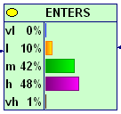 |  | existing phytosanitary measures (e.g. fire blight inspection) may detect also Pear decline infection. However, symptom expression of fireblight and Pear decline may not coincide (if nurseries are inspected in early summer for fireblight infection, Pear decline symptoms are usually not seen) | Without specific measures medium-high risk of entry | The model prediction adequately represents the judgment of assessors.
A. Visual inspection in nurseries (current measure) | i) Survive existing procedure(1.10)  ii) Likelihood of entry |  | 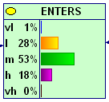 | The measure is feasible, but detection of Pear decline may be confused.  The lack of symptoms cannot fully be relied on as proof that trees are not infected | With current measures in place risk of entry is reduced to medium/low | The model prediction adequately represents the judgment of assessors.
B. Certification | i) Survive existing procedure + association (1.5)  ii) Likelihood of entry |  | 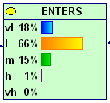 | In Europe certification schemes are in place. The use of tested basic plant material reduces the association of the pest with the plant. However, the production of certified plants in areas where the vector is abundant makes a re-infection likely. Therefore the distance between the place of production and the potential inoculum sources (orchards, pear trees in private gardens…) is crucial and contributes to the increase of uncertainty of this measure | Certification further reduces the risk of entry | The model prediction adequately represents the judgment of assessors.
C. PFPP and (buffer zone or physical protection | i) Survive existing procedure + association (1.5)  ii) Likelihood of entry |  | 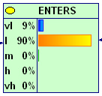 | Pest free place of production requires an official buffer zone or physical protection. Of the measures tested a PFPP is assumed to have the highest level of protection against re-infection of plants for planting in nurseries through psyllid populations. PFPP may be difficult to implement in practice | The most effective option | The model prediction adequately represents the judgment of assessors.
Notes
* including ease of implementation
** Difference between model output and assessors view
*** Only methods 4 and 5 combine all elements to determine overall risk. Methods 1, 2, and 3 do not show overall risk

Quince and Pyrus rootstocks are rated differently
1.6. volume of trade: quince: very high; pyrus: medium

Table 2: Evaluation of risk reduction options using Method 2 (reference method)
(pear grafted on quince rootstocks)
Option /description | Risk element influenced  i) Question  ii) Higher level | Risk without option(s) | Risk with option(s) | Description and technical feasibility of measure* | Evaluation of option according to model | Assessors’ judgement**
 |  | Risk element rating / score | Risk element rating / score
0. No measure | i) Survive existing procedure(1.10)  ii) Likelihood of entry | 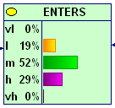 |  | See above | Without specific measures a medium risk of entry. The use of quince rootstocks (compared to Pyrus) shifts the likelihood of the pest entry from medium-high to the lower end. | The model prediction somewhat represents the judgment of the assessor, though the effect of quince rootstocks compared to Pyrus rootstocks is assumed to be higher.
A. Visual inspection in nurseries (current measure) | i) Survive existing procedure(1.10)  ii) Likelihood of entry |  | 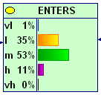 | See above | With current measures in place risk of entry is reduced to medium/low | The model prediction somewhat represents the judgment of the assessor, though the effect of quince rootstocks is assumed to be higher.
B. Certification | i) Survive existing procedure + association (1.5)  ii) Likelihood of entry |  | 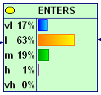 | See above | Certification further reduces the risk of entry | See above, the model prediction of the reduction of the risk of entry compared to A (visual inspections) adequately represents the judgment of assessors.
C. PFPP and (buffer zone or physical protection | i) Survive existing procedure + association (1.5)  ii) Likelihood of entry |  | 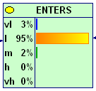 | See above | The most effective option | See above, the model prediction of the reduction of the risk of entry compared to A (visual inspections) adequately represents the judgment of assessors.

Table 3: Evaluation of risk reduction options using Method 1 (pear grafted on rootstocks of Pyrus spp.)
Answers at question level (for detailed BBN-results of the entry section see annex of this file)
Option /description | Risk element influenced  i) Question  ii) Higher level | Risk without option(s) | Risk with option(s) | Technical feasibility of measure* | Evaluation of option according to model | Assessors’ judgement**
 |  | Risk element rating / score | Risk element rating / score
0. No measure |  |  |  | See above |  | The model prediction adequately represents the judgment of assessors, though slightly higher than M2, M3 and M5.
A. Visual inspection in nurseries (current measure) | i) existing management practices (1.8)  ii) Likelihood of entry |  |  | See above | The effect of the option is minimal (the likelihood of entry is only slightly shifted towards moderately likely) | The model prediction is not in agreement with the assessors judgement. Visual inspection have a stronger influence on the likelihood of entry.
B. Certification | i) existing management practices (1.8) + + concentration (1.3)  ii) Likelihood of entry |  |  | See above | The effect of the option is minimal (the likelihood of entry is only slightly shifted towards moderately likely) | The model prediction is not in agreement with the assessors judgement. Certification has a stronger influence on the likelihood of entry.
C. PFPP and (buffer zone or physical protection | i) existing management practices (1.8) + concentration (1.3)  ii) Likelihood of entry |  |  | See above | The effect of the option is minimal (the likelihood of entry is only slightly shifted towards moderately likely) | The model prediction is not in agreement with the assessors judgement. A PFPP has a stronger influence on the likelihood of entry.

Table 3a: Evaluation of risk reduction options using Method 1 (pear grafted on rootstocks of Pyrus spp.)
Answers using the nodes PN1 and PN2 instead of the questions 1.2-1.5. (for detailed BBN-results of the entry section see annex of this file)
Option /description | Risk element influenced  i) Question  ii) Higher level | Risk without option(s) | Risk with option(s) | Technical feasibility of measure* | Evaluation of option according to model | Assessors’ judgement**
 |  | Risk element rating / score | Risk element rating / score
0. No measure |  |  |  | See above |  | The model prediction adequately represents the judgment of assessors, though slightly higher than M2, M3 and M5.
A. Visual inspection in nurseries (current measure) | i) existing management practices (1.8)  (PN1, PN2)  ii) Likelihood of entry |  |  | See above | The effect of the option is minimal (the likelihood of entry is only slightly shifted towards moderately likely) | The model prediction is not in agreement with the assessors judgement. Visual inspection have a stronger influence on the likelihood of entry.
B. Certification | i) existing management practices (1.8) + + pest associat. PN1 (PN2)  ii) Likelihood of entry |  |  | See above | The effect of the option is minimal (the likelihood of entry is only slightly shifted towards moderately likely) | The model prediction is not in agreement with the assessors judgement. Certification has a stronger influence on the likelihood of entry.
C. PFPP and (buffer zone or physical protection | i) existing management practices (1.8) + + pest associat. PN1 (PN2)  ii) Likelihood of entry |  |  | See above | The effect of the option is minimal (the likelihood of entry is only slightly shifted towards moderately likely) | The model prediction is not in agreement with the assessors judgement. A PFPP has a stronger influence on the likelihood of entry.

Table 4: Evaluation of risk reduction options using Method 1 (pear grafted on quince rootstocks)
Answers at question level (for detailed BBN-results of the entry section see annex of this file)
Option /description | Risk element influenced  i) Question  ii) Higher level | Risk without option(s) | Risk with option(s) | Technical feasibility of measure* | Evaluation of option according to model | Assessors’ judgement**
 |  | Risk element rating / score | Risk element rating / score
0. No measure |  |  |  | See above |  | The model does not represent the judgment of assessors. The probability of the pest entering on quince rootstocks is much lower
A. Visual inspection in nurseries (current measure) | i) existing management practices (1.8)  ii) Likelihood of entry |  |  | See above | The effect of the option is minimal (the likelihood of entry is only slightly shifted towards moderately likely) | The model prediction is not in agreement with the assessors judgement. Visual inspection have a stronger influence on the likelihood of entry.
B. Certification | i) existing management practices (1.8) + + concentration (1.3)  ii) Likelihood of entry |  |  | See above | The effect of the option is minimal (the likelihood of entry is only slightly shifted towards moderately likely) | The model prediction is not in agreement with the assessors judgement. Certification has a stronger influence on the likelihood of entry.
C. PFPP and (buffer zone or physical protection | i) existing management practices (1.8) + concentration (1.3)  ii) Likelihood of entry |  |  | See above | The effect of the option is minimal (the likelihood of entry is only slightly shifted towards moderately likely) | The model prediction is not in agreement with the assessors judgement. A PFPP has a stronger influence on the likelihood of entry.

Table 4a: Evaluation of risk reduction options using Method 1 (pear grafted on quince rootstocks)
Answers using the nodes PN1 and PN2 instead of the questions 1.2-1.5. (for detailed BBN-results of the entry section see annex of this file)
Option /description | Risk element influenced  i) Question  ii) Higher level | Risk without option(s) | Risk with option(s) | Technical feasibility of measure* | Evaluation of option according to model | Assessors’ judgement**
 |  | Risk element rating / score | Risk element rating / score
0. No measure |  |  |  | See above |  | The model does not represent the judgment of assessors. The probability of the pest entering on quince rootstocks is much lower
A. Visual inspection in nurseries (current measure) | i) existing management practices (1.8)  ii) Likelihood of entry |  |  | See above | The effect of the option is minimal (the likelihood of entry is only slightly shifted towards moderately likely) | The model prediction is not in agreement with the assessors judgement. Visual inspection have a stronger influence on the likelihood of entry.
B. Certification | i) existing management practices (1.8) + + concentration (1.3)  ii) Likelihood of entry |  |  | See above | The effect of the option is minimal (the likelihood of entry is only slightly shifted towards moderately likely) | The model prediction is not in agreement with the assessors judgement. Certification has a stronger influence on the likelihood of entry.
C. PFPP and (buffer zone or physical protection | i) existing management practices (1.8) + concentration (1.3)  ii) Likelihood of entry |  |  | See above | The effect of the option is minimal (the likelihood of entry is only slightly shifted towards moderately likely) | The model prediction is not in agreement with the assessors judgement. A PFPP has a stronger influence on the likelihood of entry.

Table 5: Evaluation of risk reduction options using Method 3 (pear grafted on rootstocks of Pyrus spp.)
Option /description | Risk element influenced  i) Question  ii) Higher level | Risk without option(s) | Risk with option(s) | Technical feasibility of measure* | Evaluation of option according to model | Assessors’ judgement**
 |  | Risk element rating / score | Risk element rating / score
0. No measure |  | 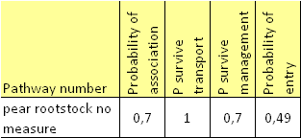 |  | See above | Without specific measures medium- risk of entry (49%). | The model prediction adequately represents the judgment of assessors. (although the lowest risk of the tested methods)
A. Visual inspection in nurseries (current measure) | i) survives pest management procedures  ii) probability of entry |  | 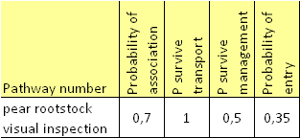 | See above | With current measures in place risk of entry is slightly reduced from 49% to 35 %. | The model prediction adequately represents the judgment of assessors. (although the lowest risk of the tested methods)
B. Certification | i) survives pest management procedures + pest being associated,  ii) probability of entry |  | 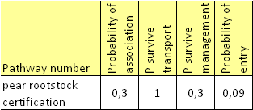 | See above | Certification greatly reduces the risk of entry  From 49% to 9%. | The model prediction adequately represents the judgment of assessors. (although the lowest risk of the tested methods)
C. PFPP and (buffer zone or physical protection | i) survives pest management procedures + pest being associated,  ii) probability of entry |  | 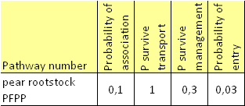 | See above | The most effective option with the lowest risk of entry (3%). | The model prediction adequately represents the judgment of assessors. (although the lowest risk of the tested methods)

Table 6: Evaluation of risk reduction options using Method 3 (pear grafted on quince rootstocks)
Option /description | Risk element influenced  i) Question  ii) Higher level | Risk without option(s) | Risk with option(s) | Technical feasibility of measure* | Evaluation of option according to model | Assessors’ judgement**
 |  | Risk element rating / score | Risk element rating / score
0. No measure |  | 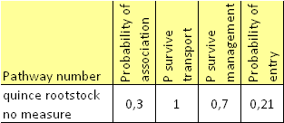 |  | See above | Without specific measures low risk of entry (21%). | The model prediction adequately represents the judgment of assessors. (although the lowest risk of the tested methods)
A. Visual inspection in nurseries (current measure) | i) survives pest management procedures  ii) probability of entry |  | 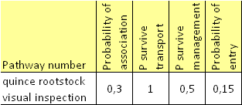 | See above | With current measures in place risk of entry is slightly reduced from 21% to 15 %. | The model prediction adequately represents the judgment of assessors. (although the lowest risk of the tested methods)
B. Certification | i) survives pest management procedures + pest being associated,  ii) probability of entry |  | 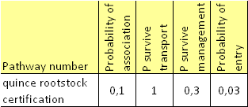 | See above | Certification greatly reduces the risk of entry from 21% to 3%. | The model prediction adequately represents the judgment of assessors. (although the lowest risk of the tested methods)
C. PFPP and (buffer zone or physical protection | i) survives pest management procedures + pest being associated,  ii) probability of entry |  | 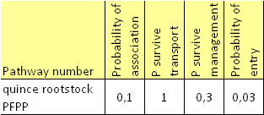 | See above | The most effective option with the lowest risk of entry (3%). | The model prediction adequately represents the judgment of assessors. (although the lowest risk of the tested methods)

Table 7: Evaluation of risk reduction options using Method 4
Option /description | Risk element influenced  i) Question  ii) Higher level | Risk without option(s) |  | Risk with option(s) |  | Technical feasibility of measure* | Evaluation of option according to model | Assessors’ judgement**
 |  | Risk element rating / score | Overall risk *** | Risk element rating / score | Overall risk ***
0. No measure |  | 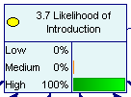 | 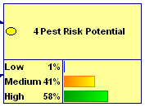 |  |  | Method (M4) addresses entry with a component referred to as "introduction potential" at the end of the risk assessment. Six independent questions are combined using a BBN-model: (1) quantity imported annually, (2) likelihood of survival following postharvest treatment, (3) survival during shipment, (4) avoiding detection at the point of entry, (5) movement to areas suitable for establishment, and (6) likelihood of coming into contact with host plants.  The association of the pest at the place of origin is not assessed. This should be considered a key and principle element within any entry section of a risk assessment scheme. In the case of Ca. Phytoplasma pyri, information which is relevant was not considered by neglecting such an association, e.g. the role of the vector in the association, the seasonal variation of colonization of the root system and the aerial parts and the different susceptibility and the survival of the pest in quince and pear rootstocks. Consequently, the effect of risk reduction options in the exporting country influencing the association cannot be tested. This explains why M4 had the highest rating of entry of all tested methods - the possibility to detect the pest during nursery inspection, the effect of a certification scheme or a PFPP cannot be shown in Method 4.
A. Visual inspection in nurseries (current measure) | i) no risk element of scheme 4 is influenced by the measure
B. Certification | i) no risk element of scheme 4 is influenced by the measure
C. PFPP and (buffer zone or physical protection | i) no risk element of scheme 4 is influenced by the measure

Table 8: Evaluation of risk reduction options using Method 5: Pyrus
Option /description | Risk element influenced  i) Question  ii) Higher level | Risk without option(s) |  | Risk with option(s) |  | Technical feasibility of measure* | Evaluation of option according to model | Assessors’ judgement**
 |  | Risk element rating / score | Overall risk *** | Risk element rating / score | Overall risk ***
0. No measure | 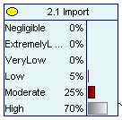 | 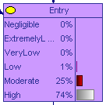 | 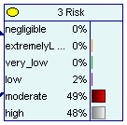 |  |  | See above | Without specific measures moderate-high risk of entry
A. Visual inspection in nurseries (current measure) | 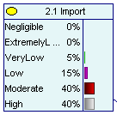 |  |  | 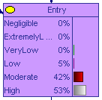 | 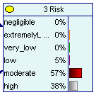 | See above | With visual inspections risk of entry is only slightly reduced  Overall risk is not affected | The model prediction adequately represents the judgment of assessors,  the influence of the measure on the risk of entry does not affect the overall risk as both disease and vector are very widespread in the PRA area.
B. Certification | 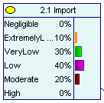 |  |  | 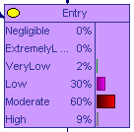 | 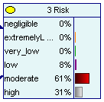 | See above | Certification reduces the risk of entry to low-moderate  Overall risk is not affected
C. PFPP and (buffer zone or physical protection | 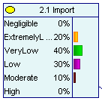 |  |  | 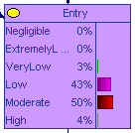 | 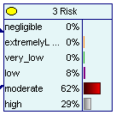 | See above | The most effective option to reduce the risk of entry  Overall risk is not affected

Table 9: Evaluation of risk reduction options using Method 5: Quince
Option /description | Risk element influenced  i) Question  ii) Higher level | Risk without option(s) |  | Risk with option(s) |  | Technical feasibility of measure* | Evaluation of option according to model | Assessors’ judgement**
 |  | Risk element rating / score | Overall risk *** | Risk element rating / score | Overall risk ***
0. No measure | 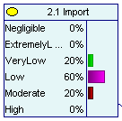 | 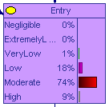 | 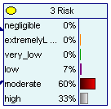 |  |  | See above | Without specific measures moderate-high risk of entry
A. Visual inspection in nurseries (current measure) | 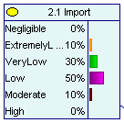 |  |  | 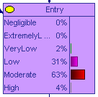 | 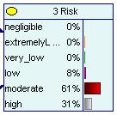 | See above | With visual inspections risk of entry is only slightly reduced  Overall risk is not affected | The model prediction adequately represents the judgment of assessors,  the influence of the measure on the risk of entry does not affect the overall risk as both disease and vector are very widespread in the PRA area
B. Certification | 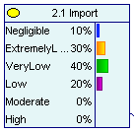 |  |  | 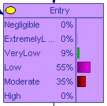 | 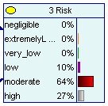 | See above | Certification reduces the risk of entry to low-moderate  Overall risk is not affected
C. PFPP and (buffer zone or physical protection | 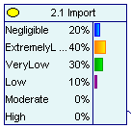 |  |  | 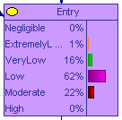 | 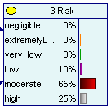 | See above | The most effective option to reduce the risk of entry  Overall risk is not affected

Annex: Detailed model results of the entry section

Method 1: Pear grafted on Pyrus rootstocks – no measures (yellow highlighted tables are used for RROs)
Answers at question level (1.2-1.5)
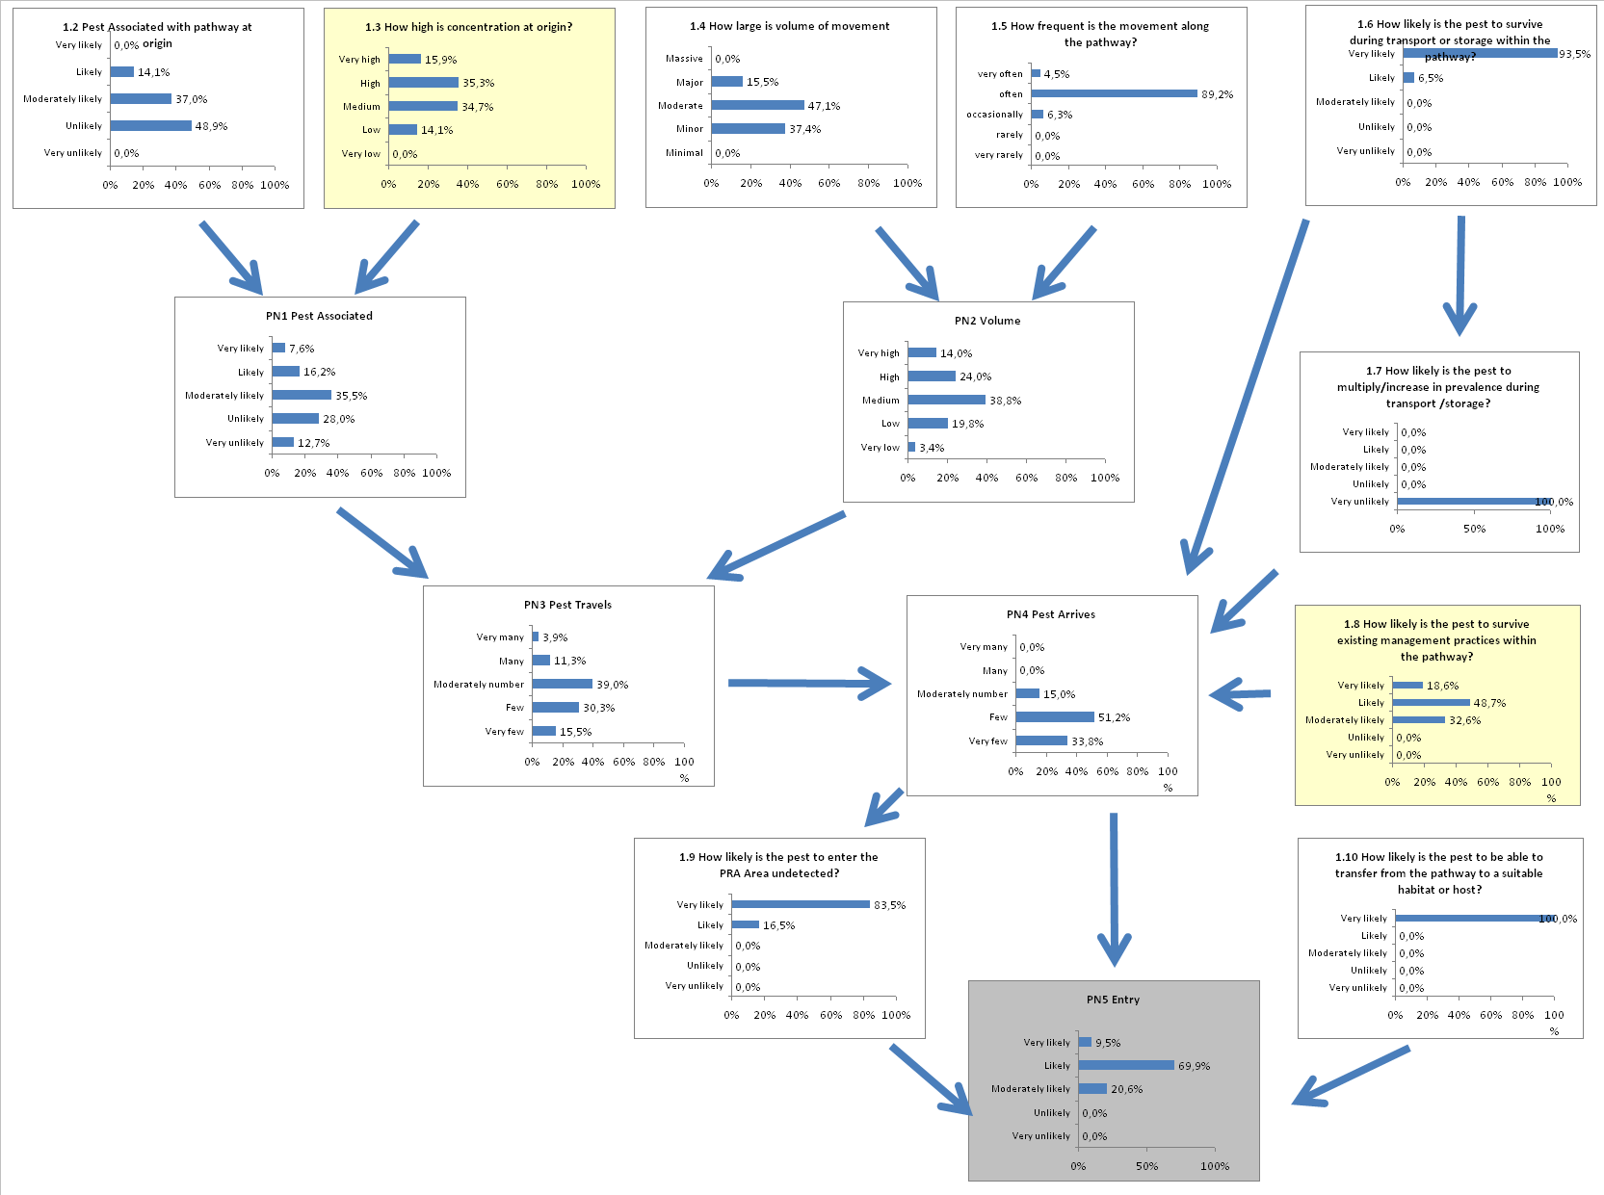

Answers using the nodes PN1 and PN2, instead of the questions 1.2-1.5.
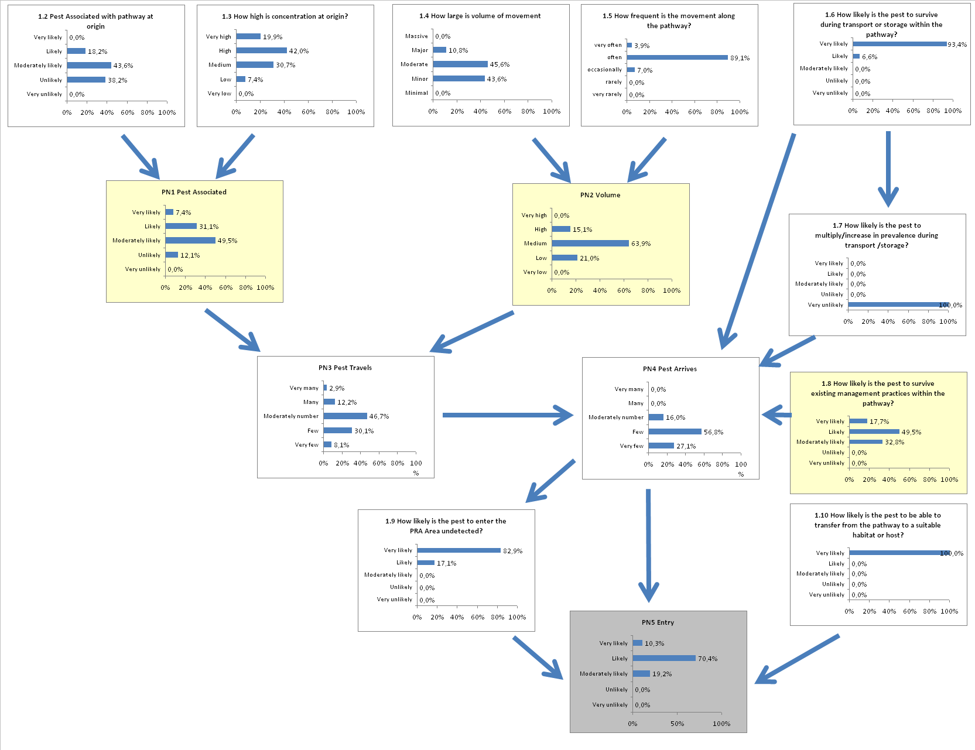

Method 1: Pear grafted on Pyrus rootstocks – visual inspection
Answers at question level (1.2-1.5)

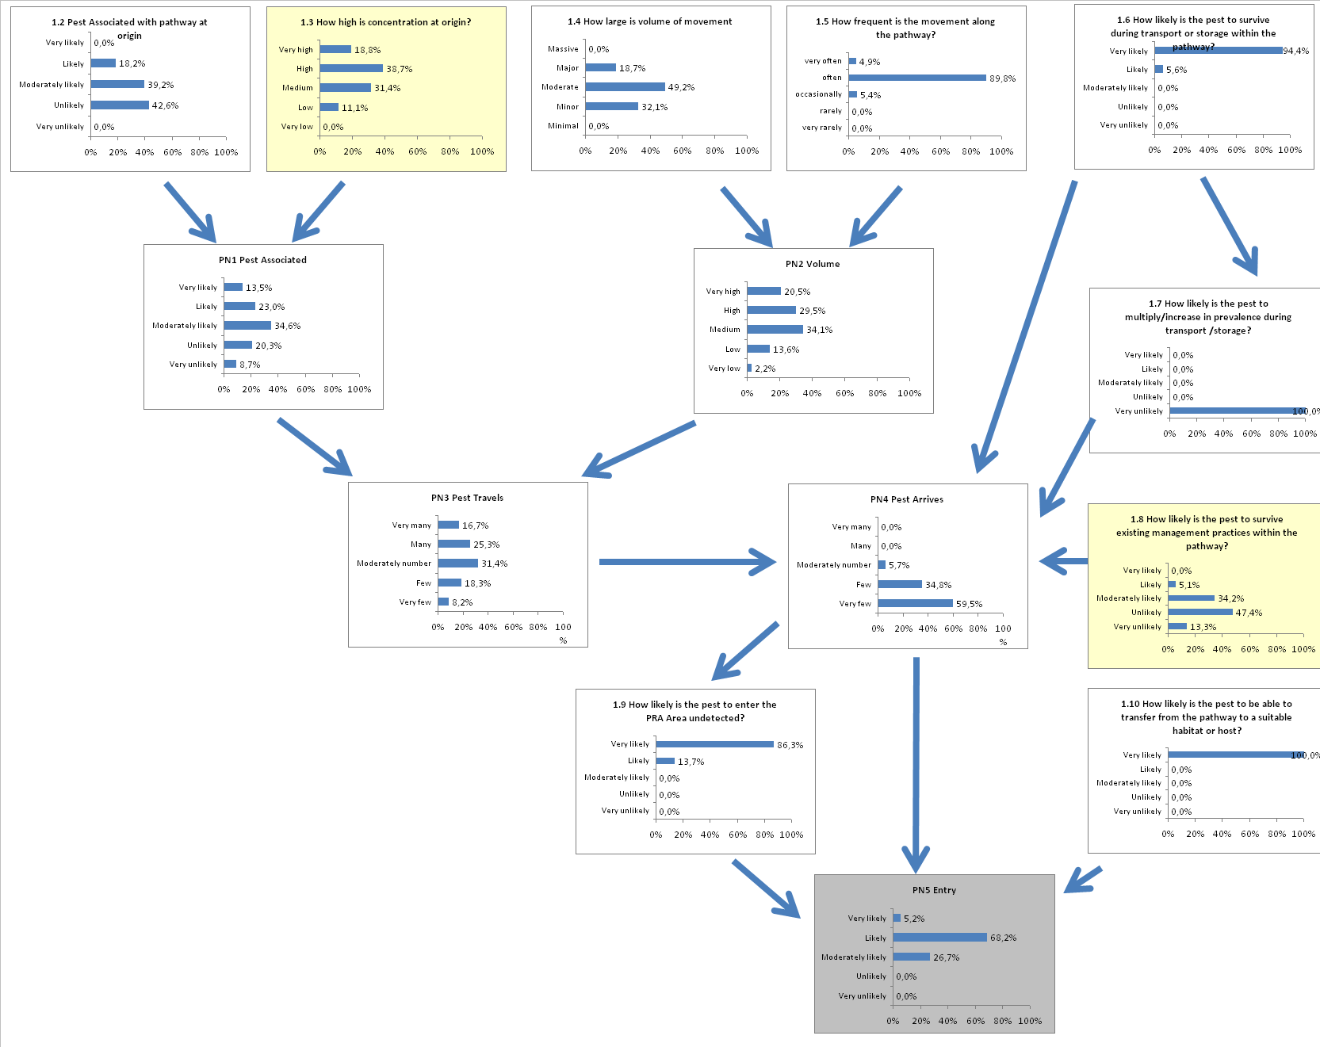

Answers using the nodes PN1 and PN2, instead of the questions 1.2-1.5.

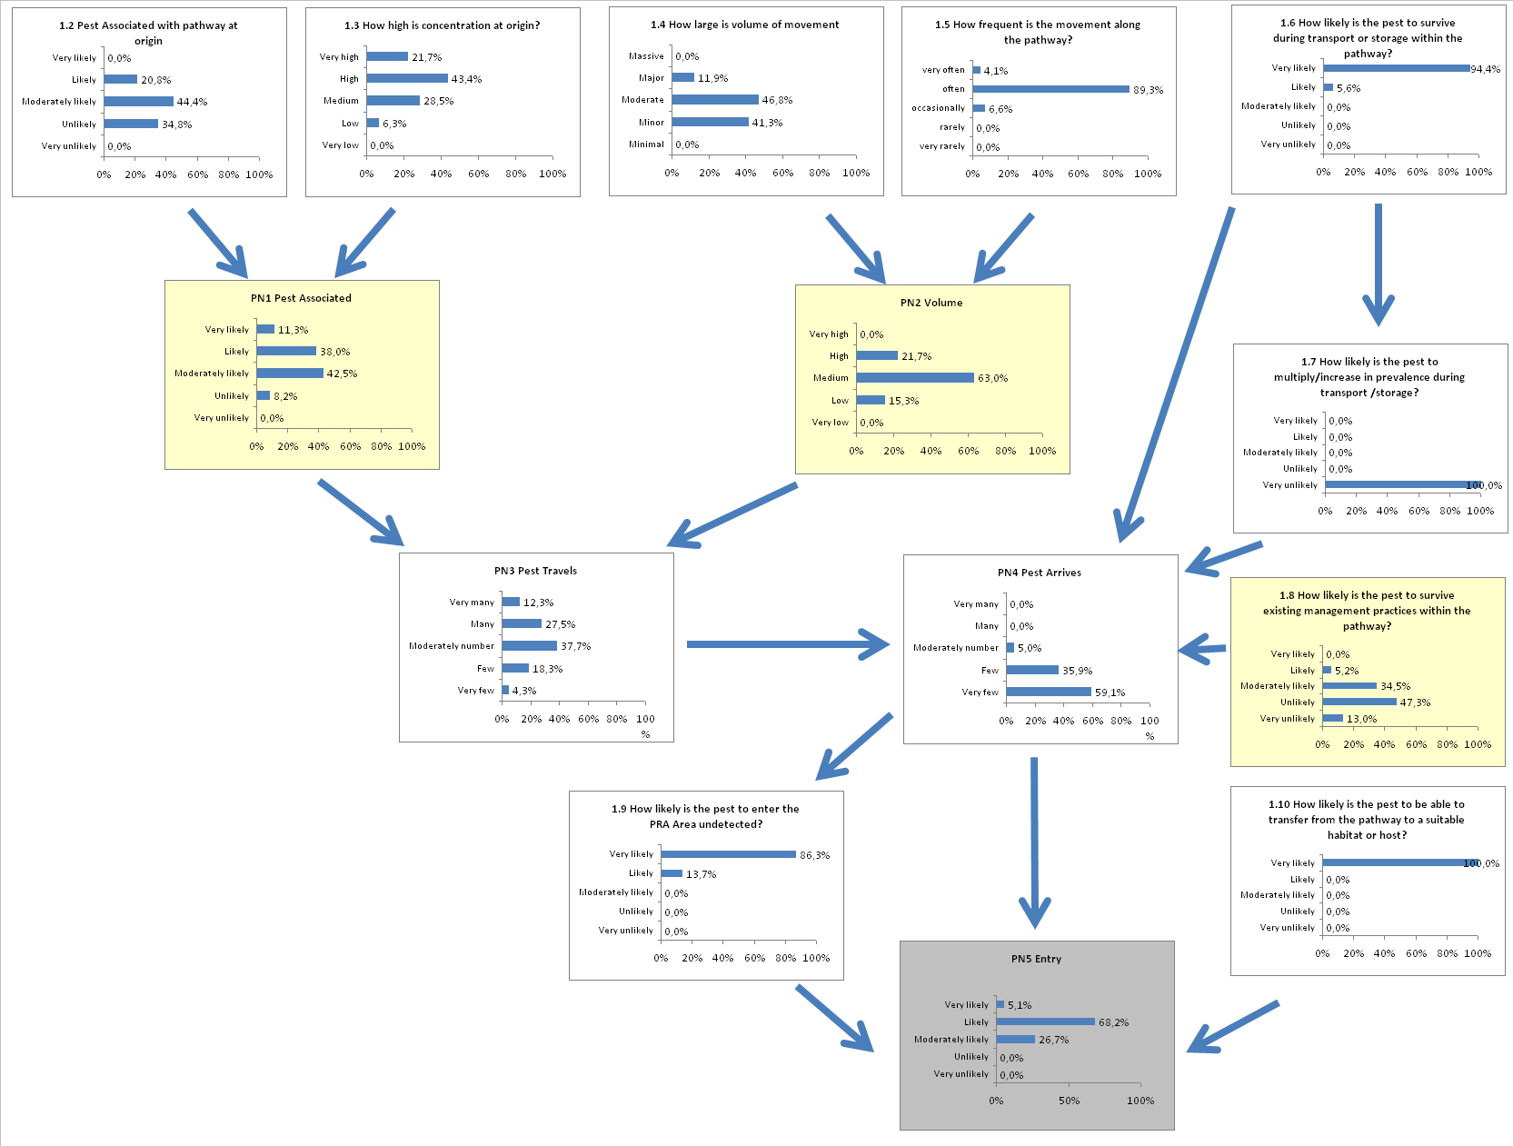
Method 1: Pear grafted on Pyrus rootstocks – certification
Answers at question level (1.2-1.5)
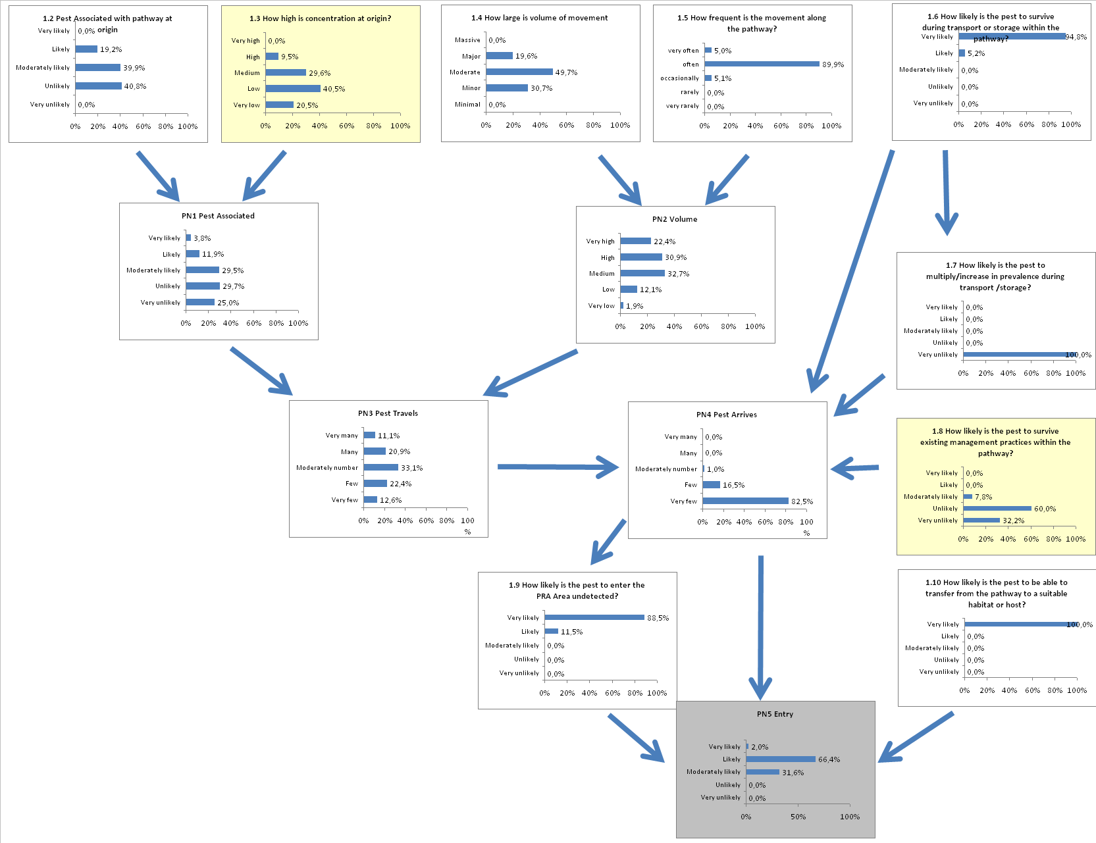

Answers using the nodes PN1 and PN2, instead of the questions 1.2-1.5.
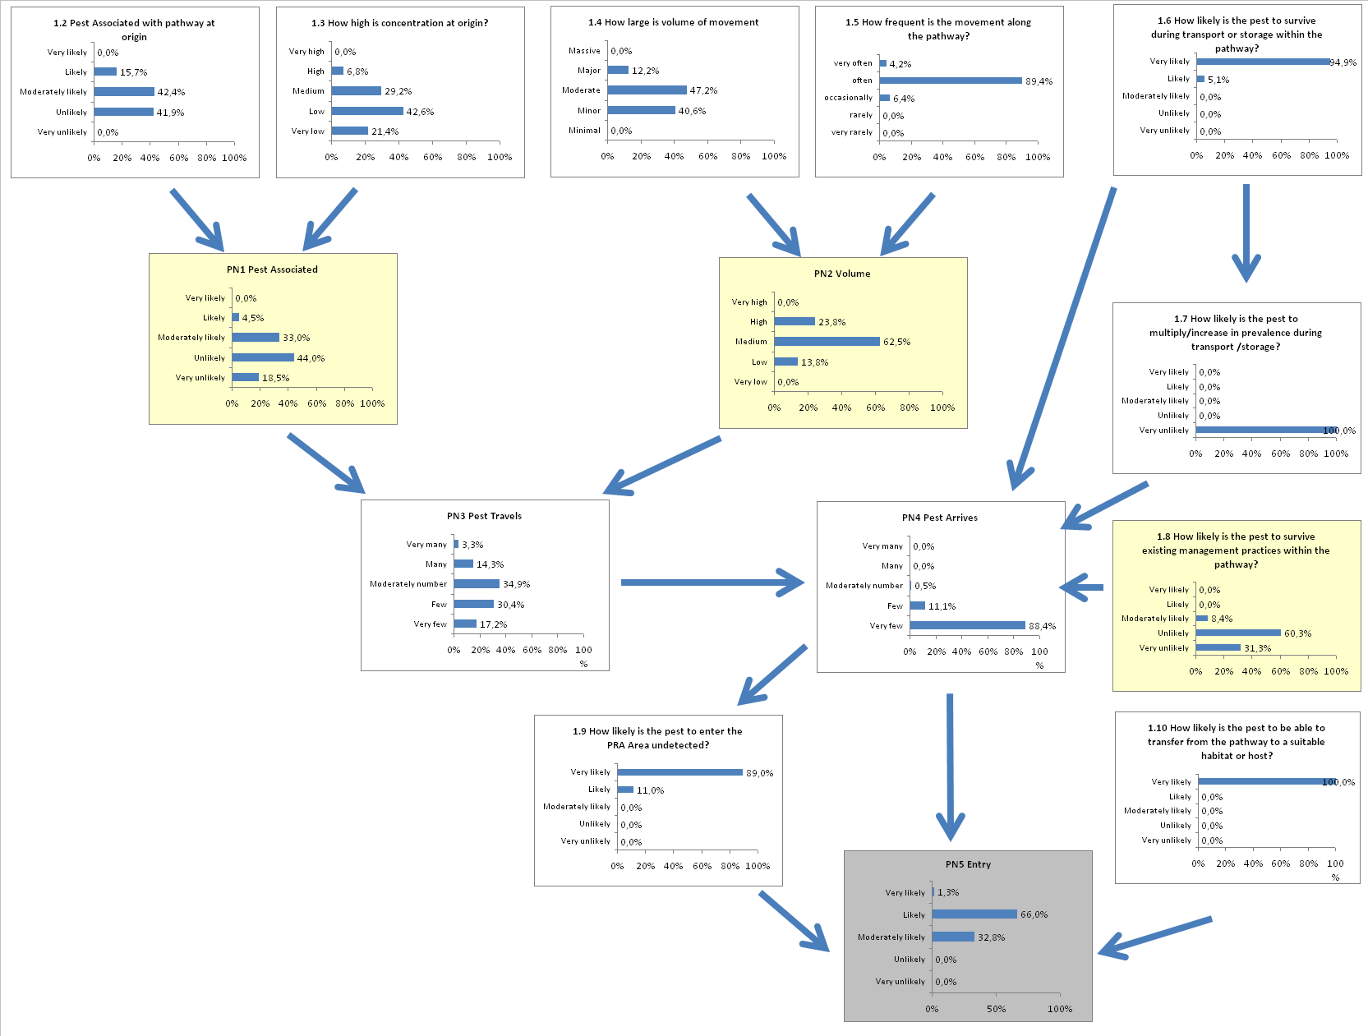
Method 1: Pear grafted on Pyrus rootstocks – PFPP
Answers at question level (1.2-1.5)
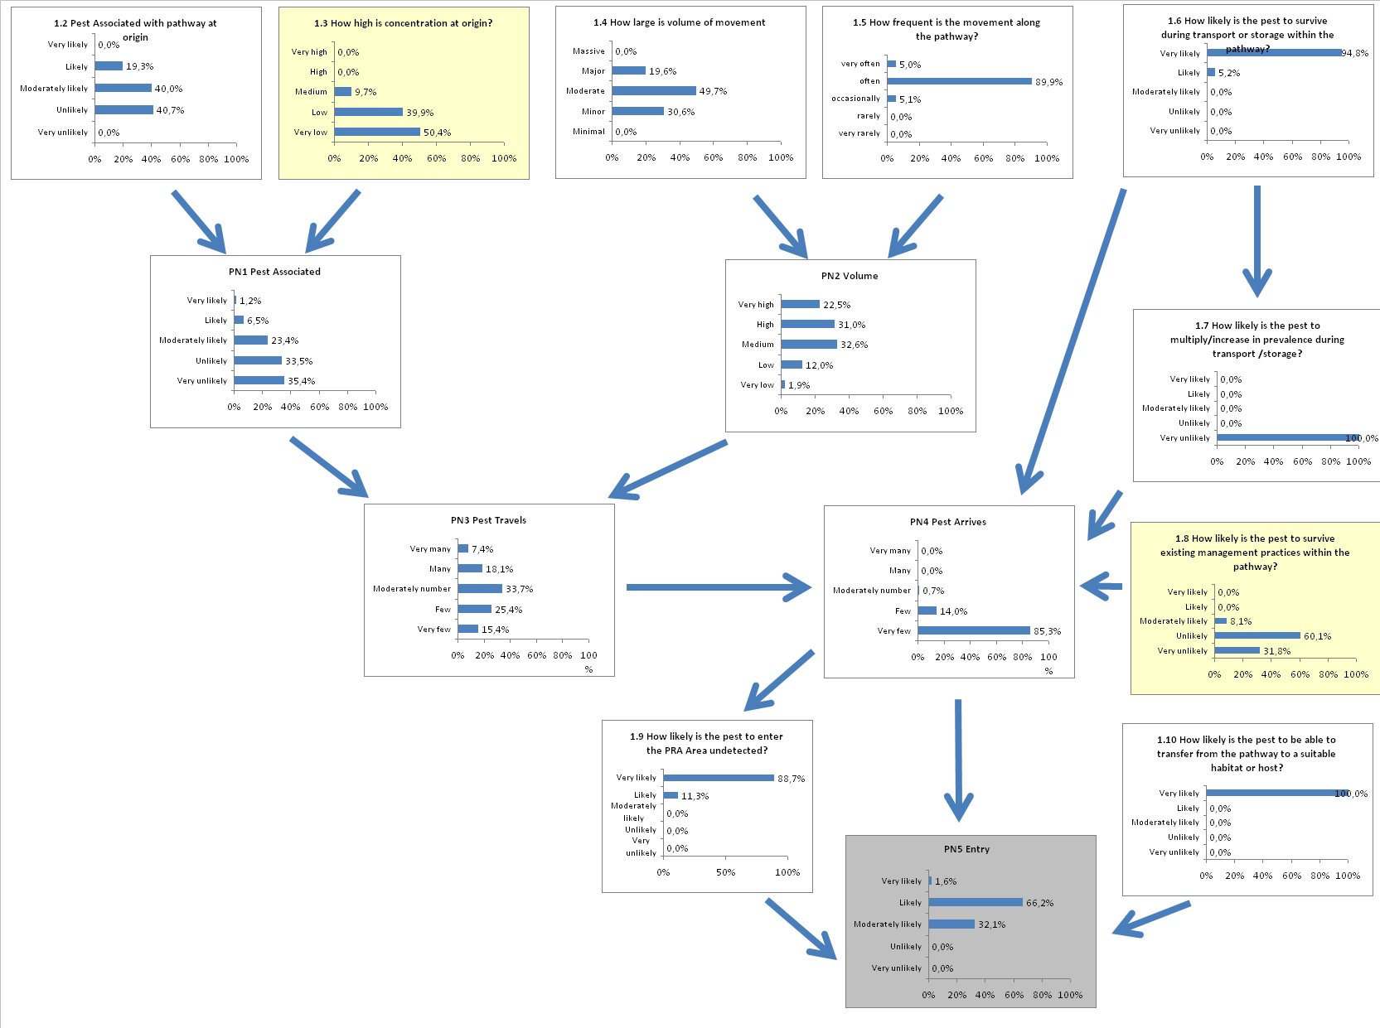

Answers using the nodes PN1 and PN2, instead of the questions 1.2-1.5.
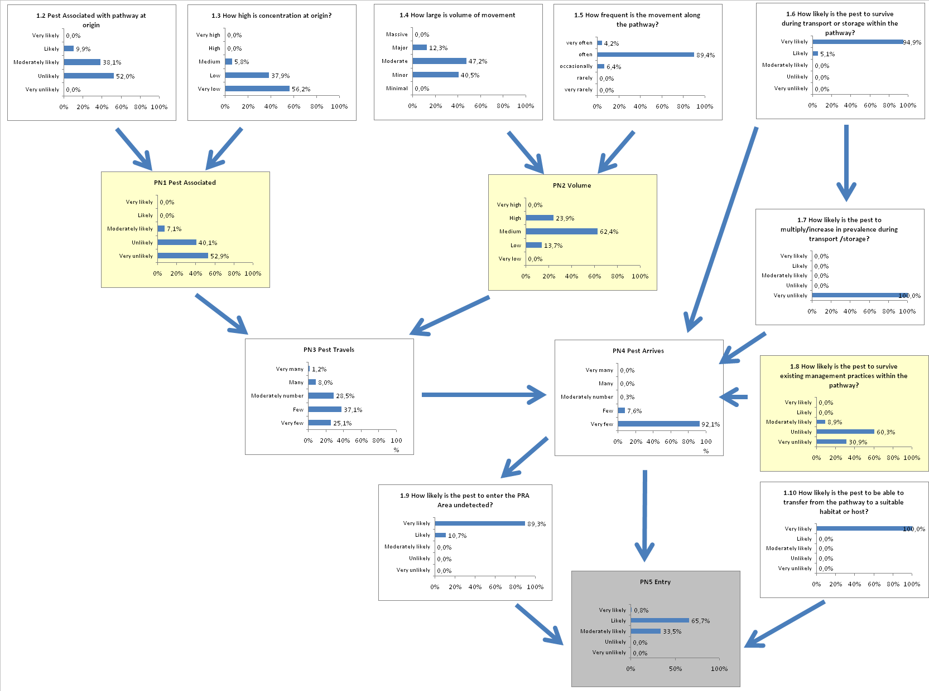
Method 1: Pear grafted on Quince rootstocks – no measures
Answers at question level (1.2-1.5)
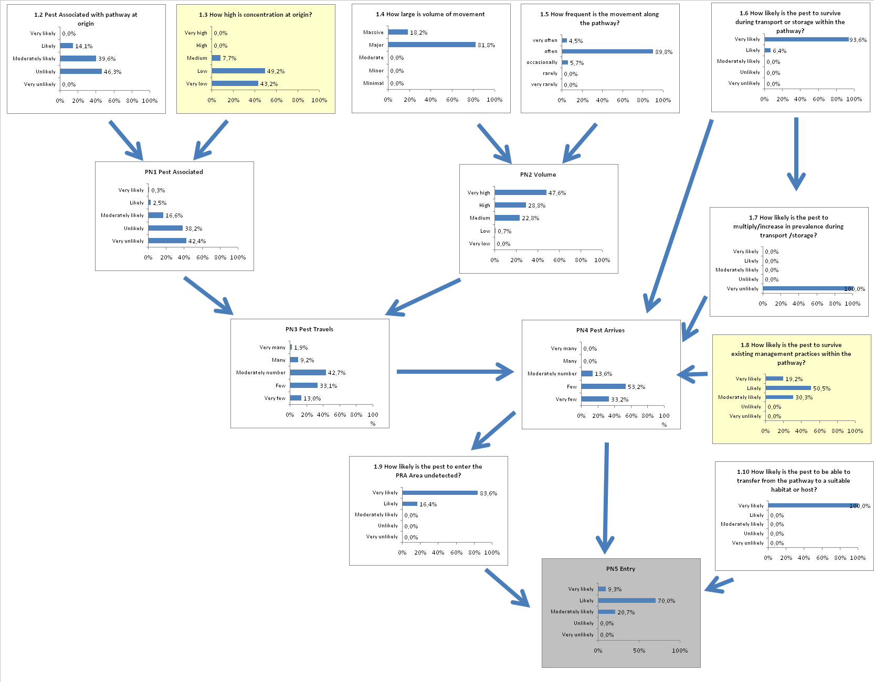

Answers using the nodes PN1 and PN2, instead of the questions 1.2-1.5.

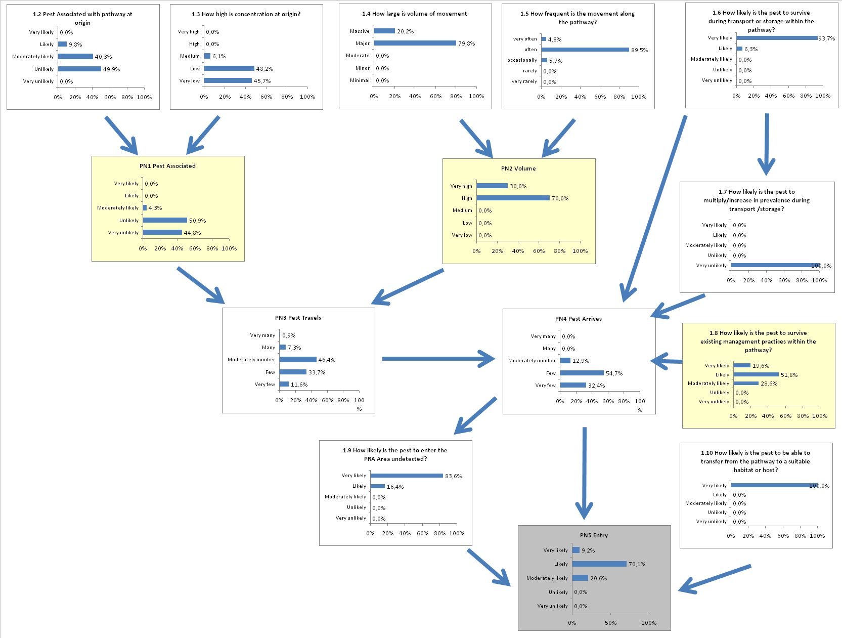
Method 1: Pear grafted on Quince rootstocks – visual inspection

Answers at question level (1.2-1.5)

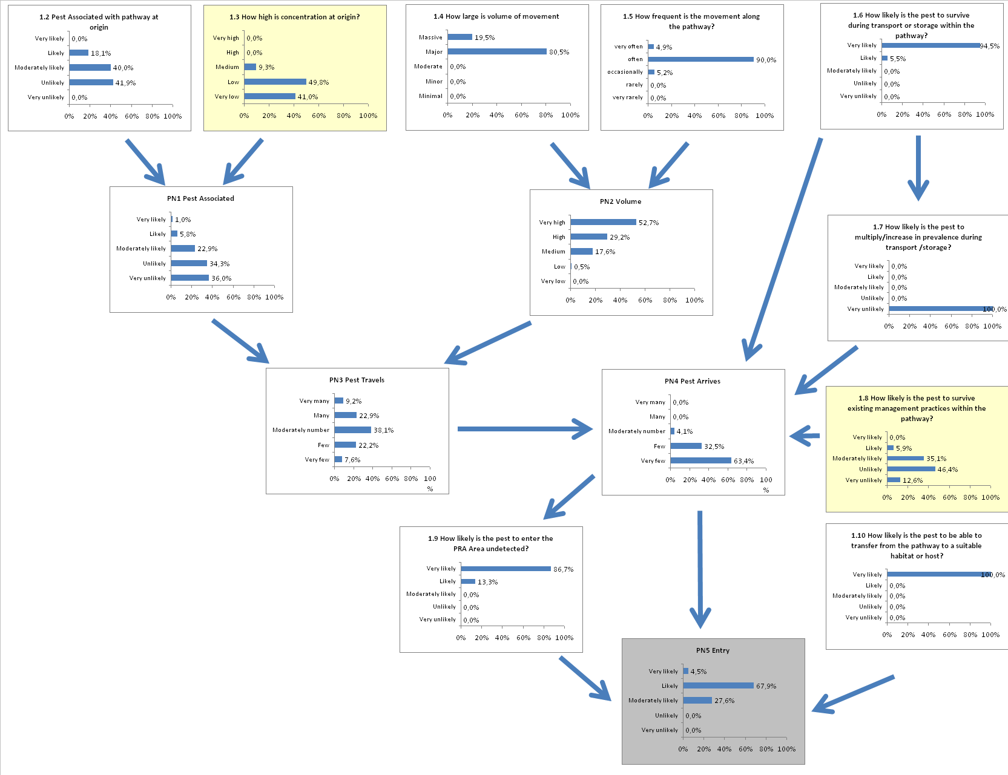

Answers using the nodes PN1 and PN2, instead of the questions 1.2-1.5.
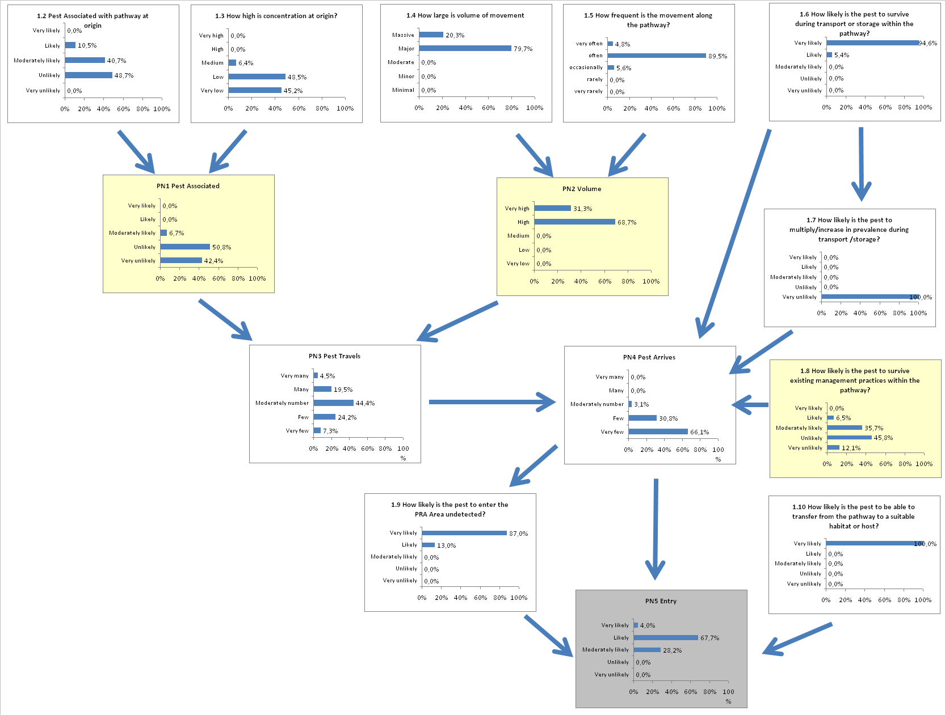
Method 1: Pear grafted on Quince rootstocks – certification
Answers at question level (1.2-1.5)

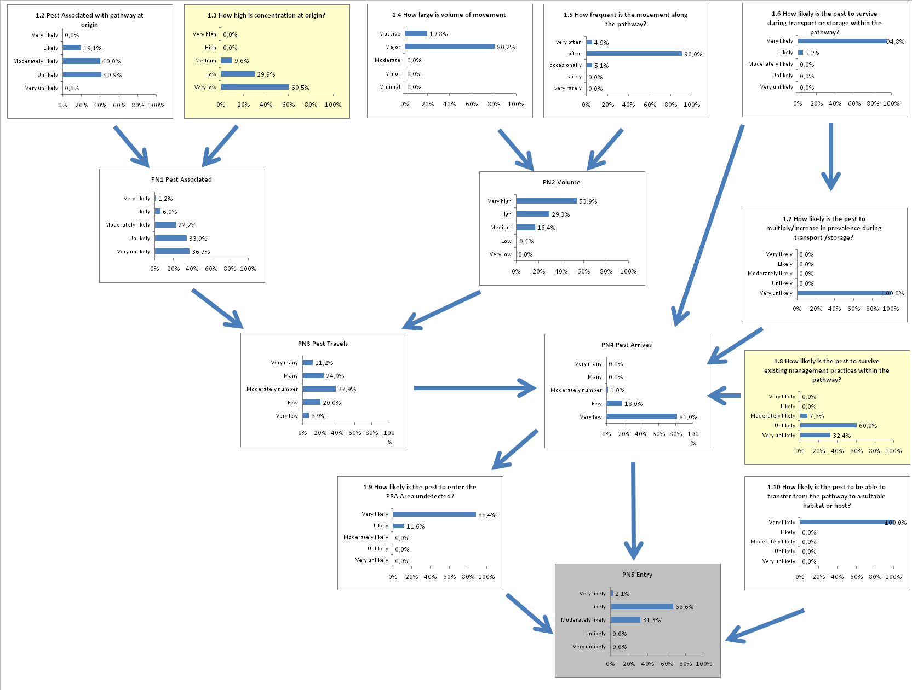

Answers using the nodes PN1 and PN2, instead of the questions 1.2-1.5.

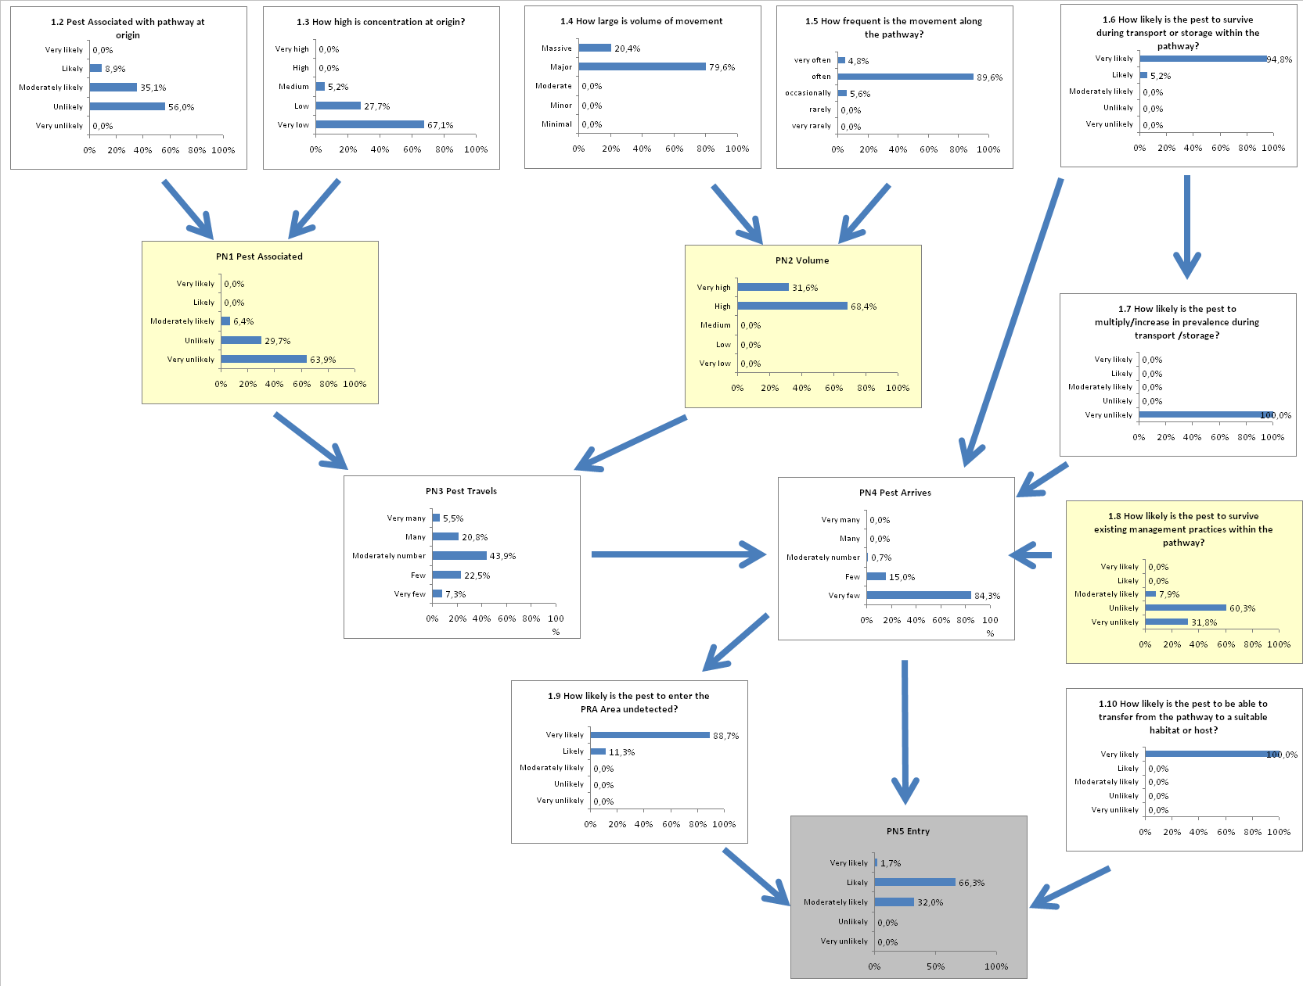
Method 1: Pear grafted on Quince rootstocks – PFPP
Answers at question level (1.2-1.5)

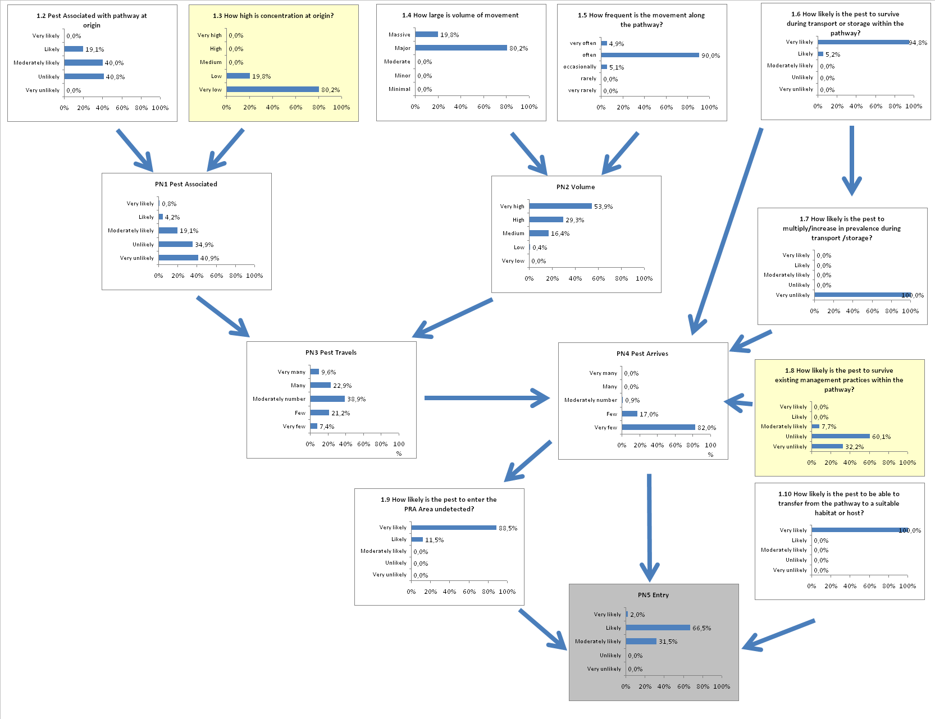

Answers using the nodes PN1 and PN2, instead of the questions 1.2-1.5.
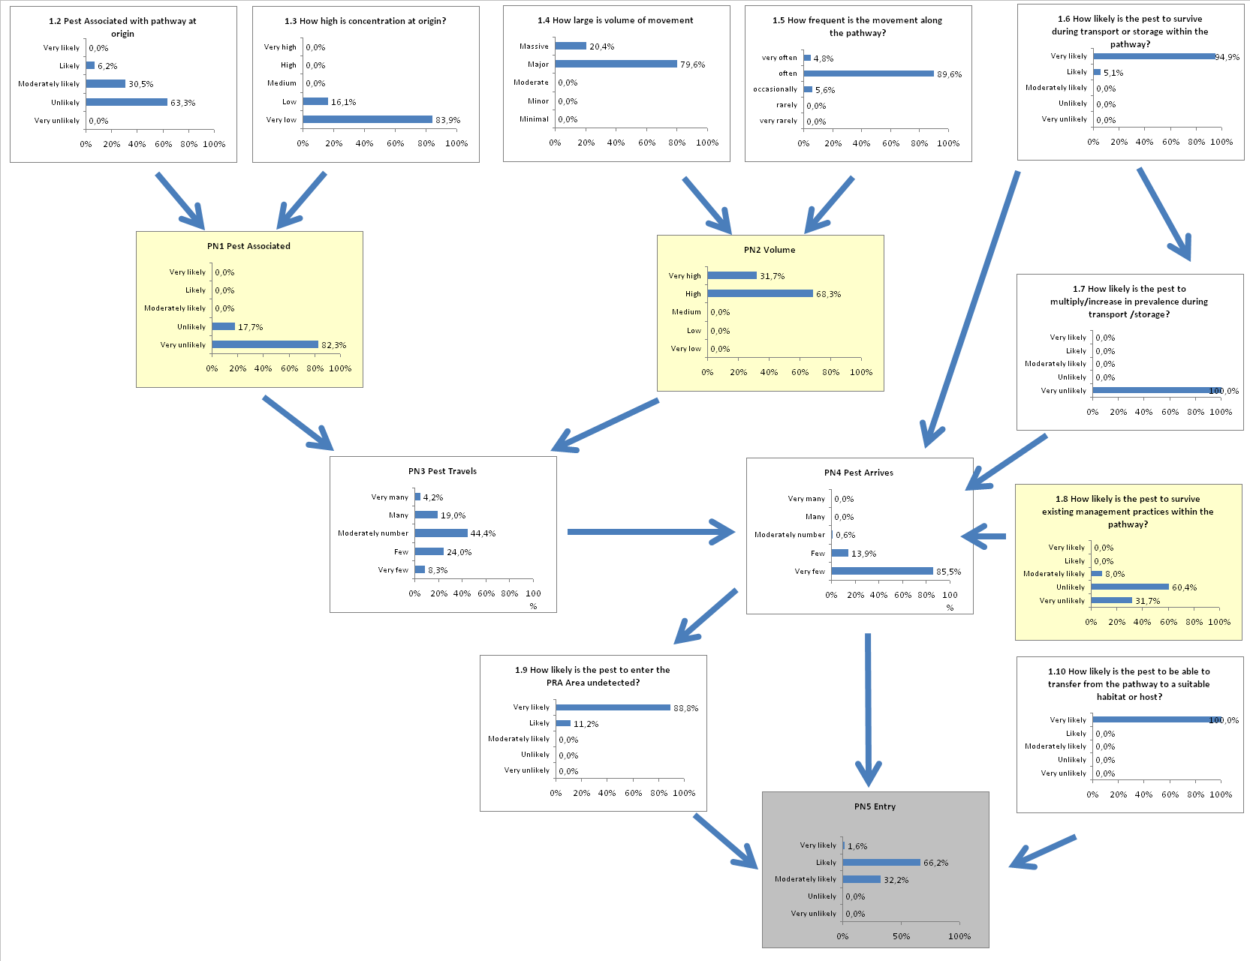

Method 2: Pear grafted on Pyrus rootstocks – no measures

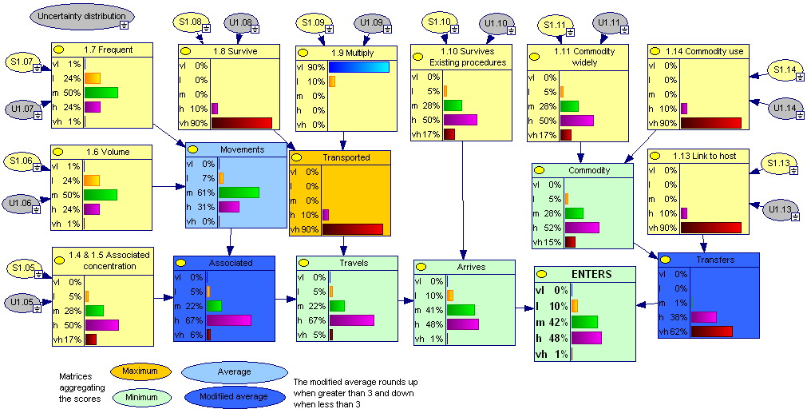

Method 2: Pear grafted on Pyrus rootstocks – visual inspections

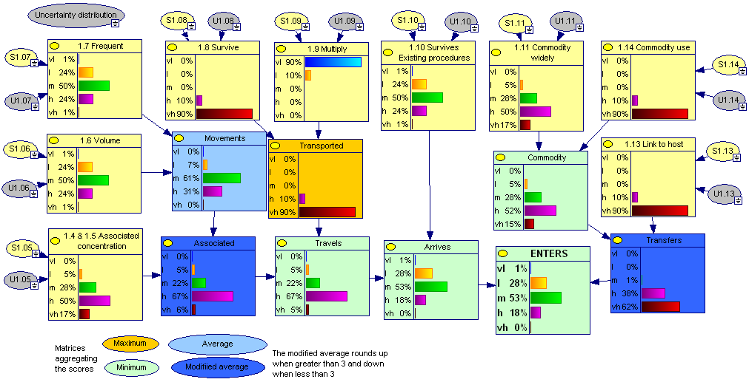

Method 2: Pear grafted on Pyrus rootstocks – certification

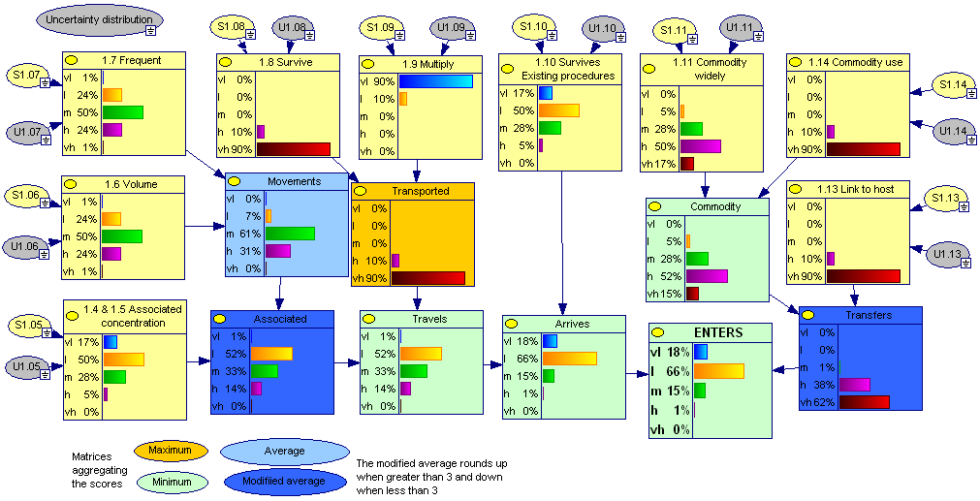

Method 2: Pear grafted on Pyrus rootstocks – PFPP

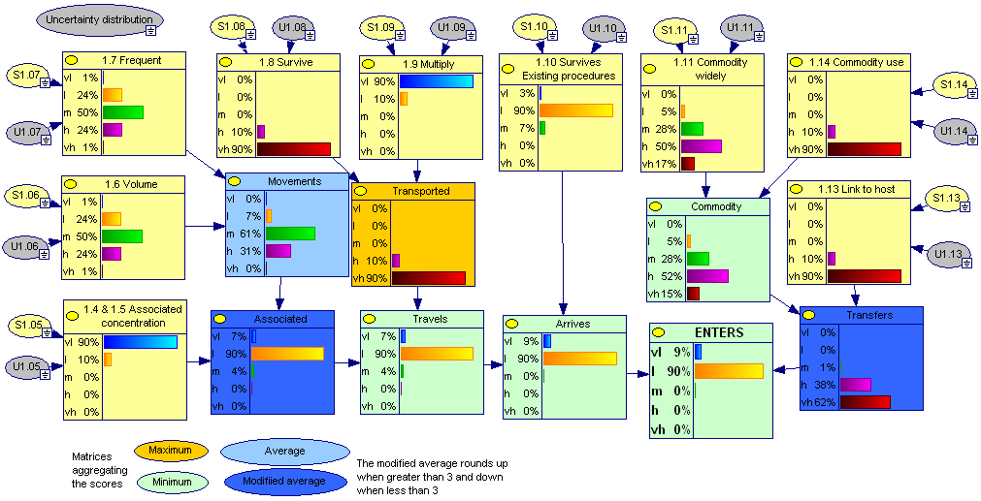

Method 2: Pear grafted on Quince rootstocks – no measures

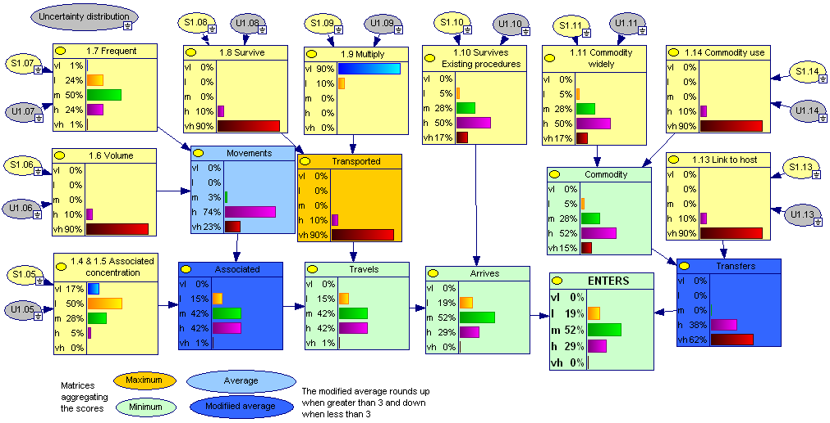

Method 2: Pear grafted on Quince rootstocks – visual inspections

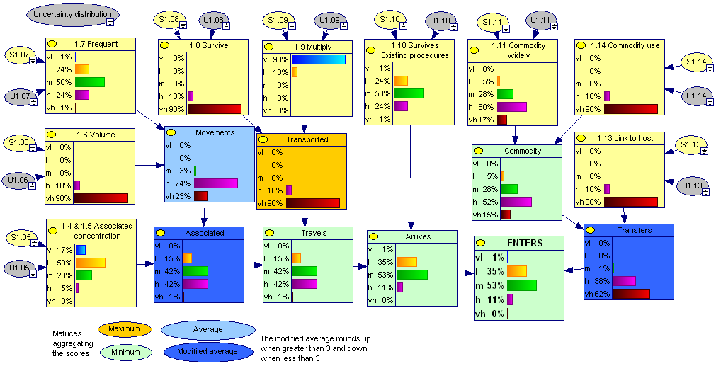

Method 2: Pear grafted on Quince rootstocks – certification

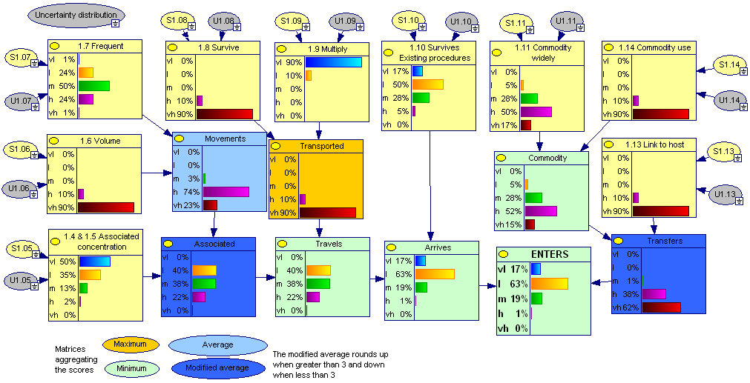

Method 2: Pear grafted on Quince rootstocks – PFPP

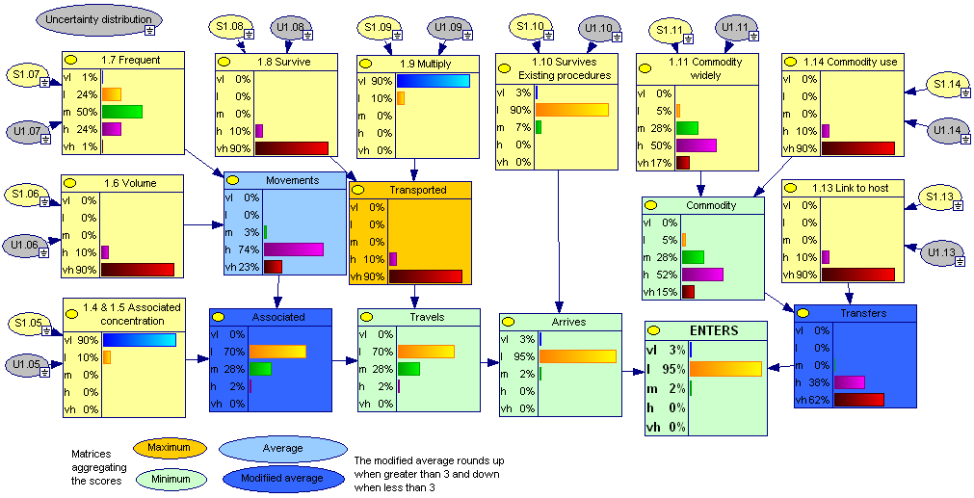

As method 3 doesn't combine risk elements in a matrix or BBN, the calculated results of method 3 are only presented in the table (see above).

As method 4 doesn't include association the effect of the measures affecting association: visual inspection, certification and PFPP cannot be shown.

Method 5: Pear grafted on Pyrus rootstocks – no measures

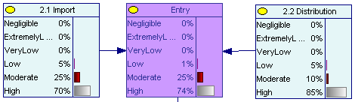

Method 5: Pear grafted on Pyrus rootstocks – visual inspections

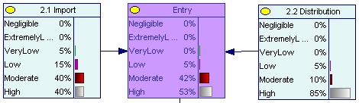

Method 5: Pear grafted on Pyrus rootstocks – certification

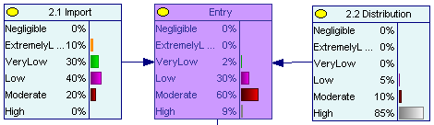

Method 5: Pear grafted on Pyrus rootstocks – PFPP

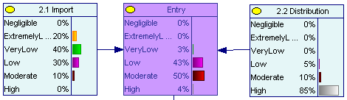
Method 5: Pear grafted on Quince rootstocks – no measures

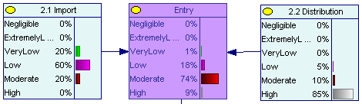

Method 5: Pear grafted on Quince rootstocks – visual inspections

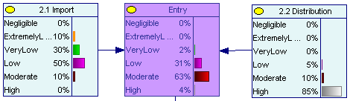

Method 5: Pear grafted on Quince rootstocks – certification

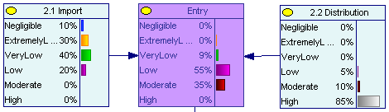

Method 5: Pear grafted on Quince rootstocks – PFPP

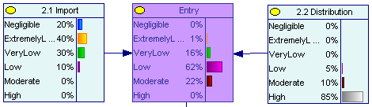
D. References
(additional references can be found in Annex 4 of the risk assessment)

Agrios, G. (1997) Plant Pathology (4th edition). Academic press, p. 635.
Babini, A.R., Fiumi, E., Giunchedi, L., Pignatta, D., Pollini, C.P., and Reggiani, N. (2008) Investigations with real-time PCR assay on the transmissibility of pear decline phytoplasma (PDP) with dormant buds. Acta Horticulturae, 781, 495-497.
Bertaccini, A., Paltrinieri, S., Caprara, L., Laimer, M., Hanzer, V., and Balla, I. (2004) Improved molecular methods for detection of <i>European stone fruit yellows</i> (ESFY) phytoplasmas from in vitro shoots of fruit trees. Acta Horticulturae, 657, 495-500.
Davies, D.L., Guise, C.M., Clark, M.F., and Adams, A.N. (1992) Parry's disease of pears is similar to pear decline and is associated with mycoplasma-like organisms transmitted by <i>Cacopsylla pyricola.</i>. Plant Pathology, 41(2), 195-203.
Debras, J.F., Rieux, R., Arcier, F.F.d., Kretsczhmar, A., and Simon, S. (1998) Regulation of pear psyllid: importance and role of the orchard environment. Phytoma, 510, 53-55.
Errea, P., Aguelo, V., and Hormaza, J.I. (2002) Seasonal variations in detection and transmission of pear decline phytoplasma. Journal of Phytopathology, 150(8), 439-443.
European-Commission-Directive. (1993) Commission Directive 93/48/EEC of 23 June 1993 setting out the schedule indicating the conditions to be met by fruit plant propagating material and fruit plants intended for fruit production, pursuant to Council Directive 92/34/EEC. http://eur-lex.europa.eu/LexUriServ/LexUriServ.do?uri=CELEX:31993L0048:EN:HTML (accessed May 2011).
European-Council-Directive. (2000/29/EC) Directive 2000/29/EC of 8 May 2000 on protective measures against the introduction into the Community of organisms harmful to plants or plant products and against their spread within the Community. OJ, L 169, 10.7.2000, pp112.
European-Council-Directive. (2008) Council Directive 2008/90/EC of 29 September 2008 on the marketing of fruit plant propagating material and fruit plants intended for fruit production. http://eur-lex.europa.eu/Result.do?T1=V1&T2=2008&T3=90&RechType=RECH_naturel&Submit=Search (accessed May 2011).
Garcia-Chapa, M., Medina, V., Viruel, M.A., Lavina, A., and Batlle, A. (2003) Seasonal detection of pear decline phytoplasma by nested-PCR in different pear cultivars. Plant Pathology, 52(4), 513-520.
Hodgson, C.J., and Mustafa, T.M. (1984) The dispersal and flight activity of <i>Psylla pyricola </i>Forster in southern England: Bulletin SROP. 1984. 7: 5, 97-124. 24 ref.
Krizan, B., Moravcova, K., Ondrusikova, E., Adam, M., Holleinova, V., and Pidra, M. (2008) Thermotherapy of grapevines and apricots by reason of viruses and phytoplasma elimination. Acta Horticulturae, 781, 93-96.
Laimer da Camara Machado, M. (2003) Detection and Elimination of Viruses and Phytoplasmas from Pome and Stone Fruit Trees. Horticultural Reviews, 28, 187-236.
Laimer, M. (2003) Detection and Elimination of Viruses and Phytoplasmas from Pome and Stone Fruit Trees. Horticultural Reviews, 28, 187-236.
Laimer, M., Hanzer, V., Kriston, E., Toth, E.K., Mendonca, D., Kirilla, Z., and Balla, I. (2006) Elimination and detection of pathogens from tissue cultures of <i>Prunus</i> sp. Acta Horticulturae, 725(Vol.1), 319-323.
Mannini, F. (2007) Hot water treatment and field coverage of mother plants vineyards to prevent propagation material from phytoplasma infection. . Bulletin of Insectology, 60, 311-312.
McIntyre, J.L., Dodds, J.A., Walton, G.S., and Lacy, G.H. (1978) Declining pear trees in Connecticut: symptoms, distribution, symptom remission by oxytetracycline, and associated mycoplasma like organisms: Plant Disease Reporter. 1978. 62: 6, 503-507. 8 ref.
McIntyre, J.L., Schneider, H., Lacy, G.H., Dodds, J.A., and Walton, G.S. (1979) Pear decline in Connecticut and response of diseased trees to oxytetracycline infusion: Phytopathology. 1979. 69: 9, 955-958. 11 ref.
Nyland, G. (1975) Tetracycline therapy of pear decline and X-disease in peach and cherry: Acta Horticulturae. 1975. 44, 17.
Nyland, G., and Moller, W.J. (1973) Control of pear decline with a tetracycline: Plant Disease Reporter. 1973. 57: 8, 634-637.
OEPP/EPPO. (1999) Certification schemes: Pathogen tested material of Malus, Pyrus and Cydonia. EPPO Standards PM 4/27(1), 1-15.
OEPP/EPPO. (2005) Good Plant Protection Practice Pome Fruits. EPPO Standards PP2, PP 2/18, 149-164.
OEPP/EPPO. (2006) Diagnostic protocol for Candidatus Phytoplasma pyri. Bulletin OEPP/EPPO Bulletin, 36, 127-128.
Poggi Pollini, C., Bissani, R., and Giunchedi, L. (1995) Overwintering of pear decline agent in some quince rootstocks. Acta Horticulturae, 386, 496-499.
Schaper, U., and Seemüller, E. (1984) Recolonization of the stem of apple proliferation and pear decline-diseased trees by the causal organisms in spring: Zeitschrift fur Pflanzenkrankheiten und Pflanzenschutz. 1984. 91: 6, 608-613. 10 ref.
Seemüller, E., Schaper, U., and Kunze, L. (1986) Effect of pear decline on pear trees on 'Quince A' and <i>Pyrus communis </i>seedling rootstocks: Zeitschrift fur Pflanzenkrankheiten und Pflanzenschutz. 1986. 93: 1, 44-50. 12 ref.
Seemüller, E., Schaper, U., and Zimbelmann, F. (1984) Seasonal variation in the colonization patterns of mycoplasmalike organisms associated with apple proliferation and pear decline: Zeitschrift fur Pflanzenkrankheiten und Pflanzenschutz. 1984. 91: 4, 371-382. 27 ref.
Trapman, M., and Blommers, L. (1992) An attempt to pear sucker management in the Netherlands. Journal of Applied Entomology, 114(1), 38-51.
Weintraub, P.G.a.W.M.R. (2010) Control of phytoplasma diseases and vectors. CAB International, 2010. Phytoplasmas: Genomes, Plant Hosts and Vectors (eds. P.G. Weintraub and P. Jones), 233-249.
Westwood, M.N., and Cameron, H.R. (1978) Environment-induced remission of pear decline symptoms: Plant Disease Reporter. 1978. 62: 2, 176-179. 11 ref.

