Summary of the Express Pest Risk Analysis for “Aromia bungii”
PRA area: Switzerland
Describe the endangered area: Stone fruit producing areas in Switzerland
Main conclusions
The risk of entry into Switzerland is moderate. The greatest risk pose Prunus plants and wood imported from Italy. In 2018 no Prunus plants for planting were imported from China. If A. bungii is introduced to Switzerland, it is very likely that it can establish due to host plant abundance and climatic conditions. If no phytosanitary measures are in place, A. bungii could spread and cause major damage to fruit orchards, ornamental Prunus spp. in parks and private gardens and to a lesser extent to wild Prunus spp. in forests and hedges. Once established, an eradication of A. bungii is very difficult. Hence, phytosanitary measures that first prevent the introduction of A. bungii and secondly help to detect an outbreak in an early stage are crucial.
To detect an outbreak at an early stage and avoid any further spread, surveillance of endangered areas is crucial. Visual control of around 10% of the total area under production carried out annually unless no pheromone traps are available.
Phytosanitary risk for the endangered area (Individual ratings for likelihood of entry and establishment, and for magnitude of spread and impact are provided in the document) | High | ☐ | Moderate | X | Low | ☐
Level of uncertainty of assessment  (see Q 17 for the justification of the rating. Individual ratings of uncertainty of entry, establishment, spread and impact are provided in the document) | High | ☐ | Moderate | X | Low | ☐
Other recommendations:
- Raising public awareness or at least to inform nurseries and commercial stone fruit producers.
- Research to develop a pheromone trap from the recently found aggregation pheromone and to assess its effectiveness.

Express Pest Risk Analysis:
…………..
(Aromia bungii)
Prepared by: Tanja Sostizzo, Barbara Egger, Markus Bünter, Agroscope, Doris Hölling, Eidg. Forschungsanstalt WSL

Date: March 2019
Stage 1. Initiation

Reason for performing the PRA: Outbreak in Italy, Campania and especially Lombardy and outbreak in Germany, Bavaria
PRA area: Switzerland
Stage 2. Pest risk assessment
1. Taxonomy: Aromia bungii, Callichromatini, Cerambycinae, Cerambycidae, Coleoptera, Arthropoda
Common names:
Deutsch: Asiatischer Moschusbockkäfer
Italiano: Cerambicide dal collo rosso
English: Red necked longhorn beetle
Français: Longicorne à col rouge
2. Pest overview
- Aromia bungii develops within 2 to 4 years from egg to adult beetle. The flight time of adults is from June to August depending on the climatic zone. Females lay their eggs in cervices of the trunk or branches of stone fruit trees. On young trees, they also lay eggs in graft scars. After hatching, larvae bore through the bark and start to feed in the sapwood. While growing, larvae bore deeper into the wood and feed on heartwood. Larvae overwinter in the wood and mature within 21 to 33 month. Pupation takes place in spring; larvae bore deep into the heartwood and build a pupation chamber (EPPO 2015 and CABI 2018).
- Host plants: Aromia bungii might be limited to wild and cultivated Prunus spp. However, also other plant species such as poplar (Populus spp.) are reported to be associated with A. bungii (EPPO 2014).
- Symptoms: Young larvae feed under the bark of the trees which leads to a cavity between the bark and the wood. Knocking on the stem sounds hollowly (personal communication phytosanitary service Bavaria, 22.03.2019). Older larval stages eject frass through holes in the bark. This can be seen as sawdust at base of infested trees (Appendix 1, Photo 3). Exit holes on the stem and large branches of emerged adults are rather big and oval (6 – 10 x 10 – 16 mm) and therefore, visible from the outside. When cutting infested trees, galleries are visible under the bark and in the wood (Appendix 1, Photo 4; EPPO 2015 and CABI).
- Adult red necked longhorn beetles are 23 to 40 mm long, shiny black with a bright red prothorax (Li-zhong 2009). Rarely, they are entirely black. Antennae and legs are coloured in a very dark steel-blue and the pronotum has fore tubercles (Li-zhong 2009). The antennae of males are much longer than their body; the ones of females are just as long as their body (Appendix 1, Photo 1). Larvae grow from 2 to 2.5 mm to 42 to 52 mm. They are pale yellowish-white with brownish-red pigmentation areas on the pronotum. Larvae are broadest across the prothorax and taper towards back end. Aromia bungii can be identified by molecular methods. Adults can be trapped with plastic bottles containing a mixture of sugar, vinegar and wine but, these traps are not specific (EPPO 2015 and CABI 2018). However, Xu et al. (2017) identified recently a sex-aggregation pheromone produced by male beetles.
3. Is the pest a vector? | Yes | ☐ | No | X

4. Is a vector needed for pest entry or spread? | Yes | ☐ | No | X

5. Regulatory status of the pest
A. bungii is regulated as quarantine pest in Switzerland and the EU.
6. Distribution
Continent | Distribution | Provide comments on the pest status in the different countries where it occurs | Reference
Africa | absent
America | absent
Asia | Native: China, Korea, Eastern Rusha, Mongolia (probably also Vietnam and Taiwan)  Introduced: Japan |  | EPPO Global Database
Europe | Italy, Germany | Germany (Bavaria): under eradication  Italy: restricted distribution, present in Campania and Lombardy | EPPO Global Database
Oceania | absent
Comments on distribution: Aromia bungii has been intercepted several times in Europe and the USA. The interceptions were related to wooden packaging material coming from China, although, this should be heat-treated (CABI 2018). Despite control measures, the pest is spreading in Italy and eradication seems not to be feasible anymore. Additionally, an eradication of the outbreak in Germany seems to be very difficult (personal communication phytosanitary service Bavaria, 22.03.2019).
7. Host plants and their distribution in the PRA area
It is though that Prunus spp. are the main hosts of A. bungii. In the table the most important Prunus spp. that are commercially used are listed. According to the commission implementing decision (EU) 2018 / 1503 only Prunus plant with a stem diameter of 1 cm or more at its thickest part have to be considered.
As in Germany, Prunus spp. are also widespread in private gardens and parks as ornamental and fruit trees (Schrader and Schröder 2012). Furthermore, Prunus spp. such as blackthorn (Prunus spinosa) and bird / black cherry (Prunus padus) can be found often on the edge of forests and hedges and are widely distributed throughout Switzerland. Wild cherry is a rather important tree species in Swiss forests and used for high grade wood production. It is often grown on forest edges and can be found in forests higher than 1000 masl.
It is unclear whether plants from other genus than Prunus can also serve as host plants. EPPO included a list of plants reported to be associated with A. bungii in its PRA (EPPO 2014). Literature from China mentions Juglans spp., Salix spp. and Quercus spp. as host trees (Li-zhong 2009). Furthermore, silver poplar (Populus alba) and Persimmon (Diospyros kaki) which are common in the canton of Ticino, might also be affected (Schrader and Schröder 2012). Since scientific records are missing, these plants are not further included in this PRA.
Host Scientific name (common name) | Presence in PRA area (Yes/No) | Comments (e.g. total area, major/minor crop in the PRA area) | Reference
Prunus armeniaca (apricot) | Yes | 739.2 ha, major crop | Federal Office for Agriculture 2018
Prunus avium (cherry) | Yes | Cultivated: 586.73 ha, major crop  Wild: 2 trees / ha of forest (~2.5 million trees in all Swiss forests together) | Federal Office for Agriculture 2018  LFI 2018
Prunus domestica (plum) | Yes | 322.91 ha, major crop | Federal Office for Agriculture 2018
Prunus persica (peach, nectarine) | Yes | 10.92 ha, minor crop | Federal Office for Agriculture 2018
8. Pathways for entry
Examples of pathways are:
- Plants for planting | - Wood and wood products
- plants for planting (except seeds, bulbs and tubers) with or without soil attached  - bulbs or tubers  - seeds  - Plant parts and plant products  - cut flowers or branches  - cut trees  - fruits or vegetables  - grain  - pollen  - stored plant products | - non-squared wood  - squared wood  - bark  - wood packaging material  - chips, firewood, waste wood…  - Natural spread  - Other possible pathways  - other packaging material  - soil/growing medium as such  - conveyance and machinery  - passengers  - hitchhiking  - plant waste  - manufactured plant products  - intentional introduction (e.g. scientific purposes)

Possible pathways  (in order of importance) | Short description explaining why it is considered as a pathway | Pathway prohibited in the PRA area?  Yes/No | Pest already intercepted on the pathway? Yes/No
Plants for planting of host plants (except seeds)  Appendix 2 Table 1 | It is thought that A. bungii can develop in Prunus plants with a stem diameter of 1 cm or more at its thickest part.  Stone fruit nursery trees and ornamental Prunus species are imported from Italy on a regular basis. However, no Prunus plants for planting have been imported from China in 2018 (Appendix 2 Table 1).  According to the implementing decision of the EU from October 2018, all nurseries producing stone fruit trees have to be controlled for A. bungii in order to receive a plant passport (Commission Implementing Decision (EU) 2018/15039). Hence, stone fruit trees imported from Italy should be free from A. bungii.  Stone fruit trees from outside of Europe are imported to Switzerland with a plant health certificate and should therefore be free from A. bungii.  Despite phytosanitary measures, A. bungii has entered Europe several times. Eggs and early larval instars may live concealed in nursery plants. They are therefore difficult to detect and might be overlooked by inspectors and /or sniffer dogs. | No | No
Wood and wooden products of Prunus spp.  Appendix 2 Table 2 and 3 | Aromia bungii can survive and develop for several month in cut wood of Prunus spp. Therefore, it can be introduced with round or sawn wood, wood packaging material, fire wood, wood waste and wood chips or particle wood, furniture and other object made out of host plants (EPPO 2014). Swiss Impex gives detailed information about all imports according to the tariff numbers. However, the tariff numbers often condense wood and wooden products from different genera. Thus, it is often unclear if and how much Prunus wood and products out of this wood are imported. Furthermore, the origin of the imported wood is unclear, for it is not stated where it has been grown and/or processed.  2018 a small amount of Prunus wood sawn longitudinally (tariff number 4407.94) was imported from Italy but none from China. If this wood originates from a region in Italy where A. bungii is present, this would pose a direct risk.  In 2018 high quantities of raw and processed wood were imported from Italy where the amount of Prunus wood is unclear. The same is true for imports from China, however to a much lesser extent. Around 40 % of the total imported raw wood excluding soft wood and wood from oak, beech, birch, poplar, aspen and eucalyptus and potentially including some Prunus wood was imported from Italy (tariff number 4403.9900). Firewood excluding soft wood (tariff number 4401.40) is regularly imported from Italy and to a lesser extent from China. This might contain some Prunus wood.  Furthermore, wooden packaging material and dunnage are imported from Italy and to a lesser extent from China (Tariff number 4415). This might contain some Prunus wood. However, wooden packaging material should be heat treated according to ISPM 15 (FAO 2013) and therefore be free from wood boring pests. Interceptions might be due to non-compliance or limited effectiveness of the treatment (EPPO 2014)  High amounts of furniture were imported from Italy and China in 2018. However, it is not specified which portion is made out of solid wood and Prunus wood. | No | Yes, on wooden pallets in the UK (Anderson et al. 2013)
Natural spread | The outbreak in Lombardy, Italy is close to Milano and about 60 kilometres from the Swiss border. It is unclear whether the Lombardy can eradicate or contain A. bungii. Natural spread to Switzerland during the next decade cannot be excluded, although it may be restricted by the pest’s limited flight capacity. There is no scientific report about the maximum spread of A. bungii in one year. However, it is thought to be comparable or faster in dispersal than Anoplophora glabripennis (few 100 m to up to 2.5 km each year) depending on the distribution of host plants (EPPO 2014). The outbreak in Bavaria, Germany is around 200 km from the Swiss border. Hence, it is unlikely that A. bungii reaches the Swiss border from there by natural spread in the next decade. | Not available | Not available
Hitch-hiking | Individual beetles can be moved as hitch-hikers on different goods or transportation pathways. This may occur during the flight period of the beetles (June to August depending on the climatic zone). (EPPO 2014) | NA | Yes

Rating of the likelihood of entry | Low ☐ | Moderate X | High ☐
Rating of uncertainty | Low ☐ | Moderate X | High ☐
9. Likelihood of establishment outdoors in the PRA area
In its native range in China A. bungii can be found in agricultural, forest and urban areas (CABI 2018). Furthermore, it can live under a large range of environmental conditions as long as host plants are available (CABI 2018). It is native to areas where mean January temperatures vary between -20 and 12 °C and mean July temperatures range from 20 to 28 °C (CABI 2018). In addition, drought does not affect A. bungii as it develops inside plants (CABI 2018). Considering its current distribution and the availability of host plants, A. bungii is thought to be able to establish in most of the EPPO region up the southern parts of Scandinavia (EPPO 2015). Hence, climatic conditions and host plant distribution in Switzerland favour the establishment of A. bungii.
Rating of the likelihood of establishment outdoors | Low ☐ | Moderate ☐ | High X
Rating of uncertainty | Low X | Moderate ☐ | High ☐
10. Likelihood of establishment in protected conditions in the PRA area
Professional and intensively managed cherry plantations are covered for a view weeks by a rainroof and nets from the side when the cherries are ripening. The nets hinder Drosophila suzukii to reach the cherries and hence, would hinder A. bungii to infest the trees. Not all of these orchards are protected by the nets at the same time since different varieties have different ripening times and the flight period of A. bungii is longer than the period where the cherry trees are protected. However, this culturing method would reduce the risk of infestation.
Furthermore, there is a new cultivation method for apricots to grow the trees below foil tunnels. These tunnels would give a certain protection but they have openings, which would allow A. bungii to enter.
Rating of the likelihood of establishment in protected conditions | Low ☐ | Moderate X | High ☐
Rating of uncertainty | Low ☐ | Moderate X | High ☐
11. Spread in the PRA area
- Adults of A. bungii are able to fly. However, it is unclear how fast it spreads. Probably, it spreads about as far or further as Anoplophora glabripennis (few 100 m to up to 2.5 km each year) (EPPO 2014). Host plants (cultivated and wild) are abundant in Switzerland and their distribution would favour the spread of A. bungii. It is unclear if A. bungii can cross the alpine barrier by natural spread.
- Human assisted spread:
Plants for planting: The plant passport and thusly the controls of host plants on the businesses should ensure that only plants free from quarantine organisms are sold and traded in Switzerland. The magnitude and speed of spread by this pathway depends much on the accuracy of the plant passport controls and the early detection of outbreaks. If nurseries are infested and the infestation is overlooked by the plant passport control, A. bungii can be spread fast in whole Switzerland with Prunus plants for planting. The risk of eggs and larvae remaining undetected is present due to the concealed way of living.
Wood and wooden products of Prunus spp.: Wild cherry trees are grown for the production of high-grade wood. Part of it is sold in Switzerland; however, a bigger portion is sold abroad. In Switzerland, the wood is used for wooden paneling and furniture. Hence, the wood is traded and transported within Switzerland, which would favor the spread of A. bungii.
Private persons may transport Prunus wood to use it as firewood or for other purposes.
Hitch-hiking: Adult beetles may be present on Prunus logs and can be spread by the transport of such logs.
Rating of the magnitude of spread | Low ☐ | Moderate X | High ☐
Rating of uncertainty | Low ☐ | Moderate X | High ☐
12. Impact in the current area of distribution
In China A. bungii causes great losses in peach and apricot orchards and damages also considerably plum and cherry trees (EPPO 2014). In Italy, A. bungii killed in a short time peach, apricot, plum and cherry trees (EPPO 2014). Losses and damage are not quantified neither in China nor in Italy (EPPO 2014). In Germany, so far no commercial orchards are infested, but wild Prunus spp. and Prunus spp. in private gardens and public areas.
Besides its negative impact on fruit orchards A. bungii can also damage wild Prunus spp. and hence, negatively influence the wood production of wild cherry (EPPO 2014). If ornamental Prunus spp. are damaged, the removal and replacement of these plants will cause costs.
There are no effective control measures against A. bungii. In Italy and Germany infested trees are completely removed in autumn and destroyed by chipping or burning.
Insecticides already used in fruit orchards are likely to be effective against the adults (EPPO 2015). However, larvae could only be killed by systemic insecticides.
Entomopathogenic nematodes (Steinernema carpocapsae) are used in China (EPPO 2015) and entomopathogenic fungi such as Beauveria bassiana can potentially be used as biological control agents (CABI 2018). To prevent oviposition, trunks can be covered with nets or treated with repellents (CABI 2018).
Rating of the magnitude of impact in the current area of distribution | Low ☐ | Moderate ☐ | High X
Rating of uncertainty | Low ☐ | Moderate X | High ☐
The rating chosen should be based on the highest type of impact.
13. Potential impact in the PRA area
Impact will be largely similar to the impact recorded in Italy, Germany and China.
Additionally, in Switzerland, wild Prunus spp., such as blackthorn (Prunus spinosa) and bird cherry (Prunus padus) are planted to environmentally upgrade hedges. Hence, the spread of A. bungii would also cause environmental losses if these species are affected and cannot be planted anymore or have to be removed from hedges.
Will impacts be largely the same as in the current area of distribution? Yes
If No
Rating of the magnitude of impact in the area of potential establishment | Low ☐ | Moderate ☐ | High ☐
Rating of uncertainty | Low ☐ | Moderate ☐ | High ☐

14. Identification of the endangered area
All regions of Switzerland where host plants are available are endangered. Greatest impacts are expected in regions with commercial stone fruit production (Cantons VS, BL, AG, TG).
In region where the strom Lothar had destroyed parts of forests, a lot of wild cherry are emerging. Wild cherry is of economic importance especially to the Lowlands (Mittelland) and Jura. Furthermore, Prunus spp., which are planted in private garden and parks can be found all over Switzerland. Hedges with blackthorn and bird cherry can also be found all over Switzerland besides mountainous regions.
15. Overall assessment of risk
The risk of entry into Switzerland is moderate. The greatest risk pose Prunus plants and wood imported from Italy. In 2018 no Prunus plants for planting were imported from China. If A. bungii is introduced to Switzerland, it is very likely that it can establish due to host plant abundance and climatic conditions. If no phytosanitary measures are in place, A. bungii could spread and cause major damage to fruit orchards, ornamental Prunus spp. in parks and private gardens and to a lesser extent to wild Prunus spp. in forests and hedges. Once established, an eradication of A. bungii is very difficult.
Hence, phytosanitary measures that first prevent the introduction of A. bungii and secondly help to detect an outbreak in an early stage are crucial.
Stage 3. Pest risk management

16. Phytosanitary measures
To detect an outbreak at an early stage and avoid any further spread, surveillance of endangered areas (Canton Ticino, nurseries importing Prunus plants for planting from Italy, commercial orchards) is crucial. Around 10% of the total area under production should be controlled annually for external signs of infestation (knock test, sawdust, exit holes). Control of wild Prunus spp. and Prunus spp. in private gardens are not feasible at the moment. Furthermore, it is important to raise public awareness to receive notifications from private persons in case of an outbreak.
Research to develop a pheromone trap for A. bungii would be an important milestone to establish an efficient detection method. The testing of the recently found pheromone in infested areas in Italy and Germany would be crucial.
In Switzerland sniffing dogs have been successfully used to locate Anoplophora glabripennis. Most likely it is also possible to train these sniffing dogs to detect A. bungii. Since these dogs are able to scent eggs and early larval stages, they might be able to detect outbreaks before any symptoms are visible and could be used to monitor endangered areas.
In case of an outbreak, the commission implementing decision (EU) 2018 / 1503 has to be followed.
17. Uncertainty
There are major uncertainties concerning the host plants of A. bungii. If for example Populus spp. were confirmed to be host plants, this would greatly affect the risk of introducing A. bungii with wood imports or packaging material. Hence, research on host plants would be crucial. Furthermore, it is unclear how much wood or wooden products from Prunus spp. are imported to Switzerland from Italy and China and the effectiveness or reliable execution of the heat treatment for packaging material can be questioned. To reduce the risk of introducing A. bungii with host plants from planting from Italy, the reliability of the plant passport controls should be analysed.
Additionally, there is no data about the speed and magnitude of the natural spread of A. bungii. Such data would be crucial to define the buffer zone in case of an outbreak.
18. Remarks
None
19. REFERENCES
Anderson Helen, Anastasia Korycinska, Dom Collins, Sharon Matthews-Berry and Richard Baker, 2013. Rabid Pest Risk Analysis for Aromia bungii. Food and Environment Research Agency UK.
CABI, 2018. Aromia bungii (red necked longicorn). Invasive Species Compendium, Datasheet. Available online: https://www.cabi.org/isc/datasheet/118984, accessed 27.02.02019.
EPPO, 2014. Pest Risk Analysis for Aromia bungii. EPPO, Paris. Available online: http://www.eppo.int/QUARANTINE/Pest_Risk_Analysis/PRA_intro.htm, accessed 27.02.2019.
EPPO, 2015. Aromia bungii. EPPO datasheet on pests recommended for regulation. EPPO Bulletin 45 (1), 4-8. DOI: 10.1111/epp.12173.
Federal Office for Agriculture, 2018. Obst- und Tafeltraubenanlagen der Schweiz 2018. Bundesamt für Landwirtschaft, Fachbereich Pflanzliche Produkte.
FAO, 2013. ISPM 15 Regulation of wood packaging material in international trade. International Standards for Phytosanitary Measures. International Plant Protection Convention.
LFI, 2018. Landesforstinventar. Available online: www.lfi.ch, accessed 27.02.2019.
Li-zhong Hua, Nara Hajime, G.A. Samuelson, S.W. Lingafelter, Guangzhou, 2009. Iconography of Chinese Longicorn Beetles serie publications of Museum of Biology, Sun Yat-sen University Press, p. 474, ISBN 978-7-306-03324-6.
Schrader Gitta and Thomas Schröder, 2012. Express-PRA for Aromia bungii. Institut für nationale und internationale Angelegenheiten der Pflanzengesundheit, Julius Khün –Institut.
Swiss-Impex. Available online: https://www.gate.ezv.admin.ch/swissimpex/index.xhtml, accessed 27.02.2019.
Xu Tian, Hiroe Yasui, Stephen A. Teale, Nao Fujiwara-Tsujii, Jacob D. Wickham, Midori Fukaya, Laura Hansen, Satoshi Kiriyama, Dejun Hao, Akio Nakano, Longwa Zhang, Takahito Watanabe, Masahiko Tokoro and Jocelyn G. Millar, 2017. Identification of a male-produced sex-aggregation pheromone for a highly invasive cerambycid beetle, Aromia bungii. Nature Scientific Reports 7: 7330. DOI:10.1038/s41598-017-07520-1.

Appendix 1. Relevant illustrative pictures (for information)
Photo 1  Adults, left male, right female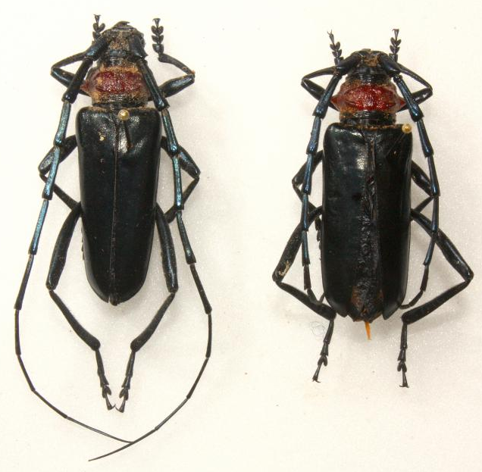 | Photo 2  Larva  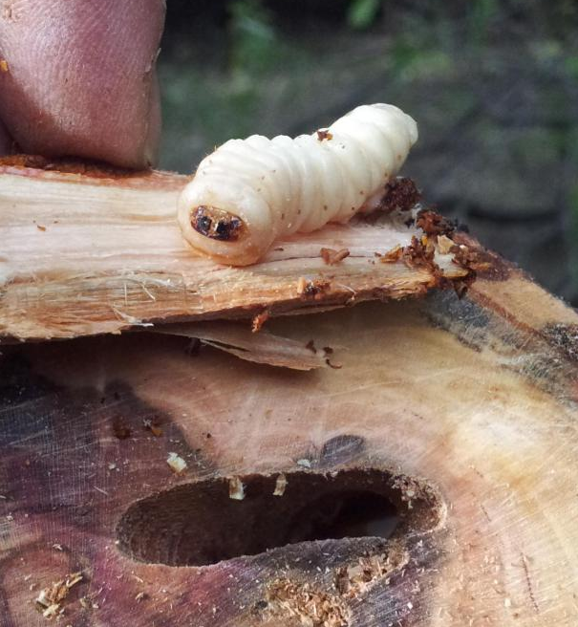
Matteo Maspero, Centro MiRT – Fondazione Minoprio (IT) | Raffaele Griffo - Plant Health Service of Campania Region, Napoli (IT)
Photo 3  Sawdust at the base of a tree  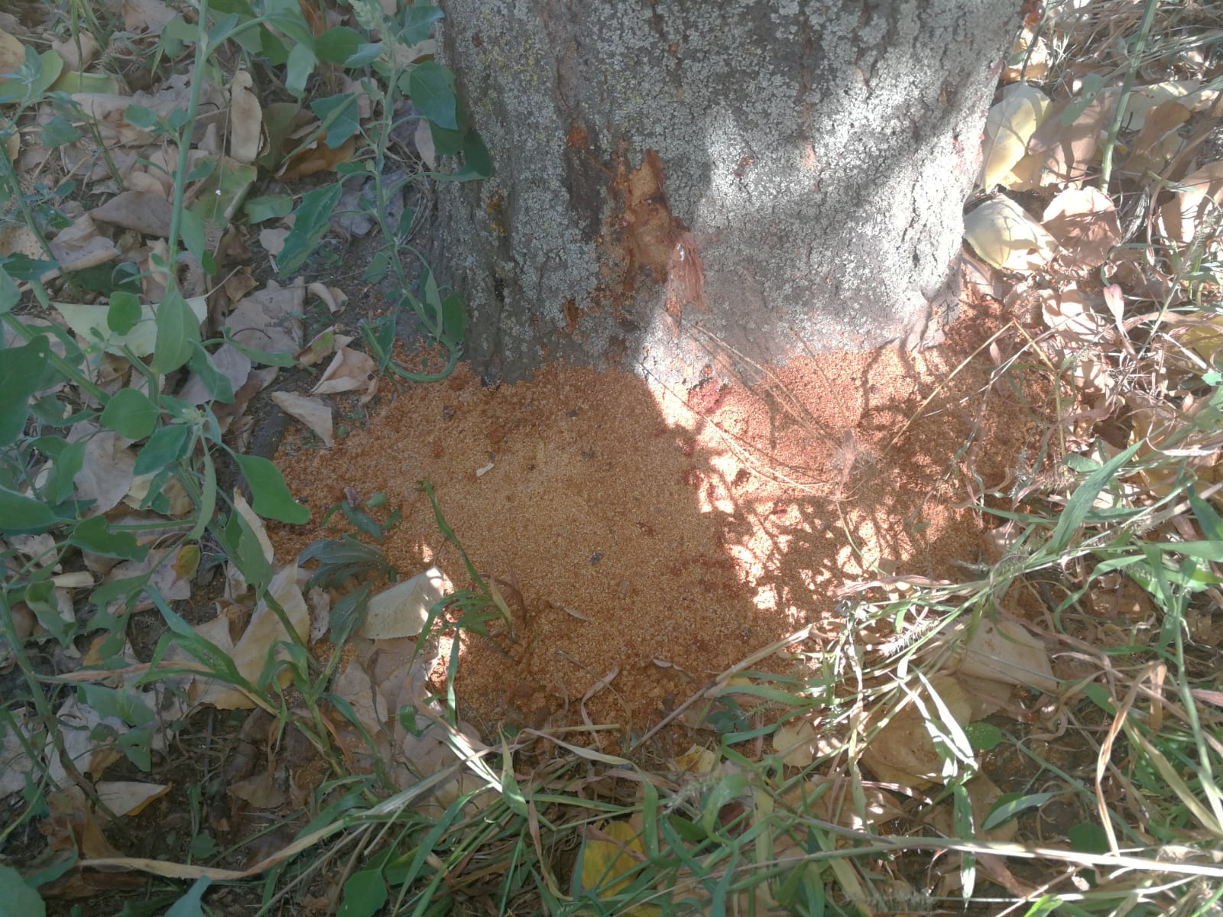 | Photo 4  Galleries in a trunk  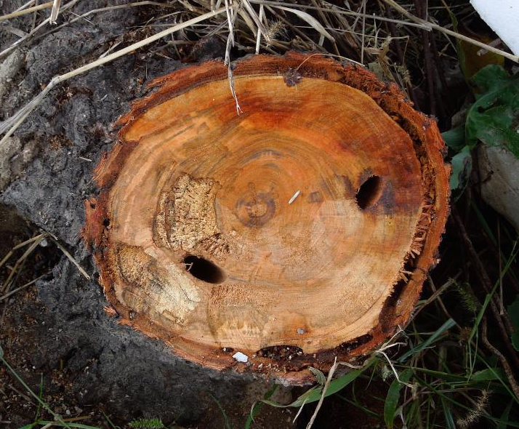
Raffaele Griffo - Plant Health Service of Campania Region, Napoli (IT) | Matteo Maspero, Centro MiRT – Fondazione Minoprio (IT)

Appendix 2. Relevant imports 2018
Table 1 Relevant imports of plants for planting 2018
Source: Swiss-Impex
 | Italy | China | total imports
0602.2049 - Unterlagen von Steinobst, unveredelt (ausg. solche mit nackten Wurzeln) | 10 kg | 0 kg | 2'914 kg
0602.2072 - Bäume, Sträucher und Büsche, von Steinobst, auch veredelt, mit nackten Wurzeln (ausg. Setzlinge [Säulinge, Pflänzlinge]) | 10'982 kg | 0 kg | 56'005 kg
0602.2082 - Bäume, Sträucher und Büsche, von Steinobst, auch veredelt (ausg. solche mit nackten Wurzeln und Setzlinge [Säulinge, Pflänzlinge]) | 34'767 kg | 0 kg | 420'614 kg

Table 2 Relevant wood imports 2018
Source: Swiss-Impex
 | Italy | China | total imports
4403.9900 - Rohholz, auch entrindet, vom Splint befreit oder zwei- oder vierseitig grob zugerichtet (ausg. grob zugerichtetes Holz für Gehstöcke, Regenschirme, Werkzeugstiele oder dergl.; Holz in Form von Brettern oder Balken usw. zugeschnitten; mit Farbe, Beize, Kreosot oder anderen Konservierungsmitteln behandeltes Holz; Nadelholz und tropisches Holz sowie Eichen-, Buchen-, Birken-, Pappel-, Aspen- und Eukalyptusholz) | 3'466'715 kg | 1'086 kg | 8'410'909 kg
4401.1200 - Brennholz in Form von Rundlingen, Scheiten, Zweigen, Reisigbündeln oder ähnlichen Formen, von anderem Holz als Nadelholz | 642'842 kg | 3'334 kg | 11'774'532 kg
4401.40 - Sägespäne, Holzabfälle und Holzausschuss, nicht zusammengepresst | 152'471 kg | 83465 kg | 149'482'770 kg
4404.20 - Holz f. Fassreifen, Holzpfähle, gespalten, Pfähle u. Pflöcke, gespitzt, nicht in Längsrichtung gesägt, Holz, nur grob zugerichtet, abgerundet, jedoch weder gedrechselt, gebogen noch and. bearbeitet, f. Spazierstöcke, Regenschirme, Griffe u. dergl., Holzspan, -streifen, -bänder u. dergl. (ausg. aus Nadelholz, Reifholz, auf Länge zugeschn. u. an Enden gekerbt, Bürsteneinfassungen u. Schuhformen) | 1'474'167 kg | 24'952 kg | 5'118'391 kg
4406.92 - Bahnschwellen aus Holz, imprägniert, aus anderem Holz als Nadelholz | 27'300 kg | 0 kg | 2'964'770 kg
4407.94 - Kirschbaumholz [Prunus spp.], in der Längsrichtung gesägt oder gesäumt, gemessert oder geschält, auch gehobelt, geschliffen oder an den Enden durch Verleimen zusammengesetzt, mit einer Dicke von > 6 mm | 5'331 kg | 0 kg | 123'307 kg
4414 - Holzrahmen für Bilder, Photographien, Spiegel oder dergleichen | 192'775 kg | 540'846 kg | 1'547'610 kg
4415 - Kisten, Kistchen, Verschläge, Trommeln und ähnliche Verpackungsmittel aus Holz; Kabeltrommeln aus Holz; Flachpaletten, Boxpaletten und andere Ladungsträger aus Holz (ausg. Warenbehälter, Container, speziell für eine oder mehrere Beförderungsarten bestimmt und ausgerüstet); Palettenrahmen aus Holz | 11'628'484 kg | 90'381 kg | 170'203'167 kg
4416.0000 - Fässer, Tröge, Bottiche, Eimer und andere Küferwaren und erkennbare Teile davon, aus Holz, einschl. Fassholz | 68'694 kg | 780 kg | 935'081 kg

Table 3 Relevant imports of wooden furniture 2018
Source: Swiss-Impex
 | Italy | China | total imports
9401.6100 - Sitzmöbel, mit Gestell aus Holz, gepolstert (ausg. in Liegen umwandelbare Sitzmöbel) | 3'332'995 kg | 5'070'516 kg | 40'100'739 kg
9401.6900 - Sitzmöbel, mit Gestell aus Holz, nicht gepolstert (ausg. in Liegen umwandelbare Sitzmöbel) | 334'388 kg | 1'230'099 kg | 5'137'713 kg
9403.3000 - Holzmöbel von der in Büros verwendeten Art (ausg. Sitzmöbel) | 1'330'862 kg | 258'704 kg | 17'260'991 kg
9403.4000 - Holzmöbel von der in der Küche verwendeten Art (ausg. Sitzmöbel) | 6'475'039 kg | 80'220 kg | 47'512'133 kg
9403.6000 - Holzmöbel (ausg. solche von der in Büros, in der Küche oder im Schlafzimmer verwendeten Art sowie Sitzmöbel) | 17'795'145 kg | 10'516'641 kg | 125'381'568 kg
9406.1000 - Gebäude, vorgefertigt, aus Holz, auch unvollständig oder noch nichtmontiert | 3'347'850 kg | 58'672 kg | 37'341'959 kg

The summary should be elaborated once the analysis is completed

