Pest risk assessment for the European Community:

plant health: a comparative approach with case studies

Pest Risk Assessment: Revised Test Method 4b
With current risk reduction options in place
Ca. Phytoplasma prunorum
[European Stone Fruit Yellows Phytoplasma]
April 2012

Authors:
Steffek¹, Robert; Follak¹, Swen
Sauvion², Nicolas; Labonne², Gerard
¹ AGES, Vienna, Austria
² INRA, Montpellier, France

Reviews:
Verhoeven³, Ko; Potting³, Roel
Karadjova⁴, Olia; Ventsislavov⁴, Ventsislav; Krumov⁴, Vladimir
Pfeilstetter⁵ Ernst
³PPS, Wageningen, The Netherlands
⁴ PPI, Kostinbrod, Bulgaria
⁵JKI, Braunschweig, Germany

Review of parts of the document / comments on specific questions were provided by:
Tedeschi, Rosemarie; University of Torino, Italy (Annex 4: C. pruni on conifers)
Ulubas Serce, Cigdem; Mustafa Kemal University, Antakya, Turkey (C. pruni on conifers)
Seemueller, Erich; JKI, Dossenheim, Germany (visual inspection, susceptibility of rootstocks and cultivars)

The risk assessment made according to method 4b is recommended to be used to reconsider the present legislation

Preface
Pest risk assessment provides the scientific basis for the overall management of pest risk. It involves identifying pests and characterizing the risks associated with those pests by estimating their probability of introduction (entry, transfer and establishment) as well as the severity of the consequences to crops and the wider environment as a result of their introduction.

Risk assessments are science-based evaluations. They are neither scientific research nor are they scientific manuscripts. The risk assessment forms a link between scientific data and decision makers and should expresses risk in terms appropriate for decision makers.

Note

Risk assessors will find it useful to have a copy of International Standards for Phytosanitary Measures No. 5, the Glossary of Phytosanitary Terms (IPPC, 2007)¹, ISPM No. 11, Pest risk analysis for quarantine pests, including analysis of environmental risks and living modified organisms (IPPC, 2004) and the EFSA guidance document on a harmonized framework for pest risk assessment (EFSA, 2010) to hand as they read this document and conduct a pest risk assessment.

CONTENTS

Executive Summary | Page  7
Stage 1: Initiation | 14
Stage 2: Pest risk assessment (outline) | 17
- Pathways | 18
Potential for entry and transfer on pathway a | 21
Potential for entry and transfer on pathway b | 35
- Overall potential for entry and transfer | 37
- Potential for establishment | 39
- Spread | 45
- Consequences of establishment and spread | 47
- Potential impact | 52
- Pest risk (potential for entry and transfer x potential impact) | 55
Uncertainties | 57
Conclusion | 59

References 60

INTRODUCTION

Concerning the distinction between entry and spread in risk assessment of pests widespread in the risk assessment area
The fruit tree phytoplasmas assessed within Prima phacie are an example of regulated pests which are widely distributed within the EU (PRA-area). There are many other pests regulated in council directive 2000/29/EC, for which the phytosanitary status may need to be revised.
Such pests may have a long history of spreading within the PRA-area (and may have occupied a considerable part of the host plant area). Common risk assessment schemes were developed to assess the risk of pests which are not present or present but not widely distributed. Method 4b has been amended to better address the needs for risk assessments of widespread pests. Below are basic considerations on the distinction between entry and spread in risk assessment of pests which are widespread in the risk assessment area.
Entry
ISPM 5 considers ‘entry’ as ‘the movement of a pest into an area where it is not yet present’. ‘Area’ is defined as ‘an officially defined country, part of a country or all parts of several countries’. ISPM 5 is not fully explicit in defining the term ‘area’ in the explanation of entry.
It is recognized that for pests which are not present or present but not widely distributed, ‘area’ is often used synonymously as ‘risk assessment area’ (RA-area). Then, entry is understood as a process which is initiated outside the RA-area. In those more regular cases of risk assessments, the entry part evaluates the likelihood of entry from outside the EU.
However, in the case of risk assessments that are initiated by a review of phytosanitary policy, the pest is often already present and fairly widespread. In such a case the contribution of entries from outside the area to the overall pest risk may be negligible as compared to the risk of further spread within the area (note: the phytoplasmas are considered to be native). The wider the distribution of a pest will be in the EU and the larger the internal trade volume is, the more important entry from infested areas within the EU will become compared to entry from outside the EU.
Moreover, for many regulated pests measures are in place to reduce the likelihood of pest entry (particularly to reduce the likelihood of association at the place of production, see Annex IV requirements of EC directive 2000/29). In cases where the phytosanitary status is revised, the effectiveness of these measures may need to be reconsidered and the effect of any other alternative phytosanitary option may need to be tested.
Instead understanding entry as process which is strictly initiated outside the risk assessment area, it would be more logic to assess the likelihood of entry into areas within the RA-area where the pest is not (yet) present. Then, entry could be through movement from infested areas within the RA-area or from outside the RA-area. Following the ISPM 5 definition, we therefore understand entry as a process of association (at any place of origin, where the pest is present), survival (along the pathway) and transfer to suitable hosts (in any area within the risk assessment area where the pest is not (yet) present).
Such an approach allows to assess the effect of present (and alternative) risk reduction options as well as deregulation on the different elements of the entry section for both entry/spread from areas already infested within the RA-areas as well as from infested areas outside the RA-area. (Note that phytosanitary requirements for the fruit tree phytoplasmas are in place for plants for planting originating within the common market since the 1980ies. These requirements aim to reduce the likelihood of the pest being associated at the place of production).

Spread
Most tested schemes result in a high risk for the phytoplasmas (they can establish in big parts of RA area, have a medium to very high spread rate (natural and human assisted), and a medium to high impact.
Usually risk assessment schemes take into account natural and human assisted spread, to rate the spread potential of a pest. If plants for planting is the major pathway of a pest (like for the fruit tree phytoplasmas), the rating of human assisted spread is in most cases very high; if this is combined with a high potential for natural spread then the result of the spread rating is very high (see method 2).
Current schemes do not distinguish if this process (spread) may happen in the future or if it already happened in the past. If a pest has been present for a long time, it had a long history of natural- and human assisted spread in the risk assessment area and may have already occupied a considerable part of the endangered area. In such cases the potential to occupy additional area in the future may be low and a high spread rating appears inappropriate.
Consequently, for a pest which is (fairly) widespread the area which remains to be occupied in the future is relatively small and the spread potential and the phytosanitary risk should be rated lower than at the time the pest had still a limited distribution or was not present at all.
In a risk assessment, we assess the potential risk of a pest for areas where it is not yet present. Thus, the risk of a pest will decrease over time when it is spreading in the RA-area. When the pest has occupied the entire endangered area the risk will be minimal.
Method 4b considers spread as the host area (suitable for establishment) that is occupied at a time horizon. It thereby allows taking the spread history of the pest into account. The area that has already been occupied in the past can be used as a baseline for the estimate of the increase of the infested area in the future.
Consequently with this pest, which has already occupied most parts of the area suitable for establishment, method 4b results in a low spread potential and consequently a lower phytosanitary pest risk (as a product of spread and consequences).

Option: entry and spread in the same section of a scheme
An alternative option for pests that are present (and fairly widespread) would be to discuss entry and spread in the same section. Thus, discuss all pathways by which the pest may spread further within the RA-area and to which extent (new) entries from outside the RA-area will contribute to further spread of the pest in the RA-area.

Executive Summary

Provide a technical summary reflecting the content of the assessment (the questions addressed, the information evaluated, and the key issues which resulted in the conclusion)

The purpose of this pest risk assessment was to evaluate the plant health risk associated with Ca. Phytoplasma prunorum (European Stone Fruit Yellows phytoplasma) within the framework of EFSA project CFP/EFSA/PLH/2009/01.
The risk assessment was made using 2 different experimental methods, which were developed within the Prima phacie project. The present method 4b was sent to reviewers for comments and revised, according to the received remarks and suggestions for improvements. The risk assessment made according to method 4b is recommended to be used by risk managers to reconsider the present legislation for Candidatus Phytoplasma prunorum.
Candidatus Phytoplasma prunorum is currently listed in Council Directive 2000/29/EC, Annex I A II – “Harmful organisms known to occur in the community and relevant for the entire community” as ‘Apricot chlorotic leafroll mycoplasm’. Import requirements and requirements for plants originating in the community are specified in Annex IV A I19. and IV A II12, respectively.
In the risk assessment the risk associated with Candidatus Phytoplasma prunorum is assessed assuming that the current phytosanitary measures are in place (question 2.01a). The effect of withdrawing the present phytosanitary measures as well as other possible risk reduction options are evaluated in the section “Identification and evaluation of risk reduction option”.

Pest biology (see datasheet for details)
• Identity of the pest: Ca. Phytoplasma prunorum
Kingdom: Bacteria
Phylum: Tenericutes
Class: Mollicutes
Order: Acholeplasmatales
Family: Acholeplasmataceae
Genus: Phytoplasma
Species: Phytoplasma prunorum (EPPO-PQR, 5.0, 2011)

• Life history: (briefly)

The phytoplasma is present throughout the year in the host plant (Jarausch et al., 1999). Systemic colonization of the phloem from the roots occurs from July throughout late autumn. Unlike phytoplasmas of the SrX- group that attack pome fruits, Ca. Phytoplasma prunorum is able to persist in the aerial parts of numerous Prunus species during winter (Jarausch et al., 1999). Through transmission experiments Seemüller et al., 1998, showed that cells of Ca. Phytoplasma prunorum are present, viable and were transmissible from the stem of various stone fruit taxa, including apricots, peach, Japanese plum, almond and flowering cherry (P. serrulata) during winter.

The psyllid Cacopsylla pruni, is the proven vector of Ca. Phytoplasma prunorum (Carraro et al., 1998). It is a European and central Asian species, which is known to occur in almost all parts of Europe (Ossiannilson, 1992; Lauterer, 1999). The adults migrate in summer/autumn from their Prunus hosts to overwinter as adult on conifers and start to colonize stone fruit orchards at the end of winter. Overwintered adults lay eggs on fruit trees. Nymphs emerge progressively and the new adults then again migrate to their alternative hosts (Ossiannilsson, 1992). The phytoplasma can be transmitted both by the overwintering generation (that retains the phytoplasma over winter) and by the young generation in summer (after a latent period) (Carraro et al., 2001; Carraro et al., 2004). In southern France, Thébaud et al. (2009) found that only a few adults of the new generation were able to transmit the phytoplasma in spring before migrating to conifers and that only after the latent period of eight months on conifers the re-immigrants transmit the phytoplasma with high efficiency to their Prunus host. They concluded that secondary spread due to the newly hatched generation is of minor importance compared to primary infections by the winterform.
Recently, the population structure in C. pruni was studied among 5 800 insects collected in 245 localities in Europe (Sauvion et al. 2007; Sauvion et al. 2009, Sauvion et al. 2010, Serce et al., 2011). Population genetic studies revealed the existence of two genetically strongly differentiated groups, hybrids of the groups are very rare. The authors therefore conclude to the existence of two species: Cacopsylla pruni, which is prevalent in the EU, and the new species Cacopsylla pinihiemata, which is only present in parts of France, northeast Spain and near Milano. Further on, in the risk assessment the vector species will not be distinguished and are considered as single entity, as they play an equal role in the epidemiology of the disease. More details are provided in ANNEX 3.

• Host range / habitat: Prunus spp.
Of the cultivated Prunus spp. apricots (Prunus armeniaca), peach (P. persicae) and Japanese plum (P. salicina) are the main hosts, on which the disease is of economic importance. European plum (P. domestica) and myrobalan (P. cerasifera) commonly used as rootstock are largely tolerant. Sweet cherries (Prunus avium), sour cherries (P. cerasus) and bird cherry (P. padus) are highly resistant and host neither the pathogen nor the vector, they do not play a role in the epidemiology (Jarausch et al., 1999; Carraro et al., 2002). Ca. P. prunorum infections have also been observed in naturally infected plants of almond (P. amygdalus) and on several other wild Prunus species, it has a much wider host range among wild Prunus spp.; moreover, it was detected in naturally infected plants of other genera (for details see ANNEX 1).
Habitat: The organism inhabits the phloem sieve elements of hosts and the gut, haemolymph, salivary gland and other organs of sap-sucking psyllids

• Means of dispersal / spread:
Cacopsylla pruni, the vector of Ca. Phytoplasma prunorum is a univoltine species, which overwinters on conifers in highland areas. The mature adults move back to Prunus hosts for oviposition in early spring. They reproduce essentially on wild host, in particular blackthorn (P. spinosa) and myrobalan (P. cerasifera), on which high density population can be observed. In orchards, the psyllids reproduce on plum and Japanese plum, but they are usually rare on other cultivated stone fruit species (Prunus armeniaca, P. persicae). After five larval instars subsequent immature adults disappear from Prunus spp. in June and migrate to conifers. In moving between Prunus hosts and conifer shelter plants, psyllids are carried by currents and are thereby able to fly distances up to 25-30 km (Cermak & Lauterer, 2008; Thebaud et al., 2009; Pizzinat et al., 2011; Serce et al., 2011). Recently, genetic population studies with microsatellites markers suggest movements between 30 and 50 km.

Time period considered by this assessment
State the time horizon that you considered during this assessment. If climate change is taken into account, note the climate change scenarios considered.
The time horizon considered is 10 years. Climate change is not considered within this timeframe. Besides, the vector is present in the northernmost parts of the risk assessment area (where host plants are present).

Geographic Distribution
The disease is very long known in Europe. With the exception of Turkey, Azerbaijan and Tunisia, Ca. Phytoplasma prunorum occurs only in Europe, where it is present and widespread in many central and south European stone fruit areas.

North America: | -
South America: | -
Europe: | Belgium, Bulgaria, Czech Republic, Germany, Greece, Spain, France, Italy, Hungary, Austria, Poland, Romania, Slovenia, Slovakia, UK;  Switzerland, Croatia, Bosnia and Herzegovina, Serbia, Albania, Ukraine, Turkey.
Africa: | Tunisia, Egypt
Asia: | Turkey, Azerbaijan
Oceania: | -

Pathways
In the risk assessment the following pathways were assessed:
- Planting material (bud- and graftwood, rootstocks and total plants) of Prunus spp.
- Planting material of conifers (the vector's shelter host for aestivation and overwintering), carrying infected psyllids.
(The assessment of pathway b concluded that entry on this pathway is unlikely. Therefore and to test the different models combining risk elements a short summary is given in the risk assessment. Detailed analysis of the pathway is presented in ANNEX 4).
A list and description of all pathways is given in stage 2 of the risk assessment (Q2.0).

Summary of risk elements
- Likelihood of entry and transfer (summarise 2.08)
The likelihood of Ca. Phytoplasma prunorum entering areas where they are not yet present on planting material is high, since:
- In areas where the pest is present the disease is likely to be associated with the pathway at the place of production, as
  - both vector and disease are widespread in the EU;
  - measures to cure a phytoplasma-infection are not available,
  - the phytoplasma is viable (and can be transmitted) in all parts of infected plants (including scions) throughout the year;
  - both vector and disease are present on wild Prunus species;
  - the vector overwinters on conifers and is able to migrate over long distance,
  - symptoms of Ca. Phytoplasma prunorum infections are often not present, particularly in young plants,
  - Prunus domestic and P. cerasifera rootstocks are commonly used; they are a favourite host of the vector and largely tolerant to the disease and may be the source of infections
- Ca. P. prunorum was found to be present in symptomless planting material in the past
- the disease survives transport and infections are unlikely to be detected (unless samples are tested)
- the high volume and the widespread distribution of the commodity within the risk assessment area
- the commodity is planted in orchards, the vector is widespread in the European Union readily spreads the phytoplasma.

- Potential area occupied at time horizon (summarise extent of spread, 3.02)
The area suitable for establishment is where host plants and the vector are present or may find suitable climatic condition for survival, including hosts of C. pruni. This is the case for most EU-member states (including areas in the north and south of the PRA area were the disease is not known), though in the southernmost parts uncertainties exists concerning the availability of suitable conditions for aestivation and overwintering (and preferred hosts for reproduction) of the vector.
Ca. Phytoplasma prunorum is unknown in many northern European countries. There, tolerant (P. domestica) and largely resistant (P. avium) hosts are produced. As surveys on these hosts and on tolerant wild Prunus spp. are not conducted, the status of Ca. P. prunorum in northern Europe remains unclear.
The endangered area, however, is much smaller and restricted to production areas in central and southern Europe where sensitive hosts are grown (i.e. apricot, peach and Japanese plum) (see ANNEX 1). Ca. Phytoplasma prunorum is already present in most parts of the endangered area (central and southern Europe), where susceptible hosts are produced (Prunus armeniaca, P. salicina, P. persicae), including the most important stone fruit production areas. It has not been reported in the southernmost parts of the risk assessment area (Portugal, Cyprus, Malta and southern Spain); no records were found for some NUTS 2 regions that are surrounded or at the same latitude as others where the ESFY occurs.
The phytoplasma has spread in the EU through the trade of planting material and the migration behaviour of the vector for many decades. It is considered unlikely that within a time horizon of ten years the occupied area will increase significantly.

- Consequences (summarise the combination of 3.03 and 3.04)
Within the endangered area, the phytoplasma has direct effects on yield, quality and marketability and can lead to plant mortality. The economic impact, depends on various factors: such as the plant species, the rootstock and scion cultivar (and its combination), the strain virulence and phytoplasma concentration, the climatic condition, the age of trees and the abundance of the insect vector population. It can vary from minor to severe.
The pest would have a negligible impact on the hosts produced in northern Europe.
Impacts on ecosystem services and biodiversity are not expected, as the pest and its vector are considered to be native to Europe.

- Pest risk (summarise 3.06, the combination of likelihood of entry & transfer 2.0, with potential impact, 3.05).
As both vector and disease are already very widespread in the endangered area (central and southern Europe), the pest is considered to have very low potential for further spread. Although it causes economic impact in the endangered area, and may cause damage if it is introduced in areas where it is not present currently.

Uncertainties
Summarise major uncertainties and report on what happens if those risk elements that are most uncertain are changed (e.g. become less uncertain) – how does the overall risk profile of expected risk change? Describe changes in the bar chart showing expected risk if uncertainty is changed.

The following uncertainties have been identified:
- The role of vectors attached to conifers for the spread of the disease
- The possible role of non-confirmed hosts (wild and cultivated) in the epidemiology
- for individual consignments there is uncertainty about the association of the pest with the pathway and the level of infested lots in trade
- the status of the pest in the different countries has been updated on a subnational level; however, for few countries, particularly in the north and southernmost parts of the risk assessment area information is lacking
- In the southernmost parts it is unclear, if the vector finds suitable conditions for aestivation and overwintering
- When C. pruni migrates from conifers to Prunus hosts it is unclear if they mainly return to the Prunus hosts where they hatched the previous year or if they fly to other locations
- The distribution of mild and severe strains of Ca. P. Prunorum in the EU.
Ca. Phytoplasma prunorum is long known in Europe and comprehensive scientific literature is available. Still, some minor uncertainties have been identified during the risk assessment process. However, it is concluded that solving these uncertainties will not have a significant influence on the conclusion of the risk assessment.

Conclusion
A risk assessment has been conducted to evaluate the plant health risk associated with Ca. Phytoplasma prunorum (European Stone Fruit Yellows phytoplasma) within the framework of EFSA project CFP/EFSA/PLH/2009/01. Ca. Phytoplasma prunorum causes diseases in stone fruits summarized as European Stone Fruit Yellows. The pathogen and its vector, the psyllid Cacopsylla pruni are native to Europe. They are widespread in most parts of the risk assessment area, including the most important stone fruit production areas, where the disease causes significant economic impact in sensitive crops: apricot (P. armeniaca), peach (P. persicae), and Japanese plums (P. salicina). It has not been reported in the southernmost parts of the risk assessment area; moreover, no records were found for some NUTS 2 regions that are surrounded or at the same latitude as others where the ESFY occurs. Furthermore, it is unknown in many northern European countries.
Ca. Phytoplasma prunorum is currently listed in Annex I AII(d). Phytosanitary measures are applicable to all Prunus spp. However, both vector and disease are widespread in Europe and occur on many different, wild and cultivated Prunus species [particularly blackthorn Prunus spinosa, myrobalane (P. cerasifera) and plum (P. domestica)], which form a reservoir for the phytoplasma. Therefore, eradication and containment of the pest is not possible.
Moreover, it is concluded unlikely that within a time horizon of 10 years the disease and its vector, which are known since the early 20th Century and which are considered native to Europe, would significantly spread to areas where they are not reported. [In most parts of northern Europe the vector is present; however, only tolerant (wild and cultivated) hosts are found there. Hence, northern Europe is not part of the endangered area. In the southernmost part of Europe (Portugal, southern Spain, Cyprus, Malta) there is uncertainty concerning suitable conditions for the vector (availability of hosts for overwintering and reproduction].
Ca. Phytoplasma prunorum is a native pest which is very widespread in the EU; hence, it doesn’t qualify as quarantine pest; however, in regions within the endangered area where the disease and the vector are abundant, there is a high risk that the phytoplasma is associated with plants at the place of production. In such cases the intended use of sensitive host plants is affected and the phytoplasma may cause significant economic impact.
Consequently, risk reduction options were elaborated to reduce the risk of Ca. P. prunorum spreading in infested planting material and causing damage for sensitive hosts only:
- apricots (Prunus armeniaca),
- Japanese plum (P. salicina) and
- peach (P. persicae).
Other cultivated Prunus spp, particularly cherries (P. avium), as non-host and plums (P. domestica), as tolerant host as well as the mainly wild Prunus species (P. spinosa, P. padus …) should not be regulated.

Keywords:
Ca. Phytoplasma prunorum, European Stone Fruit Yellows, ESFY, Apricot chlorotic leafroll, Cacopsylla pruni, Prunus;
Stage 1 – Initiation

1.1 Background and Initiation
Provide the background and terms of references as provided by the originator of the risk assessment request (European Commission, European Parliament, Member States, or EFSA)
The purpose of this assessment is to evaluate the plant health risk of Ca. Phytoplasma prunorum within the framework of EFSA project CFP/EFSA/PLH/2009/01 (Prima phacie).
The terms of reference are described in EFSA call CFP/EFSA/PLH/2009/01, Pest risk assessment for the European Community plant health: A comparative approach with case studies (EFSA, 2009). The text in Section 1.4 of the call, “Structure and essential requirements of the proposal”, pages 7-9, provide the terms of reference e.g. that a systematic review of risk assessment methodologies, with emphasis on quantitative and semi-quantitative approaches, used in pest risk assessment to analyse and predict the likelihood of entry, establishment and spread, the potential negative consequences, the overall risk characterisation and the associated level of uncertainties be assessed, together with a systematic review of the methods used to assess the effectiveness of management options in reducing the risk of introduction and/or spread. The quantification of economic losses in monetary values and the assessment of potential effects on export markets, employment and tourism were not to be included.
Initiation Point
This assessment was initiated as a case study pest to be examined within EFSA project CFP/EFSA/PLH/2009/01 (Prima phacie). Ca. Phytoplasma prunorum had been selected as a case study pest because it satisfied a number of criteria needed to provide a range of contrasting pest examples for consideration in the project.

1.2 Identification of the risk assessment area
The risk assessment area is the 27 Member States of the EU with the focus on the continental European area, specifically excluding the ultra-peripheral regions, i.e. the French overseas departments, Spanish Canary Isles and Portuguese Azores and Madeira.

1.3 Available pertinent regulatory information
(i) Previous risk assessment or pest risk analysis?
The Canadian Food Inspection Agency conducted a risk assessment in 2004 to evaluate the plant health risk of European stone fruit yellows phytoplasma (ESFYP) for Canada.
A risk assessment for the EU has not been conducted.

(ii) Available Pest Fact Sheets/ Pest Alerts etc.

EPPO datasheet; USDA datasheet, CABI datasheet; updated PrimaPhacie data sheet

(iii) Current regulatory status
What is the pest’s status in the Plant Health Directive (Council Directive 2000/29/EC) ?
Ca. Phytoplasma prunorum is currently regulated in Annex IAII of the EC directive 2000/29 as 'Apricot chlorotic leafroll mycoplasma'. The current term: Ca. Phytoplasma prunorum was introduced by Seemüller and Schneider (2004) for a phytoplasma of the 16SrX (Apple proliferation) – group which is specifically attacking stone fruit species. It causes various diseases in apricot, peach and plum which are comprised as 'European Stone Fruit Yellows'.
In Annex IV/AII 12, the EC-directive 2000/29 sets out requirements for the movement of plants originating within the community. Plants must either originate in a pest free area or contain an official statement that no symptoms of ESFY phytoplasma have been observed on the plants at the place of production since the beginning of the last complete cycle of vegetation.
Elsewhere, Ca. Phytoplasma prunorum is listed as A1 pest in Canada, Chile and Turkey. It is considered a quarantine pest in the United States of America, Israel and Jordan (EPPO PQR, 5.0).

(iv) What is the pest’s status in the European and Mediterranean Plant Protection Organisation (EPPO)? (put tick () in box if relevant) (www.eppo.org)

EPPO List: | A1 regulated pest list |  | A2 regulated pest list | only until 1999* | Action list |  | Alert list

*In 1981 Ca. Phytoplasma prunorum was included in the EPPO A2 list as Apricot chlorotic leafroll. In 1998 the EPPO panel on phytosanitary measures suggested that the phytoplasma is so widespread that it should be deleted from the A2 list. After consulting all EPPO countries, the Panel supported its deletion and proposed to the Working Party the removal from the A2 list. Apricot chlorotic leafroll phytoplasma was deleted from EPPO A2 list in 1999 (Francoise Petter, EPPO; personal communication).

1.4 Strategy of data searching (identity of databases, data banks and information systems, key search terms and strategies applied, and the time period covered should be provided)
Within the Prima phacie project systematic literature reviews (SLRs) were conducted to: 1) determine the present distribution of Candidatus Phytoplasma prunorum in the EU; 2) gather information on the impact of the pest in the EU and 3) identify official management options which are used or recommended to prevent introduction or spread of Ca. Phytoplasma prunorum. The SLRs were part of the first interim report (July 2010).
The information collected then, was updated and further information searches were performed consulting several sources such as:
- Abstracting databases: e.g. CAB Abstracts, AGRICOLA, ISI Web of Knowledge
- Internet search machines: Google Scholar
- EPPO information systems: e. g. EPPO reporting service, EPPO PQR v 5.0
- Europhyt database (for notifications of interceptions)
- CIRCA database (for outbreak notifications)
- Information from Member States on issues related to host distribution at a national level was acquired via a questionnaire prepared in the framework of the Prima Phacie project and distributed by EFSA to all NPPOs.
- References and information obtained from experts and from citations within other references.

1.5 Time period considered in this assessment
(Likelihoods of future events are only meaningful when a time period is specified. Choices that might be considered include: 3 months (short term, e.g. following discovery of an outbreak or other new potential threat), 5 years (medium term), or 30 years (long term). Choose a time scale and briefly explain why such a horizon was selected. – note whether climate change was taken into account. If climate change is taken into account, note the climate change scenarios considered.
To test any effect of RROs on the entry and further spread of the pest a time horizon of 10 years was chosen. Within this period and due to the fact that the vector is present in most parts of the risk assessment area, including the northern countries, climate warming is not considered to be relevant.

1.6 Introductions or interceptions (reported from EU or elsewhere)
Provide information on interceptions or reports of pest spread and note whether the pest has a history of increasing its area of distribution.
The Europhyt database contains two notifications of infested stone fruit species commodities: plants of Prunus persicae originating in the Ukraine (2003) and a consignment of P. armeniaca from Germany (2010). A search in the CIRCA database resulted in eight outbreak notifications from Bulgaria, France, Germany, Slovakia and Slovenia between 2005 and 2011, three of the notifications concern orchards and private gardens, five nurseries (three of them motherplantations, one was unspecified; in one case the pathogen was detected in plants that did not show symptoms using PCR-technique).

Stage 2 - Pest Risk Assessment
(Outline approach)
This method for pest risk assessment involves first evaluating the likelihood of pest entry and transfer to a host within the risk assessment area. Likelihood of entry is assessed by considering five factors:
- likelihood of association with commodity on the pathway at origin,
- pest survival during post harvest treatment,
- pest survival during storage and transport,
- pest survival during current phytosanitary procedures, and
- the quantity of commodity imported.

The likelihood that sufficient numbers of pest will transfer from a pathway to a suitable host in order to initiate a new population is then considered. The combined likelihoods of entry and transfer via each pathway are then combined before likelihood of establishment is taken into account. Assessors then move onto assess consequences of establishment.

Each risk element or sub-element is divided into five categories. Assessors review data / evidence and allocate % likelihood to appropriate categories, either selecting a single category or spreading their judgment between categories. Guidance is provided to interpret the categories in order to provide some consistency.
Overall potential impact is determined via use of BBN software based on matrices that combine consequences of establishment with establishment potential given entry and transfer. Likelihood of entry and transfer is then combined with potential impact using the BBN software to estimate pest risk.

“Acknowledgement”
Method 4b has largely adopted questions from the USDA pathway initiated pest risk assessment method (USDA, 2000). However, the arrangement and structure of questions has been revised by Prima phacie so that the method is more aligned with EFSA needs.

Reference
USDA Guidelines for pathway initiated pest risk assessments v 5.02 (2000).

Likelihood of pest entry and transfer to a host

2.0 List and describe the pathways for pest entry into the risk assessment area

A pathway is “any means that allows the entry or spread of a pest” (ISPM No. 5, IPPC, 2007). Remember to consider potential pathways that are closed due to existing phytosanitary measures but which could be opened if the phytosanitary measures were changed.
Entry is “Movement of a pest into an area where it is not yet present, or present but not widely distributed and being officially controlled” (ISPM No. 5, IPPC, 2007).
Copy 2.1a to 2.7a for each pathway, and give responses for each individual pathway. Label questions 2.1b for the second pathway assessed, 2.1c for the third pathway etc.
Pathway | Pathway name | Summary description of pathway
a. | Planting material (bud- and graftwood, rootstocks and total plants) of Prunus spp. | The principal pathway. The phytoplasma is easily transmitted from infected donor trees by budding and grafting. Unlike other fruit tree infecting phytoplasmas, Ca. Phytoplasma prunorum persists in the aerial parts of hosts during the dormant season (Seemuller et al., 1998; Jarausch et al., 1999).
b. | Planting material of conifer, carrying infected psyllid vectors. | The vector completes one generation per year reproducing on the Prunus spp. - and overwintering as adult on conifers. Planting material of conifers with phytoplasma infected vectors attached may be traded and subsequently the adult vectors could move from the conifers to Prunus spp. in the new environment and transmit the phytoplasma. Information on this pathway was collected in ANNEX 4; a summary is provided in this risk assessment. Based on the collected evidence it is considered very unlikely that psyllids would remain on the commodity and transfer on this pathway to new areas.
b1. | Cut conifers (including Christmas trees) carrying infected vectors and fresh conifer branches | Similar to pathway b, infested psyllids may enter new areas on green parts of cut conifers. However, due to the intended use of the commodity (indoors), the uncertainty linked to the survival of the psyllid on this pathway is even higher. Moreover, for b2 the quantity of trade is much lower. Therefore pw b1 and b2 are not considered separately. Some information is included within pathway b and provided in ANNEX 4.
b2. | Fresh conifer branches
c. | Wood with bark of conifers (including fire wood) | The vector needs green parts of the conifers to overwinter (see evidence in the entry section of pathway b), therefore wood with bark is not considered a possible pathway and not evaluated.
d. | Seeds of Prunus spp. | Ca. Phytoplasma prunorum is not considered to be seed transmitted. Though, Necas et al. (2008) found that the phytoplasma infects apricot flowers, fruits (specifically the flesh) and kernels. However, the seeds from infected trees had very low viability and practically no germination activity. Therefore the risk of spread by infected seeds is not evaluated in the risk assessment.
e. | Human assisted spread of infected non-Prunus hosts | Natural infections of Ca. Phytoplasma prunorum were found in several non-Prunus hosts (e.g. Németh, 1986; Jarausch et al., 2001; Navratil et al., 2004; Duduk et al., 2004). However, there is very limited information available on the presence of Ca. Phytoplasma prunorum in these hosts and whether such infections play a role in the epidemiology of the disease. Therefore this pathway is not considered to be relevant in the risk assessment.
f. | Spread via root bridges | Natural root bridges may play a role in disease spread in apple orchards (Ciccotti et al., 2007). However, this type of transmission was not confirmed for ESFY (e.g. Poggi Pollini et al. (2007). It is not further considered in the risk assessment.
g. | Spread through dodder bridges | Phytoplasmas may also have access to phloem sieve tube elements through the parasitic plant dodder (Cuscuta spp.) (Marcone in Weintraub & Jones, 2010). This pathway is considered to be a very specific mode of potential sporadic local spread. It is therefore not further considered relevant in the risk assessment.
h. | Natural spread of infected vectors | C. pruni is able to spread the phytoplasma over several km per year. This issue is being considered in detail in the spread section and in ANNEX 3.

Note that on occasions risk assessments are initiated by a review of phytosanitary policy, e.g. for pests already present and perhaps widespread in an area and which therefore may no longer be suited to being dealt with using official phytosanitary measures. In such a situation, the likelihood of pest introduction is relevant only for limited parts of the area where the pest does not occur, or where it is not widely distributed and remains under official control. Assessment of pest entry could then be restricted to such areas.

Uncertainties (regarding pathways)
Following EFSA Guidance (EFSA, 2010), to ensure transparency in risk assessment, uncertainties should be identified, characterized and documented within all risk assessments. Identifying uncertainties can show not only which aspects of an assessment are uncertain but the degree of uncertainty and can help identify where further work could usefully reduce uncertainty.

Describe the uncertainties regarding the identification of pathways.

There is no uncertainty concerning planting material (bud- and graftwood, rootstocks and total plants) of Prunus spp. (pathway a) being the most important way of spreading the disease over long distances.
The significance of infected vectors on conifers (pathway b) for the long distance spread of the disease remains uncertain. (The life cycle of the vector includes a long period on which it lives on conifers. Very little is known on this part of the vectors' life cycle, particularly it is not known whether the insects will remain attached to lifted conifers). Based on the evidence collected in ANNEX 4 and the fact that there are no reports of psyllid on traded conifers, pathway b is considered as being too hypothetical as pathway for Ca. Phytoplasma prunorum.
There is little uncertainty that the pathways c-f play a negligible role in the spread of Ca. Phytoplasma prunorum.

Pathway a: Planting material (bud- and graftwood, rootstocks and total plants) of Prunus spp.
2.01a Likelihood of the pest being associated, spatially and temporally, with the pathway at origin
(There must be some likelihood of association otherwise there is no pathway).
Take into account pre-harvest cultivation and husbandry practices such as existing pest management measures, choice of cultivar, and applications of plant protection products. If phytosanitary measures (i.e. statutory risk reduction measures) are already in place against this or other pests at origin, specify whether these are being taken into account or not.

Information / evidence: Provide reasoning then give judgment

Ca. Phytoplasma prunorum is very widespread in most countries where apricots and peach are produced in the EU and in European countries outside the EU (for details see Annex 1 and 2).

The phytoplasma is present throughout the year in the aerial parts and roots of host plants (Jarausch et al., 1999; Seemüller et al., 1998). Ca. Phytoplasma prunorum is easily transmissible by budding and grafting in summer and winter.

Moreover, the widespread distribution of Cacopsylla pruni, its ability to migrate over long distances from conifer hosts to stone fruits and the fact that vectors which have acquired the phytoplasma are able to transmit the pest during their total life span makes the association of the pest with the pathway more likely.

Wild Prunus species (Prunus spinosa, P. cerasifera and P. domestica) are natural hosts for both Ca. Phytoplasma prunorum and the vector C. pruni (Carraro, 2002) and form a reservoir for the phytoplasma and the vector, although in some areas low infection rates of wild Prunus spp. were reported (Jarausch et. al., 2008).
There are no appropriate measures to cure a phytoplasma-infected tree in a nursery. Insecticides to prevent infection may be applied at different times (against the vector re-immigrating from conifers, during egg deposition period). However, insecticide treatments to control the vector may not be practical in areas where the populations of C. pruni are abundant and the disease is present on wild plants (Jarausch & Jarausch 2010). Cacopsylla pruni has only one generation per year, it overwinters in conifers and is highly abundant only on some wild and cultivated hosts, such as P. spinosa, P. domestica, P. salicina and P. cerasifera, whereas it is of low abundance on important commercial crops (such as P. armeniaca, P. persicae). Wild P. spinosa and P. cerasifera are very widespread in the risk assessment area (Fig. 1-3). Infected psyllids can easily spread between the hosts at various times. In pesticide trials conducted in four orchards in Italy, various insecticides had very low efficacy in controlling the disease (Poggi Pollini et al., 2007).
Phytosanitary measures are based on visual inspection. In studies in France and Germany the correlation between symptoms and the presence of the pathogen was confirmed for a wide range of stone fruit species (Jarausch et al., 1998a; Jarausch et al., 2007). Surveys based on visual inspections are therefore often used to determine pest presence in orchards (Jarausch et al., 2008, Delic et al. (2008), Fialova et al. (2004). However, asymptomatic trees may be infected: Torres et al., 2004 detected ESFY phytoplasma in 50% of 69 asymptomatic apricot trees.
In general, diseased trees are not found in new orchards until the fourth or fifth year (Seemüller & Foster, 1995). Consequently, for nurseries there is a risk of maintaining phytoplasma foci in the nurseries as latent infections (Marcone et al., 2010): the Europhyt database contains two notifications of infested stone fruit species commodities: in peach originating from Ukraine (2008) and in apricots from Germany (2010). A search in the CIRCA database resulted in five outbreak notifications in nurseries. Three of them concern mother plantations, where the disease can be detected by visual symptoms. One notification reports the detection in two German regions. Ca. Phytoplasma prunorum was detected using PCR-technique in symptomless plants of P. armeniaca, P. persicae, P. pumila and P. domestica. In a detection survey in mother plant orchard of stone fruits from 2004 – 2006, the presence of phytoplasmas was confirmed in 29 out of 110 symptomless samples (Ambrozic Turk et al., 2008). The same authors report the presence of ESFY phytoplasma in propagation material of peach (P. persica) in 5 out of 35 planting stock entries, which were obtained from nurseries in different member states of the European Union and classed as either having CAC [Conformitas Agraria Communitatis] status (4 entries) or were certified (1 entry) (Ambrozic Turk, 2006).
In contrast, Pignatta et al. (2008) did not detect the phytoplasma in 203 samples from asymptomatic apricot propagation material (of two varieties grafted on two different rootstocks).

Uncertainties regarding likelihood of the pest being associated with the pathway at origin
Notifications on CIRCA and Europhyt database and quantitative data from literature (Ambrozic Turk, 2006, Ambrozic Turk et al. 2008; Torres, 2004) indicate that infection rates of asymptomatic plants may be very high. Other results indicate low infection rates (Pignatta et al., 2008).
The concentration of the pest on the pathway is highly depending on the abundance of the disease and its vector at the place of production. This may vary considerably, depending on the presence of hosts for reproduction, aestivation and overwintering of the vector. Consequently, for individual consignments there is uncertainty about the association of the pest with the pathway and the level of infested lots in trade.
Conclusions
Phytoplasma spread by latently infected, symptomless planting material is considered to be a great risk (Marcone et al., 2010). The disease is likely to be associated with the pathway, since:
- both pest and vector are very widespread in Europe,
- once a tree becomes infected the phytoplasma is present in all plant parts of the plant throughout the year,
- the vector, C. pruni is migrating over long distances and is difficult to control as it is present in high numbers on wild Prunus hosts.
- Wild Prunus species are widespread in the EU and form a reservoir for the vector and the disease.
- symptoms of Ca. Phytoplasma prunorum (e.g. early bud break, chlorotic leafroll, short internodes, phloem necrosis…) generally appear only in trees in the fourth or fifth year. Hence, the detection by symptoms may be a useful tool in mother plantations, but it is not reliable on 1-2 year old plants in nurseries.
- P. domestica and P. cerasifera are commonly used as rootstock, as they are largely tolerant and are favourite hosts of the vector these rootstocks are important sources of infections
Therefore (and based on the available quantitative data) the likelihood of association is high to very high.

2.01a: Likelihood of association with the pathway at origin
Rating | Description (likelihood of association is ....) | Justification summary | Probability Assignment ¹
Very Low | < 0.01% (less than one in ten thousand lots² of the commodity are likely to be contaminated / infested) | Quantitative data (Ambrozic Turk, 2006) indicate that the likelihood of association is very high (5 out of 35 lots were infested = 14%). Other authors (Pignatta et al., 2008) did not detect ESFY phytoplasma in planting material of apricot) | %
Low | Between 0.01% and 0.1% (between one in ten thousand and one in one thousand lots² are likely to be contaminated / infested) |  | %
Medium | Between 0.1% and 1% (between one in one thousand and one in one hundred lots² of the commodity are likely to be contaminated / infested) |  | 5%
High | Between 1% and 10% (between one in one hundred and one in ten lots² of the commodity are likely to be contaminated / infested) |  | 50%
Very High | > 10% (more than one in ten lots² of the commodity are likely to be contaminated / infested) |  | 45%
 |  | Check sum = | 100%

¹ Spread your judgment according to your belief / evidence.
²Lot: a number of units of a single commodity, identifiable by its homogeneity of composition,
origin etc., forming part of a consignment (ISPM no. 5, IPPC, 2007).
A consignment may be several lots or a single lot.

The assessment of pest entry and transfer (2.01 -2.06) is based on considering “lots”.
However, if an alternative unit would be more appropriate then describe the chosen unit and ordinal scale using five categories.

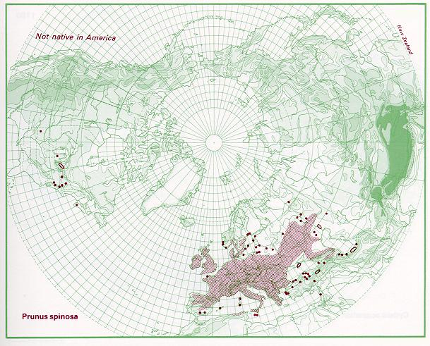
Fig. 1: Distribution of blackthorn (P. spinosa) (http://linnaeus.nrm.se/flora/di/rosa/prunu/prunspiv.jpg).
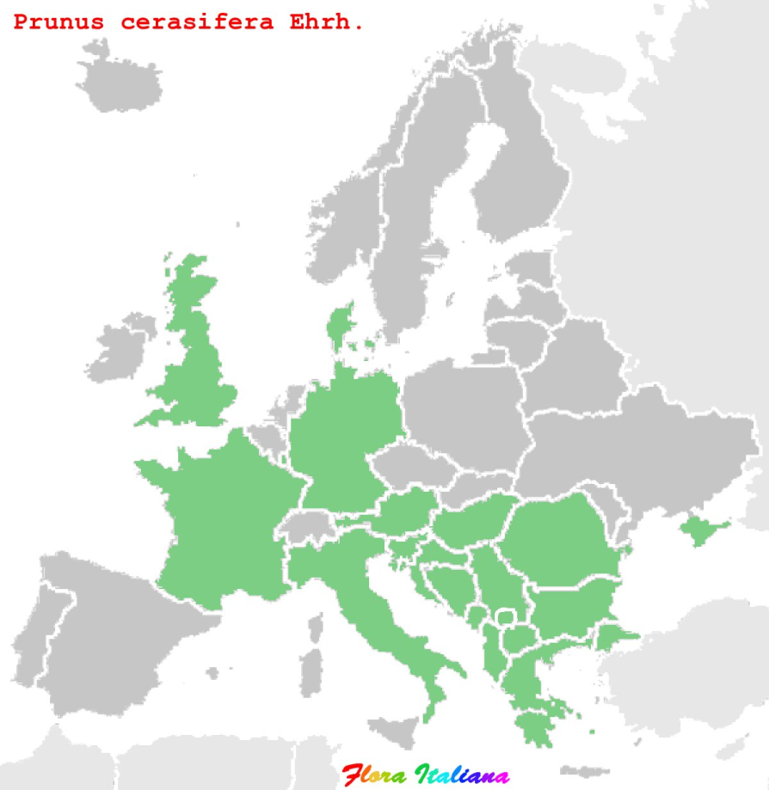

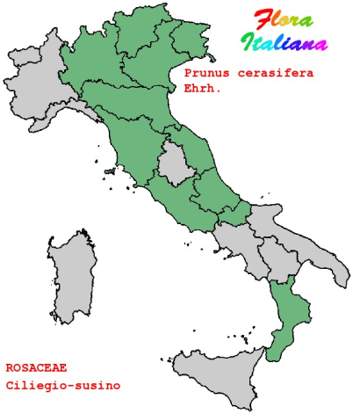

Fig. 2: Distribution of myrobalan plum (P. cerasifera) in Europe (national level) and Italy (subnational level) (Source: http://luirig.altervista.org/).

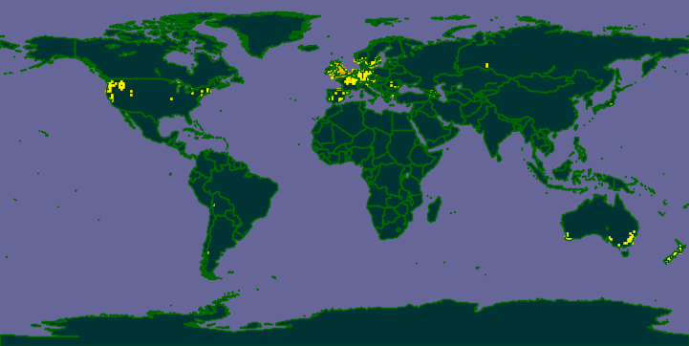

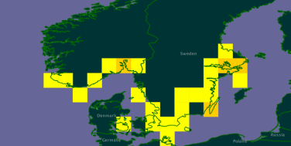
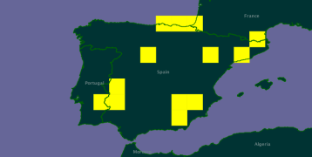

Fig. 3: Distribution of myrobalan plum (P. cerasifera) worldwide; small pictures show the distribution in Spain and northern European countries (Source: http://data.gbif.org/species/3021730/).

2.02a Likelihood of surviving postharvest treatments / measures (before pest entry into risk assessment area)
Given that a proportion of lots/ consignments may be infested / contaminated, consider the proportion of infested/contaminated lots that are likely to remain infested/contaminated after any manipulation, handling or specific phytosanitary treatment to which the commodity is subjected. Examples of postharvest treatments include culling, washing, chemical treatment and cold storage. If there are no post harvest treatments the likelihood of survival should probably be considered “very high”.
If post-harvest phytosanitary measures (i.e. statutory risk reduction measures) are already in place, specify whether these are being taken into account or not.

Information / evidence: Provide reasoning then give judgment

Effective post-harvest treatments to control the phytoplasma in infected plants for planting are not available.

Hot water treatment (dipping dormant woody grafts over a specified time period into hot water of specified temperature) was successfully used to eliminate the phytoplasma of European Stone Fruit Yellows (Krizan et al., 2008). Although promising, the method needs further testing to be widely applied. Currently it is not common nursery practice.

For basic plant material phytoplasma-elimination was achieved applying a combination of in vitro thermotherapy and meristem preparation (Laimer, 2003; Laimer & Bertaccini, 2008).

Hot-air may also be applied to eliminate the phytoplasma from basic material (Fridlund, 1989; OEPP/EPPO, 2000; Laimer, 2003).

Uncertainties regarding likelihood of the pest surviving postharvest treatments/ measures (before pest entry into the risk assessment area)

-

Conclusions

In nursery practice post harvest treatments to eliminate the phytoplasma from the planting material are not applied, hence the proportion of infested lots is unlikely to be reduced.

2.02a: Likelihood that an infested/contaminated commodity remains infested/contaminated after existing postharvest treatments/measures
Rating | Description (likelihood of remaining infested/contaminated / pest survival is ....) | Justification summary | Probability Assignment ¹
Very Low | < 0.01% (less than one in ten thousand lots² of the original commodity are likely to remain contaminated / infested) |  | %
Low | Between 0.01% and 0.1% (between one in ten thousand and one in one thousand lots² of the original commodity are likely to remain contaminated / infested) |  | %
Medium | Between 0.1% and 1% (between one in one thousand and one in one hundred lots² of the original commodity are likely to remain contaminated / infested) |  | %
High | Between 1% and 10% (between one in one hundred and one in ten lots² of the original commodity are likely to remain contaminated / infested) |  | 1%
Very High | > 10% (more than one in ten lots² of the original commodity are likely to remain contaminated / infested) |  | 99%
 |  | Check sum = | 100%

¹ Spread your judgment according to your belief / evidence

²Lot: a number of units of a single commodity, identifiable by its homogeneity of composition,
origin etc., forming part of a consignment (ISPM no. 5, IPPC, 2007).
A consignment may be several lots or a single lot.
2.03a Likelihood of surviving storage and transport
Given that a proportion of lots/ consignments may still be infested / contaminated, estimate the proportion of lots that are likely to remain infested/contaminated because the pest can survive storage and transport; consider speed and conditions of transport and duration of the life cycle of the pest in relation to time in storage and transport, commercial procedures (e.g. refrigeration) applied to consignments in the country of origin, during shipping, and in the country of destination, that could affect the likelihood of pest survival. Take into account previous live interceptions on this or similar pathways (see 1.6).
If phytosanitary measures (i.e. statutory risk reduction measures) are already in place which act on the likelihood of pest survival during storage and transport, specify whether these are being taken into account or not.

Information / evidence: Provide reasoning then give judgment
In infected plants, phytoplasmas inhabit the phloem sieve tubes. Ca. Phytoplasma prunorum is able to persist in the aerial parts of various Prunus species during winter (Jarausch et al., 1999). Therefore, the probability of survival during transport and storage is very likely for all traded plants (rootstocks, grafted plants, budwood (summer), and graftwood (winter).

Uncertainties regarding likelihood of the pest surviving storage and transport
-

Conclusions
In plant material the phytoplasma will survive during transport and storage, hence the proportion of infested lots is unlikely to be reduced.

2.03a: Likelihood of surviving storage and transport
Rating | Description (likelihood of remaining contaminated / pest survival is ....) | Justification summary | Probability Assignment ¹
Very Low | < 0.01% (less than one in ten thousand lots² of the original commodity are likely to remain contaminated / infested) |  | %
Low | Between 0.01% and 0.1% (between one in ten thousand and one in one thousand lots² of the original commodity are likely to remain contaminated / infested) |  | %
Medium | Between 0.1% and 1% (between one in one thousand and one in one hundred lots² of the original commodity are likely to remain contaminated / infested) |  | %
High | Between 1% and 10% (between one in one hundred and one in ten lots² of the original commodity are likely to remain contaminated / infested) |  | 1%
Very High | > 10% (more than one in ten lots² of the original commodity are likely to remain contaminated / infested) |  | 99%
 |  | Check sum = | 100%

¹ Spread your judgment according to your belief / evidence

²Lot: a number of units of a single commodity, identifiable by its homogeneity of composition,
origin etc., forming part of a consignment (ISPM no. 5, IPPC, 2007).
A consignment may be several lots or a single lot.
2.04a Likelihood of pest surviving current phytosanitary procedures at the point of entry or elsewhere in the risk assessment area
Given that a proportion of lots may still be infested / contaminated, estimate the proportion of lots that are likely to remain infested/contaminated because the pest survives existing phytosanitary procedures e.g. it is not detected at entry and/ or it can survive any existing phytosanitary procedures within the pest risk assessment area. Take into account the intensity of sampling and inspection and ease of detecting and distinguishing the pest from other organisms.

Information / evidence: Provide reasoning then give judgment
Current phytosanitary measures are only applied at the place of origin (see 2.01). Plants may be infected latently (Ambrozic Turk 2006; Ambrozic Turk et al. 2008; CIRCA database). Symptoms are often not present on young trees. Moreover, plants are usually traded during the dormant season or as budwood (removed leaves) in summer. Consequently, the likelihood of pest surving the current phytosanitary measures at the point of entry is very high.

Uncertainties regarding likelihood of the pest surviving current phytosanitary procedures
Text
-
Conclusions
At the point of entry, infected plants may only be detected if specified tests are undertaken. This is usually not the case, hence the proportion of infested lots is unlikely to be reduced.

2.04a: Likelihood of pest surviving current phytosanitary procedures
Rating | Description (likelihood of remaining contaminated/ pest survival is ....) | Justification summary | Probability Assignment ¹
Very Low | < 0.01% (less than one in ten thousand lots² of the original commodity are likely to remain contaminated / infested) |  | %
Low | Between 0.01% and 0.1% (between one in ten thousand and one in one thousand lots² of the original commodity are likely to remain contaminated / infested) |  | %
Medium | Between 0.1% and 1% (between one in one thousand and one in one hundred lots² of the original commodity are likely to remain contaminated / infested) |  | %
High | Between 1% and 10% (between one in one hundred and one in ten lots² of the original commodity are likely to remain contaminated / infested) |  | 1%
Very High | > 10% (more than one in ten lots² of the original commodity are likely to remain contaminated / infested) |  | 99%
 | Check sum = |  | 100%

¹ Spread your judgment according to your belief / evidence

²Lot: a number of units of a single commodity, identifiable by its homogeneity of composition,
origin etc., forming part of a consignment (ISPM no. 5, IPPC, 2007).
A consignment may be several lots or a single lot.

2.05a Quantity of commodity imported annually
Quantity of commodity imported annually: The likelihood that a pest will enter depends on the amount of the potentially-infested commodity that is imported. For qualitative pest risk assessments, the amount of commodity imported is estimated in units of tonnes, or other metric such as standard 40 foot long shipping containers.
If the quantity of commodity imported is better described using alternative units, such as the number of plants for planting, assessors should devise a 5 level scale and provide some reasoning to support use of the scale.

Information / evidence: Provide reasoning then give judgment
In the European Union apricots and peach are grown on an area of 67.370 ha, 206.800 ha, respectively (Eurostat). They are mainly produced in the central and southern part of Europe. Production or trade data for Japanese plum (P. salicina) being not available. Plums (P. domestica) which are symptomless carriers of the disease are produced on an area of 180.000 ha throughout the risk assessment area, including also the northern countries (ANNEX 1).
Stone fruits are mainly produced in orchard production systems with estimated tree densities of around 500-1000 trees/ha. The mean lifespan of a tree in an orchard is estimated to be 20 years, resulting in an estimated annual demand of approximately 1.7 to 3.4 million grafted apricot plants, 4.5-9.0 million grafted plum plants and 5.15 to 10.3 million grafted peach plants (area*density/lifespan).
The European Plant Health Directive (Council Directive 2000/29/EC; IIIA(18) prohibits the introduction of plants of Prunus L. intended for planting, other than seeds from non-European countries, other than Mediterranean countries, Australia, New Zealand, Canada, the continental states of the USA.
Of the countries in which ESFY phytoplasma is reported to occur outside the EC27, only Bosnia and Herzegovina, Serbia, Switzerland, Turkey, Ukraine and Albania may export plants for planting of Prunus species into the EC27. The only available trade data from Eurostat is on the import of fruit trees and shrubs in general. These data summarize all fruit bearing trees and shrubs and include several non-hosts. Imports of such plants for planting from Bosnia and Herzegovina, Croatia, Serbia, Switzerland, Turkey, Ukraine and Albania appear to be very limited (ANNEX 5).
Imports are considered to be negligible compared to trade within the EU.

Uncertainties regarding the quantity of commodity imported annually
Only estimates, no precise trade data
Conclusions
The volume of movement along the pathway is estimated to be moderate to high, the demand is assumed to be mainly accommodated by EU - nurseries
2.05a Quantity of annual imports (Examples provided for tonnes and containers, other units can be used) (If an alternative scale is used, describe each category in the scale)
Rating | Tonnes imported into PRA area (per year) | Number of containers  (per year) | Justification summary | Probability Assignment ¹
Very low | < 100 | <10 containers |  | %
Low | 100 – 1,000 | 10- 100 containers |  | %
Medium | 1,000 -100,000 | 100 – 10,000 containers |  | %
High | 100,000 – 1,000,000 | 10,000 – 100,000 containers |  | %
Very high | > 1,000,000 | > 100,000 containers |  | %
 |  |  | Check sum = | 100%

¹ Spread your judgment according to your belief / evidence

Proposed RATING GUIDANCE for perennial plants for planting:
2.05a Quantity of annual imports (Examples provided for tonnes and containers, other units can be used) (If an alternative scale is used, describe each category in the scale)
Rating | Plants for planting imported per year  (grafted trees) | Justification summary | Probability Assignment ¹
Very low | < 100.000 |  | %
Low | 100.000 - 1.000.000 |  | %
Medium | 1.000.000 - 10.000.000 |  | 50%
High | 10.000.000 - 100.000.000 |  | 50%
Very high | > 100.000.000 |  | %
 |  | Check sum = | 100%

¹ Spread your judgment according to your belief / evidence

The rating guidance was developed based on the following simple estimation of annual demand of plants for planting in the PRA area (EU-27). It is assumed that the rating guidance may also be used for other perennial crops, such as wine and olive trees.
 |  | apple | pear | citrus | stone fruit
Production area (EU-27) | ha | 485.000 | 112.000 | 493.000 | 205.000
Density | trees/ha | ~5.000 | ~4.000 | ~1.000 | ~1.000
Lifespan of an orchard | years | ~20 | ~20 | ~30 | ~20
Annual demand of grafted trees (EU-27) | area*  density  /lifespan | ~120.000.000 | ~22.000.000 | ~14.000.000 | ~10.000.000

2.06a Likelihood of transfer via pathway
Consider the likelihood that the commodity will be distributed and subsequently allow the pest to transfer to a suitable host. For example, consider the geographic location of likely markets and the proportion of the commodity that is likely to move to locations where the pest could transfer to a host. Even if infested commodities are shipped to areas where environmental factors allow establishment, unless the pest can locate a host, establishment will not be possible. Consider the intended use of the commodity, e.g. plants for planting or produce for processing and consumption; likelihood of transfer from by-products of processing, or disposal of the commodity in the vicinity of suitable hosts; the pests ability to disperse and whether vectors provide a route from the pathway to a host; the time of year at which import takes place.

If possible consider the likelihood that sufficient numbers of the pest will transfer from the pathway to a suitable host in order to potentially initiate a new population. The reproductive strategy of the pest should be taken into account. Alternatively consider the potential number of “transfer events” that could occur per infested/contaminated consignment that has entered. See table for descriptions.

Information / evidence: Provide reasoning then give judgment
- In all countries that produce stone fruits, there is demand for planting material. Consequently, it is assumed that consignments are distributed throughout the risk assessment area. The commodity is a suitable host which is planted in orchards; the psyllid vector of Ca. Phytoplasma prunorum (Cacopsylla pruni) is widespread in the European Union (see 2.0) and readily spreads the phytoplasma.

Uncertainties regarding likelihood of transfer
-
Conclusions
The likelihood is very high.
2.06a: Likelihood pest will transfer in sufficient numbers to a host
Rating | Description (likelihood of pest transfer is ....) | Justification summary | Probability Assignment ¹
Very low | < 0.01% (less than one in ten thousand contaminated consignments will provide transfer opportunities) |  | %
Low | Between 0.01% and 0.1% (between one in ten thousand and one in one thousand  contaminated consignments will provide transfer opportunities) |  | %
Medium | Between 0.1% - 1% (between one in one thousand and one in one hundred contaminated consignments will provide transfer opportunities) |  | %
High | Between 1% and 10% (between one in one hundred and one in ten contaminated consignments will provide transfer opportunities) |  | 1%
Very high | > 10% (more than one in ten contaminated consignments will provide transfer opportunities) |  | 99%
 | Check sum = |  | 100%

¹ Spread your judgment according to your belief / evidence

2.07a Overall likelihood of entry and transfer via pathway a
Use the BBN to combine the scores to questions 2.01 to 2.06, which all relate to the likelihood of pest entry then transfer. Present it as Figure x.
The result of combining scores to individual questions 2.01(a) to 2.05(a), that relate to likelihood of entry is combined with score for likelihood of transfer 2.06(a) using a BBN to provide an assessment of potential for entry and transfer for the pathway and is shown in Figure 4.
Alternatively to the BBN presented in Figure 4, a matrix model was tested and is presented in Figure 5. Minimum matrices are used where both inputs constrain the result (e.g. the matrix “associated” is constrained both by the likelihood of association and the likelihood of the pest surviving post harvest measures), minimum matrices are highlighted light blue. The average round out matrix (highlighted dark blue) is used to combine “entry potential” and “quantity”, it rounds up when greater than 3 and down when less than 3.
Both methods that were tested suggest that the potential for entry and transfer via pathway a is high, which is in agreement with the assessors judgement.

Uncertainties regarding likelihood of entry and transfer
(Summarise uncertainties from 2.01 to 2.06)
For individual consignments the association of the pest on the pathway is depending on the presence and abundance of the vector in an area,
Only estimates of the quantity of trade within the EC27

Conclusions

Plants for planting of Prunus sp. is the principal pathway. The likelihood of the pest to enter and transfer is rated to be high to very high as the diseases is likely to be associated with the pathway at origin: both vector and disease being widespread; the vector has the ability to spread over long distances; natural hosts of the disease and the vector are widespread and characteristic symptoms are not fully reliable and often not present in 1-2 year old trees in nurseries. Moreover, treatments to control the disease are not available; the phytoplasma survives during transport and storage. Specific testing of consignments in trade that would allow the detection of latent infection is not common practice. There is a large volume of traded plants for planting, which is accommodated by nurseries in the European Union. The pyhtoplasma is in the phloem of the host, if vector population is present it is likely to transfer through vector activity to other hosts.
As the other elements are unlikely to be influenced, the association of the pest at the place of production is the key element to reduce the likelihood of the pest entering areas where it is not present (i.e. to use pest free rootstock and scion in propagation and to obviate any re-infastation from migrating psyllids).

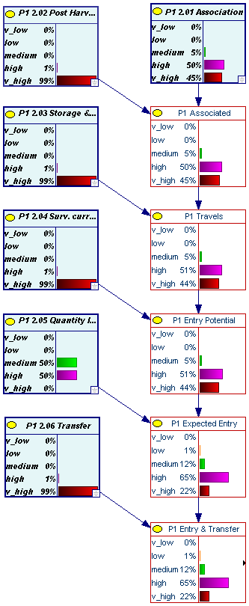
Fig. 4: Graphical representation of combining scores for questions 2.01 to 2.06, using a BBN to give an overall likelihood of entry and transfer on pathway a.

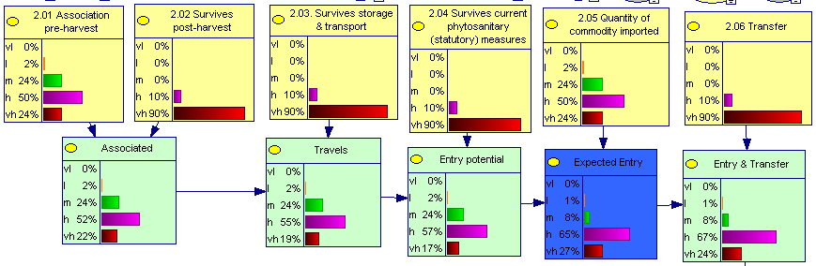

Fig. 5: Graphical representation of combining scores for questions 2.01 to 2.06, using a matrix model to give an overall likelihood of entry and transfer on pathway a.

Pathway b: Planting material of conifers, carrying infected psyllid vectors
It is considered very unlikely that the pest would enter new areas on this pathway. To test the two models in combining pathways a short summary is presented here together with the graphical representation using the BBN and a matrix combination. The detailed assessment of pathway b is provided in ANNEX 4.

2.07b Overall likelihood of entry and transfer via pathway b
Use the BBN to combine the scores to questions 2.01 to 2.06, which all relate to the likelihood of pest entry then transfer. Present it as Figure x.
Conclusions
The likelihood of the pest entering new areas on pathway b is considered very low to low.

Cacopsylla pruni, the vector of Ca. Phytoplasma prunorum overwinters as adult on conifers. Planting material of conifers with phytoplasma infected vectors attached may be traded and subsequently the adult vectors could move from the conifers to Prunus spp. in the new environment and transmit the phytoplasma. However, this event was considered to be unlikely as:

psyllids are present as adults on conifers; the adults are active even in the middle of winter and very sensible to vibrations. It is likely that they would fly away to other conifers when trees are uprooted and manipulated for transport and/or during transport,
- psyllid larvae with limited mobility are not present on conifers,

there are no reports of psyllid infestation in conifer nurseries (although the pest was found on young conifers).

Uncertainties regarding likelihood of entry and transfer
(Summarise uncertainties from 2.01 to 2.06)
- There is limited information available and hence high uncertainty, whether psyllids would remain attached to the plant,
- A plant passport for conifers is required only for plants 'authorised to persons professionally engaged in plant production'. Hence, phytosanitary inspections are not required for plants of conifers which are sold to the final consumer, e.g. forest holders.

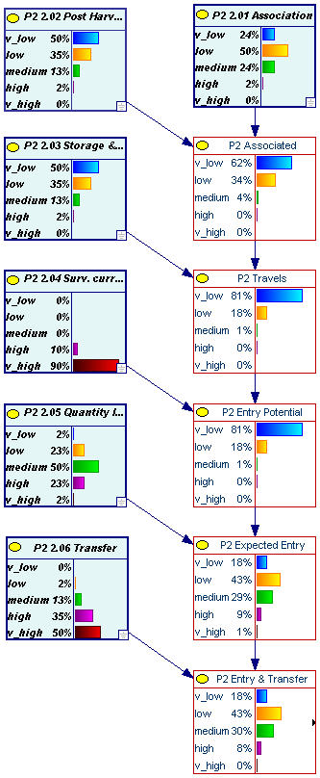
Fig. 6: Graphical representation of combining scores for questions 2.01 to 2.06, using a BBN to give an overall likelihood of entry and transfer on pathway b.

The result of combining scores to individual questions 2.01(b) to 2.05(b), that relate to likelihood of entry is combined with score for likelihood of transfer 2.06(a) using a BBN to provide an assessment of potential for entry and transfer for the pathway and is shown in Figure 6. It suggests that the potential for entry and transfer via pathway b is low to moderate, which is higher than assumed by the assessor. The BBN reflects the ‘Entry potential’ as very low to low, which appears to be correct. However, the medium rating in ‘quantity’ increases the rating for ‘expected entry’.
The matrix model uses an average round out matrix (highlighted dark blue) to combine “entry potential” and “quantity”, which better reflects the assessors view (Figure 7).

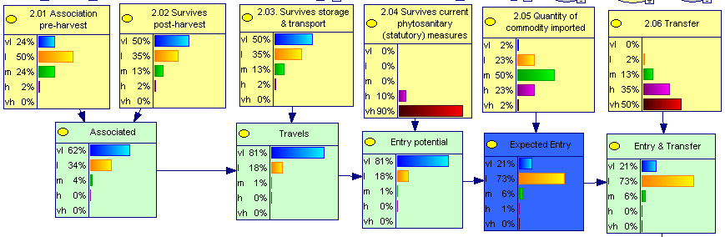

Fig. 7: Graphical representation of combining scores for questions 2.01 to 2.06, using a matrix model to give an overall likelihood of entry and transfer on pathway b.

2.08 Overall likelihood of entry and transfer via all pathways assessed

Combine all pathways a, b, c etc.

Pathway a “plants for planting of Prunus spp.” is the principal pathway. As pathway b is considered to be of minor significance, the combination of the pathways is not expected to add much to the overall risk of entry and transfer. This is correctly reflected in the matrix model. In the BBN, however, pathway b significantly increases the overall risk of entry, which is not considered to be correct (Figure 8).

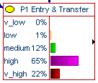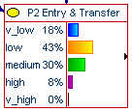

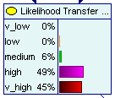

Graphical representation of combining results from 2.08 for all pathways using a matrix model using a BBN

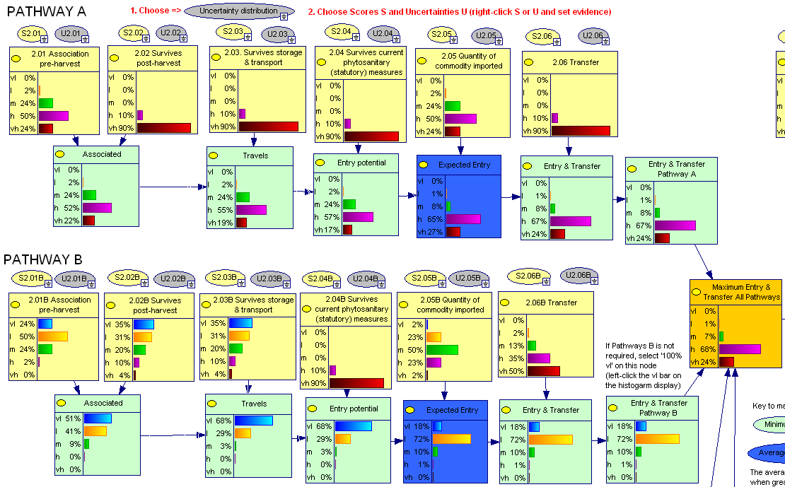

Fig. 8: Graphical representation of combining results from 2.08 for all pathways using a matrix model

3.00 Potential for pest establishment and extent of spread given entry and transfer

Having transferred to a host we next consider whether the pest will survive and reproduce to initiate a population that will establish.

3.01 Environmental suitability (particularly considering climate and hosts)
When introduced to new areas, pests can be expected to behave as they do in their native areas if host plants and climates are similar. Ecological zonation and the interactions of the pests and their biotic and abiotic environments are considered here, with a focus on hosts and climate so that an assessment is based on availability of both host material and suitable climatic conditions.
If a pest’s distribution is likely to be limited by frosts and/ or low winter temperatures first consider which hardiness zones the pest currently occurs in outside of the risk assessment area. Next consider the area occupied by hosts in relevant hardiness zones within the risk assessment area.
If a pest’s distribution is likely to be limited by a lack of accumulated temperature, e.g. low summer temperatures, first consider where the pest occurs in terms of accumulated degree day zones outside of the risk assessment area. Next consider the area occupied by hosts in relevant degree day zones within the risk assessment area.
Recall that hardiness maps and accumulated degree day maps are based on 30 year averages. In reality the areas of each zone vary year to year.
Taking into account the area of suitable climate and availability of host plants judge what area the pest could potentially establish in.
In addition to climate and host, many other factors can be taken into account when assessing likelihood of establishment. ISPM 11 lists other factors to consider, e.g. biotic factors such as the reproductive strategy of the pest, whether the species is polymorphic and the degree to which the pest has demonstrated the ability to adapt to conditions like those in the risk assessment area; the minimum population needed for establishment; competition and natural enemies. Abiotic factors in the environment such as soil type could also be important.

Where applicable, practices employed during the cultivation/production of the host crops should be compared to determine if there are differences in such practices between the risk assessment area and the origin of the pest that may influence its ability to establish. Pest control programs already in the risk assessment area which reduce the probability of establishment should be taken into account. Pests for which control is not feasible should be considered more likely to establish than those for which treatment is easily accomplished. The probability of establishment in a protected environment, e.g. in glasshouses, should also be considered.

Contracting parties to the IPPC recognise the necessity for preventing the international spread of plant pests and their introduction into areas (FAO, 1997). The IPPC defines “endangered area” as “an area where ecological factors favour the establishment of a pest whose presence in the area will result in economically important loss”. For the purposes of EFSA, assessors are advised to interpret endangered area as “the area where ecological factors favour the establishment of a pest whose presence in the area will result in harmful consequences to cultivated and managed plants and/ or the environment”.
If the risk assessment has been initiated by a review of phytosanitary policy where the pest is already present and perhaps widespread in an area, the likelihood of pest establishment should focus on those parts of the area where the pest does not occur.
Fill out table 3.01 by considering how much of the HOST area within the pest risk assessment area is suitable for the pest’s establishment taking into account relevant factors such as where host distribution overlaps with suitable climatic conditions (e.g. plant hardiness zones or accumulated degree day zones). For example an assessor could judge that it is 75% likely that 1/3 – 2/3 of the host area is suitable for establishment but 25% likely that between 2/3 and 90% of host area is suitable.

In Table 3.01 distinguish between the host area suitable for establishment and the ENDANGERED AREA which is, for the purposes of EFSA, the area where ecological factors favour the establishment of a pest whose presence in the area will result in harmful consequences to cultivated and managed plants and/ or the environment. In making a judgment regarding the endangered area, the rate of pest population development and any threshold required for harmful pest consequences to materialize within cultivated and managed plants could be taken into account. The magnitude of consequences is considered in Q 3.03 and 3.04.
Sophisticated quantitative environmental modelling could be used to more precisely identify the area where establishment is most likely and to identify the endangered area.

Information / evidence: Provide reasoning then give judgment.
Ca. Phytoplasma prunorum is a European species (Seemüller and Schneider, 2004), which occurs in most stone fruit producing areas of central and southern Europe. There, it is very widespread, including the most important stone fruit production areas in each country (though no records were found for some NUTS 2 regions that are surrounded or at the same latitude as others where the ESFY occurs).
It has not been reported in Portugal, Cyprus, Malta, southern Spain and most of the northern European countries were sensitive hosts are not grown (for details and references see Annex 1 and 2).
To establish in an area the phytoplasma needs suitable hosts, the presence of the vector and alternative conifers hosts that allow aestivation and overwintering of the vector.
Host plants including wild hosts are widely grown in the EU member states. In the European Union apricots and peach are grown on an area of 67.370 ha, 206.800 ha, respectively (Eurostat, 2007). They are mainly produced in the central and southern part of Europe. Production and trade data for Japanese plum (P. salicina) is not available. Plums (P. domestica) are produced on an area of 180.000 ha throughout the risk assessment area, including also the northern countries. Japanese plum (P. salicina) and apricot (P. armeniaca) are the most sensitive hosts. European plum (P. domestica) is susceptible but generally tolerant to ESFY (ANNEX 1). Wild hosts of the vector and disease are very widespread, particularly blackthorn (P. spinosa, Figure 1) and myrobalan (P. cerasifera, Figure 2 & 3).
The vector, Cacopsylla pruni is a European-Middle Asiatic species which is known to occur in many European countries (Lauterer, 1999, Ossiannilsson, 1992). It is present in European countries where the disease is not known (Finland, Sweden and Danmark (Ossiannilsson, 1992; Fauna Europaea) and Ireland (Fauna Europaea). No information on the status of the vector was found for Lithuania, Latvia and Estonia (for details see ANNEX 1 and 2). In the Baltic countries blackthorn and myrobalan are absent too (Fig. 1-3).
The vector C. pruni migrates in summer/autumn from their Prunus hosts to overwinter as adult on conifers. As suitable hosts the following species were reported: Abies alba, Abies nordmannia, Picea abies, Pinus nigra, P. sylvestris and P. halepensis (Thebaud et al., 2009; Serce et al., 2011). Conifers are very widespread in Europe (Flora Europaea), however uncertainties exists for their presence in the southernmost parts.

Climate
Figure 9 shows the annual degree days on a basis of 10°C. The known current distribution of Ca. Phytoplasma prunorum includes areas between 750 (e.g. Poland, fruit growing areas in Germany and Czech Republic) and 2.500 degree days (Spain, Italy, including the southern parts, Greece).
The countries and fruit growing areas where the current status of Ca. Phytoplasma prunorum is unknown are:
- Southern and Central Europe (where sensitive hosts are grown: apricot, peach, Japanese plum): Cyprus, Malta and Portugal and a few fruit growing regions in France, Italy and Spain.
- Northern Europe (where sensitive hosts are rarely grown): Denmark, Sweden Estonia, Latvia, Lithuania, Luxembourg and the Netherlands (no fruit production of Prunus spp. in Ireland and Finland)
Most fruit growing areas in central and southern Europe are located in areas between 750 and 2500 degree days. However, southern parts of Spain (Andalucía), parts of Portugal as well as Cyprus tend to have warmer temperatures (>2.500 degC), which may be an explanation for pest absence. Moreover, it is not known if the vector is present in this very southern part of the EU. P. spinosa which is an preferred for reproduction of C. pruni, is not present (http://linnaeus.nrm.se/flora/di/rosa/prunu/prunspiv.jpg).

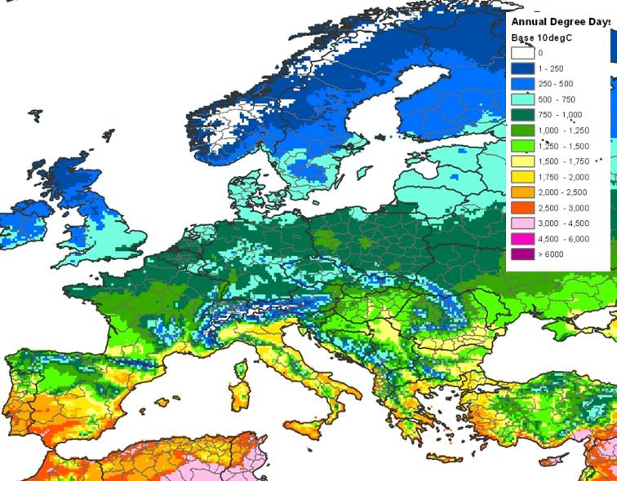

Fig. 9: Annual degree days in Europe (base 10 degC).

In northern Europe the presence of the ESFY-phytoplasma was confirmed from Belgium (in a 20 year old Prunus domestica tree growing in a private garden; Olivier, 2004), England (30 years old trees of a Prunus varieties grafted on P. domestica rootstocks in a Fruit Collection in Kent; Davies & Adams, 2001), northern Germany (Schleswig Holstein; CIRCA database 2009) and Poland, where ‘Ca. Phytoplasma prunorum’ was detected in 7 (of 16) provinces, the northernmost being Lubuski, Wielkopolski and Mazowiecki (Cieslinska & Morgas, 2011); at least parts of these areas are located between 500 and 750 annual degree days. It can be concluded that for the following reasons the disease may be wider spread in the northern countries then currently known:
- the main hosts which express symptoms, such as apricot and peach are not produced in northern countries; hosts of commercial importance, which are present are plum (Prunus domestica), which usually does not show symptoms and cherry (Prunus avium) which is highly resistant (Jarausch et al., 1999).
- wild Prunus hosts such as blackthorn (Prunus spinosa) and myrobalan plum (Prunus cerasifera) are widespread in northern Europe (Fig. 1-3), but usually do not show symptoms (these species play an important role in the epidemiology of the disease, as they are preferred hosts of the vector and represent a reservoir for the pathogen (Carraro et al., 2002; Fialova et al., 2004; Yvon et al., 2004, Jarausch et al., 2008, Jarausch et al., 2007)
- None of the northern countries (with the exception of Lithuania) performed a survey to confirm pest freedom (see ANNEX 1 & 2), particularly with regard to the status of the pest on wild Prunus spp.

Uncertainties regarding environmental suitability
As surveys on tolerant hosts (P. domestica, P. spinosa, P. cerasifera) are not available it is difficult to judge whether Ca. Phytoplasma prunorum is absent in Northern Europe or present, surviving in symptomless hosts.
Uncertainty concerning the presence of the vector, of suitable conifer hosts and the suitable climatic conditions for establishment remains for the most southern parts of the EU (Southern Portugal and Spain (Andalucia), Cyprus, Malta). Survey data from these regions are not available. In Malatya, the most important apricot production area of Turkey, conifers are not present. The nearest forests are 100-120 km away, which is considered to be the reason that the vector doesn’t survive in this province (Serce et al., 2011). This observation leads to uncertainties, since the conifer species, allowing the survival of the psyllid in other European regions, are not present in this very southern part of the risk assessment area (ANNEX 4). Moreover, blackthorn (P. spinosa), a favourite host for reproduction of the vector which was shown to be a key factor in the life cycle of the vector in other regions is not present in the southernmost parts of the risk assessment area (Figure 1).

Conclusions
The area suitable for establishment is where host plants and the vector are present or may find suitable climatic condition. This is the case for most EU-member states (including areas in the north of the PRA area were the disease is not known, but tolerant hosts, the vector and alternative hosts are present.).
There is uncertainty concerning the suitability of the area in the very south (presence of the vector and of suitable hosts for aestivation and overwintering and of favoured hosts for reproduction of the vector).

Comment regarding the endangered area
EFSA understands the endangered area as the area where ecological factors favour the establishment of a pest whose presence in the area will result in harmful consequences to cultivated and managed plants and/ or the environment. Following this definition, it can be concluded that northern European countries in which sensitive stone fruit crops are not produced are not included in the endangered area. Therefore the endangered area is much smaller and restricted to production areas in central and southern Europe where sensitive hosts are grown (i.e. apricot, peach and Japanese plum) (see ANNEX 1).

3.01: Environmental suitability (particularly climate and host)
Rating | Pest is likely to be able to establish in ... | Justification summary | Probability for suitable area ¹ | Probability for endangered area %
Very low | Less than 10% of host area |  | -% | -%
Low | Between 10% and 1/3 of host area |  | -% | -%
Medium | Between 1/3 and 2/3 of host area |  | - % | 90%
High | Between 2/3 and 90% of host area |  | 20 % | 10%
Very high | More than 90% of host area |  | 80% | -%
 | Check sum = |  | 100% | 100

¹ Spread your judgment according to your belief / evidence

3.02 Extent of spread
Having found a host and established in the PRA area, a pest will need to spread / disperse after introduction. Consider how quickly the pest could spread. For example, take into account its reproductive potential, suitability of the environment and inherent powers of movement. Assessors should take into account the likelihood that spread may not be contiguous and satellite populations may develop at significant distances from the original point of establishment. Such dispersal could occur via biotic or abiotic vectors, wind, water, or, for example, be facilitated via trade or transport links or via others forms of human assistance, such as movement of infected/infested plant material for propagation purposes (seedlings, scions, budwood).

Taking into account the time horizon considered within this assessment (see Initiation, 1.5) estimate the area likely to be occupied by the pest. Fill out table 3.02 by estimating the likelihood that the pest would have spread to occupy the given proportion of the host area suitable for establishment within the time period / time horizon considered by this assessment. Also note the endangered area occupied at the time horizon.

The table is used to consider the extent of spread in relation to the area where establishment is suitable. Hence it is recognised that fast moving pests with a large area suitable for establishment may be rated below slower moving pests with much smaller areas suitable for establishment. Quantitative spread modelling could be considered to examine spread more precisely.

Specify the time period / time horizon considered by this assessment (refer to 1.5).

Information / evidence: Provide reasoning then give judgment
Ca. Phytoplasma prunorum is considered to be a native species. It causes different diseases on several stone fruit species, summarized under 'European stone fruit yellows (ESFY)'. A decline by apoplexy was first reported for apricot in France (Chabrolin, 1924 in Jarausch & Jarausch, 2010) and for Japanese plum in Italy (Goidànich, 1933 in Jarausch & Jarausch, 2010).
The phytoplasma is long known in Europe. The systematic literature review on the distribution of Ca. Phytoplasma prunorum within the EU has shown that the disease was found in 15 of 25 EU countries, in which stone fruits are produced. It is widespread in the most important European stone fruit production areas and present on common wild Prunus species.
As native species the pest and its vector have spread for many decades through the trade of planting material and the migration behaviour of the vector. It is therefore unlikely that within a time horizon of ten years the occupied area will increase significantly.

Uncertainties regarding extent of spread
With this respect the uncertainty is regarded to be low.
However, it is noted that within the endangered area the pest still may enter locations where it has not been known before, through the trade of planting material (see entry section) and vector migration (from Prunus crops to wild Prunus, conifers and back).
Uncertainty exists concerning the significance of spreading the disease through plant propagation compared to the role of the vector. A short term experiment has been conducted within Prima phacie to evaluate the relative role of human activities and psyllid vectors in the dissemination of European stone fruit yellows in apricot orchards. The results suggest that new infection of trees is presumably due to ESFYP transmission by vectors, which acquire the pathogen from wild Prunus spp. and transmit them in orchards than by contamination of propagation material. This is in agreement with recent results from Italy (Pignatta et al., 2008).
(For details on the short term experiments refer to ANNEX 3).

Conclusions
Within a time horizon of 10 years the infested area where hosts are present as well as the endangered area are unlikely to increase significantly. The extent of spread is rated to be very low with a low uncertainty.

3.02: Extent of spread
Note: that the rating guidance was developed for a pest that is not present (or present but not widely distributed). To fit the requirement for the specific case of a widespread native species, the term ‘additional’ was added in the rating guidance.
Rating | Within the time horizon considered the pest is likely to have spread to ... | Justification summary | Probability of additional host area occupied at time horizon¹ | Additional host area endangered at time horizon¹
Very low | Less than 10% of the area suitable for establishment |  | 80% | 90%
Low | Between 10% and 1/3 of the area suitable for establishment |  | 20% | 10%
Medium | Between 1/3 and 2/3 of the area suitable for establishment |  | % | %
High | Between 2/3 and 90% of the area suitable for establishment |  | % | %
Very high | More than 90% of the area suitable for establishment |  | % | %
 | Check sum = |  | 100% | 100

¹ Spread your judgment according to your belief / evidence

Consequences of pest introduction
3.03 Crop consequences (yield and quality)
Introduced pests are capable of causing a variety of direct and indirect impacts. The remit of EFSA limits assessors to consider the consequences of pest introduction on crop yield and quality (crop consequences / impacts) (3.03) and environmental consequences /impacts (3.04) e.g. impacts on ecosystem services or biodiversity itself. We recognise that other types of impacts, listed in ISPM 11, may also occur.
Fill out table 3.03 by taking into account the extent of pest spread within the endangered area up to the time horizon of the assessment, and other factors such as the rate of pest population development and any threshold required for harmful pest consequences to materialize within cultivated and managed plants. Consequences should be estimated taking into account the current situation in the endangered area with respect to the control efforts undertaken by growers /nurserymen/ producers etc. against other pests. Although we recognise that growers may respond by increasing pest management efforts to minimize impacts of a new pest, such additional efforts are not taken into account.
If the risk assessment has been initiated by a review of phytosanitary policy where the pest is already present and action is being taken against it, specify whether consequences are being assessed assuming that action is stopped.

Information / evidence: Provide reasoning then give judgment
Official control measures are implemented in the European Union for many decades. When not coming from an area free of ESFY, no symptoms of ESFY should have been observed on plants at the place of production since the last complete cycle of vegetation. Nevertheless ESFY infections are discovered regularly in planting material (Europhyt and CIRCA database, Ambrozic Turk 2006; Ambrozic Turk et al., 2008; Q 2.01a).
Ca. P. prunorum is a major limiting factor in the production of apricots (Prunus armeniaca) and Japanese plums (P. salicina) in Europe. It causes substantial economic losses due to tree decline, reduction in fruit weight and quality. Its economic impact is less in peach (P. persica), almond (P. amygdalus) and European plum (P. domestica). In France, in the department Pyrenees-Orientales, about 80 % of the mortality and decline observed on apricot is due to ESFY (Cornaggia et al., 1994) and the production losses associated with ESFY in Italian plum orchards reach up to 40 % in Japanese plum (Landi et al., 2001). Infected trees may die 1 to 2 years after first appearance of symptoms (e.g. Polak et al., 2007).
Differences in susceptibility to ESFY were found in stone fruits rootstocks and varieties (Carraro et al., 1998; Jarausch et al., 2000, Kison and Seemüller, 2001). In apricots, less sensitive cultivars such as ‘Hungarian Best’ declined more slowly than highly sensitive cultivars such as ‘Canino’ (Morvan, 1977). The common European plum varieties develop few or no symptoms. Jarausch et al. (2000) report that ‘Reine Claude’ (‘Greengage’) and related cultivars, ‘Ruth Gerstetter’, ‘Bluefree’, ‘President’ and ‘Stanley’ are robust, whereas Prune d’Ente (Prune d’Agen)-related cultivars, including ‘Primacotes’, ‘Tardicotes’, ‘Lorida’ and ‘Spurdente’ are affected. 54-100% of inoculated trees of different French prune cultivars showed typical ESFY symptoms of off-season growth until the fifth winter, some of them also chlorotic leafroll in summer. The mortality reached 19 % within the first five years following inoculation (Jarausch et al., 2000).
Gazel et al. (2009) showed that ESFY in apricot trees caused a considerable yield reduction up to 50 % (kg/tree) and affects significantly fruit quality (fruit weight, length, height and width). A reduction in fruit weight (between 8 and 32 %) was also observed in several new P. domestica culitivars, although P. domestica is known as being rather tolerant to ESFY (Jarausch et al., 2000).
Differences were also found in the susceptibility of various stone fruit rootstocks (Kison und Seemüller, 2001). Trees on P. domestica and some P. cerasifera stock were little affected. GF-677 (Prunus amygdalus x P. persica), GF 8-1 (‚Mariana‘ P. cerasifera x P. munsoniana), were slightly more affected. P. insititia (‘St. Julien’) stocks showed moderate to high susceptibility, whereas peach and apricot rootstocks were most sensitive.
None of the rootstocks appear to be resistant as even in least affected P. domestica rootstocks the phytoplasma was detected and trees were slightly damaged.
Recovery is a common phenomenon in phytoplasma infected stone fruits. Recovered trees enduring symptom freedom in the aerial parts, still infections of ‘Ca. P. prunorum’ persists in infected trees (Musetti et al., 2005).

Uncertainties regarding crop consequences
The severity depends on various factors: such as the plant species, rootstock, scion cultivar (and its combination), strain virulence, phytoplasma concentration, climatic condition, age of trees and abundance of insect vector population (Seemüller & Foster, 1995; Kison & Seemüller, 2001; Thébaud et al., 2006).
Thebaud et.al, 2006 recorded several risk factors to explain the number of diseased trees among a known number of exposed trees in an orchard and found that the age, species, and cultivar of the scion were the major factors explaining the observed number of diseased trees. The planting density and the rootstocks used were less significant, and the size of the orchard had no effect.

‘Ca. P. prunorum’ includes strains which greatly differ in virulence (Marcone et al., 2010). In an inoculation experiment, the most virulent strains of ESFY killed all trees on peach rootstocks, whereas mild strains did not cause mortality, but induced only mild foliar symptoms and slightly reduced vigour (Kison & Seemüller, 2001).

Wild Prunus plants (e.g. P. spinosa, P. cerasifera, P. salicina and P. domestica) around host plant orchards (apricots, peach …) may present a source of infection as these wild species are the preferred hosts of the vector C. pruni (Carraro et al., 2002, Labonne and Lichou, 2004) and may harbour the pathogen without obvious symptoms. If such species are present, they should be carefully monitored and removed if they test phytoplasma-positive.
In addition suckers from rootstocks (P. domestica and P. cerasifera) should be removed as they may facilitate colonization and reproduction of C. pruni and thereby form a risk for ESFY infections (Labonne & Lichou, 2004).

Conclusions
Within the endangered area, the phytoplasma has direct effects on yield, quality and marketability and can lead to plant mortality. The economic impact is often high in central and southern European countries, however, depends on various factors: such as the plant species, the rootstock, the scion cultivar (and its combination), the strain virulence, the phytoplasma concentration, the climatic condition, the age of the trees and the abundance of the insect vector population and can vary from minor to severe.

3.03: Potential consequences on crops and managed plants
Rating | Description (if established in the endangered area, the pest ....(descriptions within categories provide guidance, not all descriptions need to be satisfied in each category) | Justification summary | Probability Assignment ¹
Very low | Under existing pest management regimes, the pest is likely to have negligible or no impact on a standing crop and/or stored products.  Yield and/or quality losses would be negligible and within the range of natural variation. |  | %
Low | Under existing pest management regimes, the pest is likely to have minimal impact on a standing crop and/or stored products.  Yield / quality losses would be minimal. |  | 20%
Medium | Under existing pest management regimes, the pest is likely to have a minor to moderate impact on a standing crop and / or stored products.  Yield / quality losses would be moderate. |  | 30%
High | Under existing pest management regimes, the pest is likely to have a moderate to severe impact on a standing crop and / or stored products. Thus the pest  will not be effectively controlled by actions already applied against other pests by growers.  Yield / quality losses would be moderate to severe. |  | 35%
Very high | Under existing pest management regimes, the pest is likely to have a severe impact on a standing crop and / or stored products. Thus the pest will not be effectively controlled by actions already applied against other pests by growers.  Yield / quality losses would be severe. |  | 15%
 |  | Check sum = | 100%

¹ Spread your judgment according to your belief / evidence

3.04 Environmental Consequences
The assessment of the potential of a pest to cause environmental damage proceeds by considering the following factors:
- can the introduction of the pest cause permanent (irreversible) significant, direct environmental impacts, e.g. reduced biodiversity, ecological disruption.
- can the pest have direct impacts on endangered/threatened species by infesting/infecting a plant listed in Annex II or IV of the EC Habitats Directive or infesting / infecting a plant which is a key component of a habitat listed in Annex I of the EC Habitats Directive? If the pest attacks other species within the genus or other genera within the family, and preference/no preference tests have not been conducted with the listed plant and the pest, then the plant is assumed to be a host.
- Can the pest have indirect impacts on species that are listed in Annex II or IV of the EC Habitats Directive or on species that are key components of habitats listed in Annex I of the EC Habitats Directive?
- Would the introduction of the pest stimulate chemical or biological control programmes which would disrupt existing biological or integrated systems for control of other pests or have negative effects on the environment e.g. biodiversity (at various levels), reduce population sizes, or increase their fragmentation.

Fill out table 3.04 by considering the likely magnitude of the above impacts, taking into account the extent of pest spread within the endangered area up to the time horizon of the assessment, and other factors such as the rate of pest population development and any threshold required for the pest to cause environmental harm in the environment.

Information / evidence: Provide reasoning then give judgment
Impacts on ecosystem services and biodiversity are not expected, as the pest and its vector are considered to be native to Europe. The section "environmental consequences" is therefore not assessed.

Uncertainties regarding environmental consequences
No uncertainties

Conclusions

3.04: Potential environmental consequences
Rating | Description | Justification summary | Probability Assignment ¹
Very low | None of the above would occur; the pest is only able to establish on crops grown in protected cultivation such as glasshouses or shade houses. Nevertheless, it is assumed that introduction of a non-indigenous pest will have some environmental impact (by definition, introduction of a non-indigenous species affects biodiversity). | Pest and vector are considered to be indigenous | 100%
Low | None of the above would occur; nevertheless the pest could establish outdoors and it is assumed that introduction of a non-indigenous pest will have some environmental impact (by definition, introduction of a non-indigenous species affects biodiversity). |  | %
Medium | One of the above would occur.  However, if effects are relatively small, the potential consequences can be rated Low instead of Medium. |  | %
High | Two of the above would occur.  However, if effects are relatively small, the potential consequences can be rated Medium |  | %
Very high | Three or more of the above would occur.  However, if effects are relatively small, the potential consequences can be rated High |  | %
 |  | Check sum = | 100%

¹ Spread your judgment according to your belief / evidence

3.05 Potential impact

The potential impact is assessed assuming entry has occurred and takes into account the endangered area occupied at the given time horizon (3.02) with consequences to crops (3.03) and the environment (3.04) within the endangered area.

Method 4b considers spread as increase of the occupied area within a time horizon. In the endangered area, which is restricted to production areas of sensitive host in central and southern Europe the pest is already present and widespread. It is not known particularly in the southernmost part of the risk assessment area. However, as both the phytoplasma and the vector are considered to be native and have spread (naturally and by human assistance) throughout many decades since the early 20th Century, it is considered unlikely that the occupied area will increase within a time horizon of 10 years. Spread is therefore rated to be very low.
Generally, the crop consequences may vary from low to severe, depending on the plant species, rootstock, scion cultivar (and its combination), strain virulence, phytoplasma concentration, climatic condition, age of trees and abundance of insect vector population.

Conclusions

Within a chosen time frame of 10 years the disease is very unlikely to spread significantly, Hence, in Method 4b, the overall potential impact, which is combining the ‘extent of spread’ with the ‘consequences’ appears to be low. Both methods (BBN, Matrix) have similar results. However, the effect of the ‘very low spread rating’ on the potential pest risk is more distinct in the matrix model (68% very low to low) than in the BBN (46%) (Figures 10 & 11).

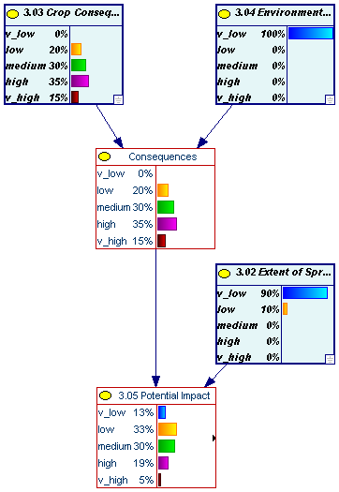
Fig. 10: Graphical representation of potential impact, combining crop consequences and environmental consequences of pest introduction with the area occupied by the pest at the time horizon.

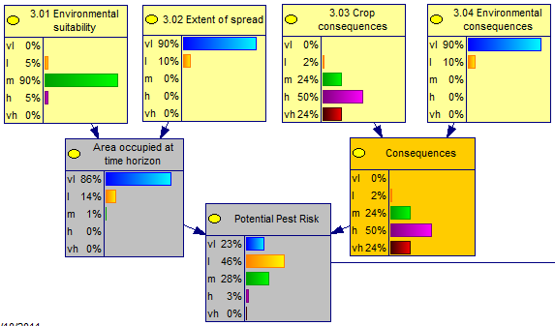

Fig. 11: Graphical representation of potential impact, combining crop consequences and environmental consequences of pest introduction with the area occupied by the pest at the time horizon.

3.06 Pest Risk
To assess the risk for a pest that has not yet entered the PRA area, the potential impact (3.05) which assumes entry has occurred, must be combined with likelihood of entry and transfer (2.08).
As both vector and disease are widespread in central and southern Europe, the pest risk is assessed only for the part of the endangered area in which the pest is not reported: particularly the southernmost parts of the risk assessment area (Portugal, southern Spain, Malta and Cyprus) and few administrative units in other central and Southern European countries. The northern part of Europe, where sensitive hosts are not present, is not within the endangered area.

Text
The pest is considered to have very low potential for further spread (see above), and though low to very high crop consequences are expected, the ‘potential impact’ is very low to medium depending on the model (see above).
Combining the results of the ‘potential impact’ with the high rating for ‘overall Entry & Transfer’ the BBN results in a low to high ‘Pest Risk’ for the southernmost parts of the PRA area; whereas the matrix model, suggests a very low to medium expected pest risk for this area (Figures 12 & 13).

Fig. 12: Graphical representation of Pest Risk (3.06), combining overall potential for pest entry and transfer (2.08) with potential impact (3.05).

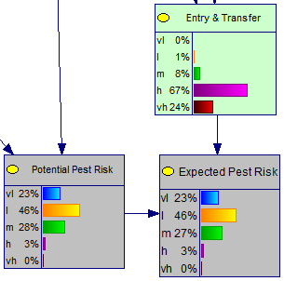

Fig. 13: Graphical representation of Pest Risk (3.06), combining overall potential for pest entry and transfer (2.08) with potential impact (3.05).

4.0 Uncertainties
Following EFSA Guidance (EFSA, 2010), to ensure transparency in risk assessment, uncertainties should be identified, characterized and documented within all risk assessments. This can show not only which aspects of an assessment are uncertain but the degree of uncertainty and can help identify where further work could usefully reduce uncertainty.

The relative importance of uncertainties and their influence on the assessment outcome should be described. – This can be done by changing the uncertainty associated with selected questions and reporting how such change impacts on subsequent pest risk.
Ca. P. prunorum is long known in Europe and comprehensive scientific literature is available. Still, some minor uncertainties have been identified during the risk assessment process. However, it is concluded that solving these uncertainties will not have a significant influence on the conclusion of the risk assessment.
Summary of uncertainties identified and further work that could be undertaken to reduce uncertainties
Section of risk assessment |  | Uncertainties | Research that would reduce uncertainty
2.0 | Pathways | the role of non-confirmed hosts in the epidemiology
2.01a | Pest associated | the level of infested lots in trade
2.02a | Survive post harvest
2.03a | Survive storage
2.04a | Survives measures
2.05a | Quantity imported | Only estimates of the trade within the EU
2.06a | Transfer
2.01b | Pest associated | The role of vectors attached to conifers for the spread of the disease | Answer question if adult psyllids remain attached to the conifer, when plants are uprooted and manipulated for transport
2.02b | Survive post harvest
2.03b | Survive storage
2.04b | Survives measures
2.05b | Quantity imported | Only estimates of the trade within the EU
2.06b | Transfer
3.01 | Environmental suitability | The status of the disease in northern countries,  The presence of the vector and suitable hosts for overwintering and reproduction of the vector in the southernmost parts of Europe: Portugal, southern Spain, Cyprus, Malta | Survey, including particularly wild Prunus hosts
3.02 | Extent of spread | When C. pruni migrates from Prunus hosts to conifer shelter plants do they mainly return to the Prunus hosts where they hatched the previous year or do they fly to other locations.  The occurrence of the vector is not clear, particularly for the southernmost parts of the EU
3.03 | Crop consequences | The distribution of mild and severe strains of Ca. P. Prunorum in the EU.
3.04 | Environmental consequences
5.0 Conclusions

A risk assessment has been conducted to evaluate the plant health risk associated with Ca. Phytoplasma prunorum (European Stone Fruit Yellows phytoplasma) within the framework of EFSA project CFP/EFSA/PLH/2009/01. Ca. Phytoplasma prunorum causes diseases in stone fruits summarized as European Stone Fruit Yellows. The pathogen and its vector, the psyllid Cacopsylla pruni are native to Europe. They are widespread in most parts of the risk assessment area, including the most important stone fruit production areas, where the disease causes significant economic impact in sensitive crops: apricot (P. armeniaca), peach (P. persicae), and Japanese plums (P. salicina). It has not been reported in the southernmost parts of the risk assessment area; moreover, no records were found for some NUTS 2 regions that are surrounded or at the same latitude as others where the ESFY occurs. Furthermore, it is unknown in many northern European countries.
Ca. Phytoplasma prunorum is currently listed in Annex I AII(d). Phytosanitary measures are applicable to all Prunus spp. However, both vector and disease are widespread in Europe and occur on many different, wild and cultivated Prunus species [particularly blackthorn Prunus spinosa, myrobalane (P. cerasifera) and plum (P. domestica)], which form a reservoir for the phytoplasma. Therefore, eradication and containment of the pest is not possible.
Moreover, it is concluded unlikely that within a time horizon of 10 years the disease and its vector, which are known since the early 20th Century and which are considered native to Europe, would significantly spread to areas where they are not reported. [In most parts of northern Europe the vector is present; however, only tolerant (wild and cultivated) hosts are found there. Hence, northern Europe is not part of the endangered area. In the southernmost part of Europe (Portugal, southern Spain, Cyprus, Malta) there is uncertainty concerning suitable conditions for the vector (availability of hosts for overwintering and reproduction].
Ca. Phytoplasma prunorum is a native pest which is very widespread in the EU; hence, it doesn’t qualify as quarantine pest; however, in regions within the endangered area where the disease and the vector are abundant, there is a high risk that the phytoplasma is associated with plants at the place of production. In such cases the intended use of sensitive host plants is affected and the phytoplasma may cause significant economic impact.
Consequently, risk reduction options were elaborated to reduce the risk of Ca. P. prunorum spreading in infested planting material and causing damage to sensitive crops for sensitive hosts only:
- Apricots (Prunus armeniaca),
- Japanese plum (P. salicina) and
- Peach (P. persicae).
Other cultivated Prunus spp, particularly cherries (P. avium), as non host and plums (P. domestica), as tolerant host as well as the mainly wild Prunus species (P. spinosa, P. padus …) should not be regulated.

ISPMs Nos. 5 and 11 available at https://www.ippc.int/index.php?id=ispms&no_cache=1&L=0
EFSA Journal 2010, 8(2),1495-1561, Available at http://www.efsa.europa.eu/en/scdocs/doc/1495.pdf
http://eur-lex.europa.eu/LexUriServ/LexUriServ.do?uri=CELEX:32000L0029:EN:NOT
Establishment; Perpetuation, for the foreseeable future, of a pest within an area after entry (ISPM No. 5, IPPC, 2007).
Managed plants are those plants appreciated / valued/ desired by man, whose growth and spread / distribution are modified by human intervention. It would include plants grown in private gardens.
When assessing the extent of spread, be clear about the scenario being considered e.g. you could be considering a scenario without risk reduction options in place, or a scenario with specific phytosanitary measures that inhibi spread (risk reduction options) in place.
Council Directive 92/43/EEC (as amended) on the Conservation of natural habitats and of wild fauns and flora. Available at http://www.central2013.eu/fileadmin/user_upload/Downloads/Document_Centre/OP_Resources/HABITAT_DIRECTIVE_92-43-EEC.pdf

