
Rapid Pest Risk Analysis (PRA) for:
Chilli veinal mottle virus
May 2022

Summary and conclusions of the rapid PRA
Chilli veinal mottle virus (ChiVMV) is a Potyvirus that is widespread in Asia and infects solanaceous hosts, including pepper, tobacco and tomato. Infection by this virus is one of the limiting factors in the production of chilli pepper plants worldwide. ChiVMV is spread by grafting, mechanical transmission and aphid vectors, including aphid species that are present in the UK. It is expected that this virus could establish in the UK, since hosts of this virus are produced commercially as well as being present in the wild.

Risk of entry
Seed transmission was rated as very unlikely, with medium confidence, as there is no evidence in the existing literature that this occurs. Imported produce and natural spread via aphid transmission were both considered unlikely pathways (with high and low confidence ratings respectively). The highest risk pathway for ChiVMV was judged to be the imported host plants for planting. This was considered moderately likely with a low confidence, given the import volumes, the potential presence in Italy still, and the reported association with the virus spread. The delay in symptom development could also prevent infected plants being detected at the border.

Risk of establishment
The establishment of ChiVMV under protection was rated likely, with high confidence, given the scale of commercial production and cultivation of tomatoes and peppers in the UK. The movement or handling of infected materials could then transmit the virus or aphid vector between greenhouses.
Outdoor establishment would require the presence of host plants, which is less likely. Although tomatoes and ornamental hosts of ChiVMV are grown outside in gardens or allotments, the distribution will be small-scale. However, a natural host, Solanum nigrum, is present across the UK. As this weed has been found to be infected in the wild of some affected countries, outdoor establishment was rated moderately likely with medium confidence.

Economic, environmental and social impact
ChiVMV represents a risk to commercial production of chilli peppers worldwide, by drastically reducing quality and yield (over 50% in some cases). Impacts on the yields of other major crops (tomato, tobacco, African eggplant) has not been quantified, however the recorded symptoms are expected to carry a significant economic impact. Disease incidence appears to be particularly high in tomato and African eggplant. Due to the commercial production of sweet peppers and tomatoes in the UK, as well as the sale of certain species as ornamental plants, the economic impacts were rated as medium. A medium confidence was provided with this rating, as there is some uncertainty surrounding the host range of ChiVMV.
No social or environmental impacts of this virus have been reported in its existing distribution, though this virus has been identified on wild species in India and Pakistan. This could similarly occur in the UK on Solanum nigrum. The ecological role of this native weed is unclear; therefore, the environmental impacts of ChiVMV were rated small (with a low confidence). As ChiVMV can also attack certain ornamental plants, social impacts were rated small with a high confidence.

Endangered area
Protected solanaceous crops in the UK.

Risk management options
ChiVMV is highly transmissible with limited controls, for example, the removal of host plants or control of aphid vectors. There is no treatment for infected plants and controlling the natural spread of ChiVMV becomes increasingly difficult over time. Therefore, exclusion would be the best option for this pest with regulatory controls on imports of plants for planting (excluding seeds). There is already an existing prohibition on the import of solanaceous plants from third countries outside of the Euro-Mediterranean area.
If a pest outbreak occurred in the UK, eradication could be considered and attempted with the destruction of all host plants on site followed by re-inspections of the site over time. This was the strategy taken in Italy. Measures could also be taken to prevent the spread of the pest from the site.

Key uncertainties and topics that would benefit from further investigation
A key uncertainty is whether ChiVMV has been completely eradicated in Italy or is still present with a restricted distribution. It would be beneficial if the site of the original outbreak and the surrounding area was inspected for ChiVMV.
It would also be useful to understand the impact of this virus on tomato yields, given that significant volumes are produced in the UK. This impact is not reported in the existing literature.

Images of the pest
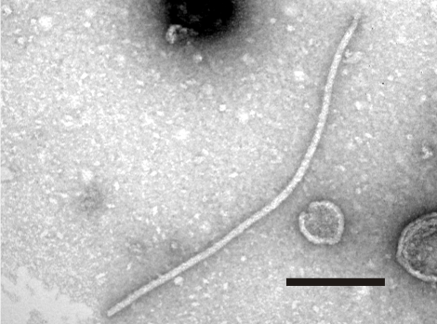 | 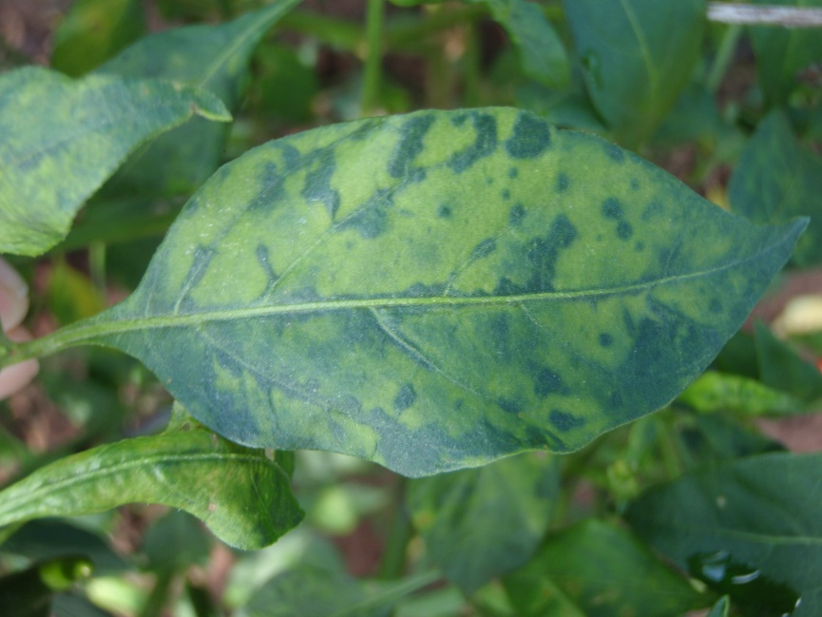
Viral particle of Chilli veinal mottle virus (the bar represents 200 nanometres) © Banerjee et al., 2014. | Symptoms on Capsicum leaves © Chiemsombat, personal communication, 2022.

Is there a need for a detailed PRA or for a more detailed analysis of particular sections of the PRA? If yes, select the PRA area (UK or EPPO) and the PRA scheme (UK or EPPO) to be used.

No | P
Yes |  | PRA area: UK or EPPO |  | PRA scheme:  UK or EPPO

Given the information assembled within the time scale required, is statutory action considered appropriate / justified?
[The text below is a recommendation by the risk analyst which requires approval by PHRG]
Yes  Statutory action | P | No  Statutory action
There is a high risk that if ChiVMV entered the UK, it would become established, either in glasshouses or outdoors, and cause high losses on sweet pepper and tomato yields as well as potentially impacting the wider environment. Eradication would be extremely difficult due to the high transmissibility of this virus and the presence of reservoir hosts (Solanum nigrum) in the wild.
However, this Pest Risk Analysis concludes that the highest risk pathway for ChiVMV entering the UK is via the import of plants for planting from countries infected with the pest. ChiVMV presently resides in countries outside of the Euro-Mediterranean area (see Table 1), where growing plants are prohibited from being imported into the UK under the retained Implementing Regulation (EU) 2019/2072². It therefore appears that the highest risk pathway is currently being addressed by the existing regulations and no further action is required. However, this is on the basis that the outbreak in Italy has been successfully eradicated, as previously communicated in early 2022.

Stage 1: Initiation

1. What is the name of the pest?
Chilli veinal mottle virus (Potyviridae: Potyvirus)
Common name: ChiVMV or CVMV; Synonyms include chilli vein-banding mottle virus (CVbMV), chilli veinal mottle potyvirus, pepper vein-banding virus, or pepper vein-banding mottle virus.
Chilli vein-banding mottle virus and the pepper vein-banding virus are classified as strains of ChiVMV (Tsai et al., 2008).

2. What initiated this rapid PRA?
In the past three years, this pest has been intercepted multiple times in the UK on imported goods. A decision was made, back in 2019, to only take statutory action on plants for planting due to the low risk of transmission from infected produce.
An assessment is required to help decide whether this pest should be regulated as a quarantine pest.

3. What is the PRA area?
The PRA area is the United Kingdom of Great Britain and Northern Ireland.

Stage 2: Risk Assessment

4. What is the pest’s status in the plant health legislation, and in the lists of EPPO?
The legislation for Great Britain is Implementing Regulation (EU) 2019/2072 as retained and made operable in GB by The Plant Health (Phytosanitary Conditions) (Amendment) (EU Exit) Regulations 2020. This pest will be regulated as a provisional quarantine pest from 8th August 2022, as legislated for by The Phytosanitary Conditions (Amendment) Regulations 2022.
The legislation which applies to Northern Ireland is the EU legislation: 2019/2072 and 2016/2031. However, this pest is not listed in the EU plant health legislation and is not recommended for regulation as a quarantine pest by EPPO, nor is it on the EPPO Alert List.

5. What is the pest’s current geographical distribution?
This pest was first identified in Malaysia in the 1970s and has been reported across Asia since (CABI, 2021; Ong et al., 1979). ChiVMV is present on crops grown in China, India, Indonesia, Korea, Malaysia, Pakistan, the Philippines, Sri Lanka, Taiwan, Thailand and Vietnam, and is a significant problem on chilli production (Ong et al., 1979; Gao et al., 2016; Siriwong et al., 1995; Tsai et al., 2008; Yang et al., 2013). Notably, ChiVMV has also been found in the wild in Asia on several different weeds (IPM CRSP, 2008; Mehra et al., 2006).
There have been some reports of ChiVMV being present in Japan, however solid evidence could not be found. Additionally, in the UK there have been pest interceptions on imported produce from Laos and Bangladesh, which have not been recorded in the known distribution of this virus.
This virus has also been identified in eastern Africa, in Tanzania and Uganda and possibly neighbouring countries (IPM CRSP, 2008; Nono-Womdim et al., 2001). Imported produce from Kenya into the UK recently tested positive for ChiVMV although this has not been documented in the existing literature.
This pest has been reported in Papua New Guinea, however further examination of the primary source indicated that ChiVMV was only found in Papua, Indonesia (Davis et al., 2002).
More recently, ChiVMV was detected in Italy, the first reporting of this pest in Europe. The virus was found in 2015 on chilli plants in a single site, where cultivars had been collected from different parts of the world and grown as a germplasm outdoors. Eradication measures were taken on all plants, however there was a risk acknowledged that aphid species could have already aided the spread of ChiVMV from this site. A follow-up inspection was completed in 2016 on chilli plants from the original site. ChiVMV was identified again, and all plants were destroyed (Tiberini et al., 2017). Production of chilli on this site has now been stopped and no further controls have been conducted on this site. In addition, a survey was conducted on samples from four different regions of Italy from 2017-2020, and ChiVMV has not been identified (Tomassoli, personal communication, 2022). However, it is possible that ChiVMV is still present in Italy in a restricted distribution.

Table 1: Distribution of Chilli veinal mottle virus
North America: | Not present
Central America: | Not present
South America: | Not present
Europe: | Potentially eradicated in Italy.
Africa: | Present in Tanzania, Uganda.
Asia: | Present in China, India, Indonesia, Korea, Malaysia, Pakistan, the Philippines, Sri Lanka, Taiwan, Thailand, Vietnam.
Oceania: | Not present

6. Is the pest established or transient, or suspected to be established/transient in the UK/PRA Area?
The pest is not known to be present in the UK. There have been no known findings of ChiVMV on growing plants in the UK. In 2020, there were 12 interceptions in England and Wales: six from India, two from Uganda, and one each from Laos, Thailand, Kenya, and Bangladesh. In 2021, there were three interceptions of ChiVMV, two from India and one from Tanzania. Most of these interceptions have been on the produce of imported Capsicum species.

7. What are the pest’s natural and experimental host plants; of these, which are of economic and/or environmental importance in the UK/PRA area?
This pest is chiefly recorded in the existing literature as a pest of Capsicum spp. (chilli pepper) (C. annuum, C. chinense, C. frutescens, C. baccatum). It does have several other hosts, as listed below.

Natural hosts:
Buddleja crispa
Commelina spp., including C. erecta
Datura metel, D. inoxia
Nicotiana tabacum L (tobacco)
Physalis floridana
Solanum aethiopicum (African eggplant)
Solanum lycopersicum L. (tomato)
Solanum nigrum
Experimental hosts:
Amaranthus spp.
Capsicum microcarpum, C. pendulum
Chenopodium amaranticolor
Datura stramonium
Nicandra physalodes
Nicotiana benthamiana, N. glutinosa, N. occidentalis, N. megalosiphon, N. sylvestris, N. rustica, N. debneyi
Physalis minima
(Kaur et al., 2015; Mehra et al., 2006; Nandappa et al., 2020; Nono-Womdim et al., 2001; Prakash et al., 2002; Shah et al., 2008; Yang et al., 2013).
There is some contradictory information in the existing literature on the host range for the pest, this has been attributed to the difference in isolates used in each study (Shah et al., 2008).
Natural hosts are restricted to the Solanaceae family, apart from Buddleja crispa (from the Scrophulariaceae family) and Commelina species (from the Commelinaceae family). The existing literature on host range studies for this pest appears to indicate that experimental host susceptibility varies depending on the cultivar and the infecting isolate (Shah et al., 2008; Ong et al., 1979).
Peppers and tomatoes are of economic importance in the UK as they are grown domestically. Wild growing plants of Buddleja crispa, Commelina spp., Datura metel, D. inoxia, Physalis floridana, and Solanum nigrum have all been found infected in other countries, raising concerns that they could act as reservoir hosts and subsequently as a source of inoculum (IPM CRSP, 2008; Mehra et al., 2006; Veniari et al., 2015; Shah et al., 2009). This is significant as Solanum nigrum is a common weed in parts of the UK, and others are sold in the UK for ornamental use.

8. Summary of pest biology and/or lifecycle
ChiVMV is composed of a flexuous rod particle spanning around 750 x 12 nanometres (Siriwong et al., 1995; Ong et al., 1979). Virions contain a single-stranded RNA and possesses all the features of an aphid-transmitted potyvirus (for example, a poly-A tail, a 3’UTR repeat sequence and a DAG motif in the coat protein coding region) (Siriwong et al., 1995; Tsai et al., 2008). This viral genome encodes a polyprotein that results in 10 functionally distinct proteins when cleaved (Anindya et al., 2004). The virus is thermally inactivated after being exposed to temperatures of 55-60°C for 10 minutes (Ong et al., 1979).
Following infection, the virus has been shown to induce cytoplasmic inclusions, that appear as pinwheels, scrolls and laminated aggregates in the cell (Siriwong et al., 1995). ChiVMV can spread to the rest of the plant after a single month and causes mottling, vein banding and distorting of leaves followed by stunted growth of the infected plant (Ali et al., 2020; Sulaiman and Gim, 1981; Shah et al., 2008).
It has been demonstrated that this virus can be transmitted from plant to plant mechanically, by grafting, or by an aphid vector transmitting non-persistently, to solanaceous hosts (Shah et al., 2008). Ong et al., 1979 identified that aphids Aphis craccivora, A. gossypii, A. spiraecola, Hysteroneura setariae, Myzus persicae, Rhopalosiphum maidis and Toxoptera citricida transmit the virus, chiefly by the winged aphids of each species.
ChiVMV has been detected on the surface of imported seeds, however the existing literature indicates that the seed from infected plants does not transfer the virus to the seedlings (IPM CRSP, 2008; Ong et al., 1979; Sahu et al., 2016; Shah et al., 2008). Some potyviruses are seed transmissible, however the potyviruses that infect pepper are only known to be transmitted mechanically or by aphids and not by seed. Therefore, it is unlikely that ChiVMV is seed transmissible.
Single resistance genes, Cvr1 and cvr4, have been identified as well as oligogenic resistance loci, in different pepper varieties (Capsicum annuum). This work will assist in combining these genetic sources to develop broad resistance against ChiVMV (Lee et al., 2017). However, this resistance may not be effective in every country, as different pathotypes of ChiVMV have been identified in different areas of Asia (Tsai et al., 2008). This would explain the uncertainties around host range (see section 7). In addition, ChiVMV can work synergistically with other viruses, such as chilli leaf curl virus and cucumber mosaic virus, which increases the severity of viral infection (Sahu et al., 2016; Subektid et al., 2006).

9. What pathways provide opportunities for the pest to enter and transfer to a suitable host and what is the likelihood of entering the UK/PRA area?
There are several pathways by which ChiVMV could potentially enter the UK. These include the import of infected material, the movement of contaminated tools, clothing (enabling mechanical spread), and natural spread by the long-distance movement of viruliferous aphids. The main pathways are assessed below.

Seeds
There is no evidence in the existing literature that seed transmission of ChiVMV occurs. Seed transmission has been rated as very unlikely, with medium confidence.
Seeds | Very  unlikely | P | Unlikely |  | Moderately likely |  | Likely |  | Very  likely
Confidence | High Confidence |  | Medium Confidence | P | Low Confidence

Plants for planting
The movement of host plants for planting is judged to be the highest risk pathway for the introduction of ChiVMV into the UK. The occurrence of ChiVMV in certain regions of Pakistan has been attributed to the movement of plants from infected nurseries (Shah et al., 2009). Around 1800 consignments of host plants for planting (including tomatoes and peppers) moved into England and Wales in 2021; data for Scotland and Northern Ireland are not available but are expected to be relatively small. The vast majority of these imports were from Europe, namely the Netherlands, where the virus is not believed to be present. However, it is possible that ChiVMV is still present in a restricted distribution in Italy.
Only two solanaceous consignments of planting material were from outside of the Euro-Mediterranean region and, as prohibited goods in Great Britain, failed the inspections (APHA, personal communication, 2022). Northern Ireland imposes a similar prohibition for these goods.
Border inspections are conducted on these plants, mainly looking at the leaves for mosaic, mottling or distortion symptoms. Consignments exhibiting these symptoms would be held and a sample sent to the laboratory for diagnosis. If positive, the plants would then be destroyed. However, testing for ChiVMV would not be carried out on asymptomatic plants (APHA, personal communication, 2022). This is significant as symptoms only develop on host plants between 7-14 days after infection, so infected plants could be missed (Nandappa et al., 2020; Shah et al., 2008).
Plants for planting | Very  unlikely |  | Unlikely |  | Moderately likely | P | Likely |  | Very  likely
Confidence | High Confidence |  | Medium Confidence |  | Low Confidence | P

Produce
The import of host produce, such as tomatoes or bell peppers, is not seen as a high-risk pathway. Imports of tomatoes and bell peppers chiefly come from the Euro-Mediterranean region. Trade data from 2014-2021 indicates that out of the top fifteen countries that the UK imports fresh or chilled tomatoes, only two countries are outside of the Euro-Mediterranean region (in tenth and fourteenth position). Similarly, only two countries are outside this region for the importation of fresh or chilled sweet peppers (this time in fourteenth and fifteenth place).
The main pest risk for this pathway is importing fresh or chilled fruits of Capsicum (i.e. chilli peppers). Trade data from 2014-2021 indicates that out of the top fifteen countries that the UK imports from, eight countries are outside of the Euro-Mediterranean region. In addition, some of these countries are higher ranking importers. For example, India, Kenya and Uganda are third, fourth, and fifth top importers to the UK for chilli peppers. ChiVMV has already been identified in India and Uganda.
Imported peppers would go directly for consumption or out to retail. It is unlikely that an aphid, having fed on the calyx of the infected fruit, would have access to a host plant. Aphids are not known to feed on the fruit itself. It is also unlikely that imported produce would go to a growing site for re-packing, though some growers do have packhouses on their sites and pack produce from other growers. However, there are usually biosecurity measures in place to prevent transmission, like keeping the areas separate, in light of the outbreaks of tomato brown rugose fruit virus. For example, AHDB guidance recommends strict control/prohibition of staff movement between packhouses and production areas (AHDB, personal communication, 2022). For these reasons, a decision was made back in 2019 to not take statutory action on produce infected with ChiVMV.
Produce | Very  unlikely |  | Unlikely | P | Moderately likely |  | Likely |  | Very  likely
Confidence | High Confidence | P | Medium Confidence |  | Low Confidence

Natural spread
Natural spread to the UK is also judged unlikely, as this virus has only been found in one country in Europe and has been under eradication. If ChiVMV was still present in Italy, which is possible, a viruliferous aphid would need to travel significant distances via wind after feeding on an infected plant. This is possible, given the existing evidence of aphids, such as Myzus persicae, travelling long distances (Taylor, 1977). However, as aphid transmission is non-persistent, the first plant the migrant aphid feeds on would need to be a host plant. This would be unlikely as the commercial production of host plants is in protected conditions and most of the aphid vectors are polyphagous and don’t have a feeding preference for solanaceous plants. The host Solanum nigrum will be growing wild but is expected to have a patchy distribution.
Natural spread | Very  unlikely |  | Unlikely | P | Moderately likely |  | Likely |  | Very  likely
Confidence | High Confidence |  | Medium Confidence |  | Low Confidence | P

10. If the pest needs a vector, is it present in the UK/PRA area?
Yes. Amongst the seven identified aphid vectors of ChiVMV; Aphis craccivora, A. gossypii, A. spiraecola, Myzus persicae, Rhopalosiphum maidis are present in the UK (CABI, 2022a-e).

11. How likely is the pest to establish outdoors or under protection in the UK/PRA area?

Outdoors
Ornamental hosts of ChiVMV, such as Buddleja crispa and Commelina species, are sold by UK nurseries, and could be grown in gardens. Tomato plants are also a very popular option in gardens or allotments. Despite this consideration, it is unlikely that the virus could access these plants, as the area of cultivation will be small and patchy.
However, it is likely that the virus could establish outdoors on weeds Solanum nigrum and Datura stramonium. These hosts are both present in parts of the UK (see Figure 1). Most significantly, S. nigrum has been found to be naturally infected in the wild in India (IPM CRSP, 2008) and therefore could act as a reservoir host for this virus, though this would require the weed being in the vicinity of an infected crop or a vector. Interestingly though, this weed was not infected in the Italian outbreak of ChiVMV despite growing next to infected chilli plants. This could be due to a number of factors, such as the method of transmission, the virulence of the isolate or potentially the genetic composition of the Italian S. nigrum.
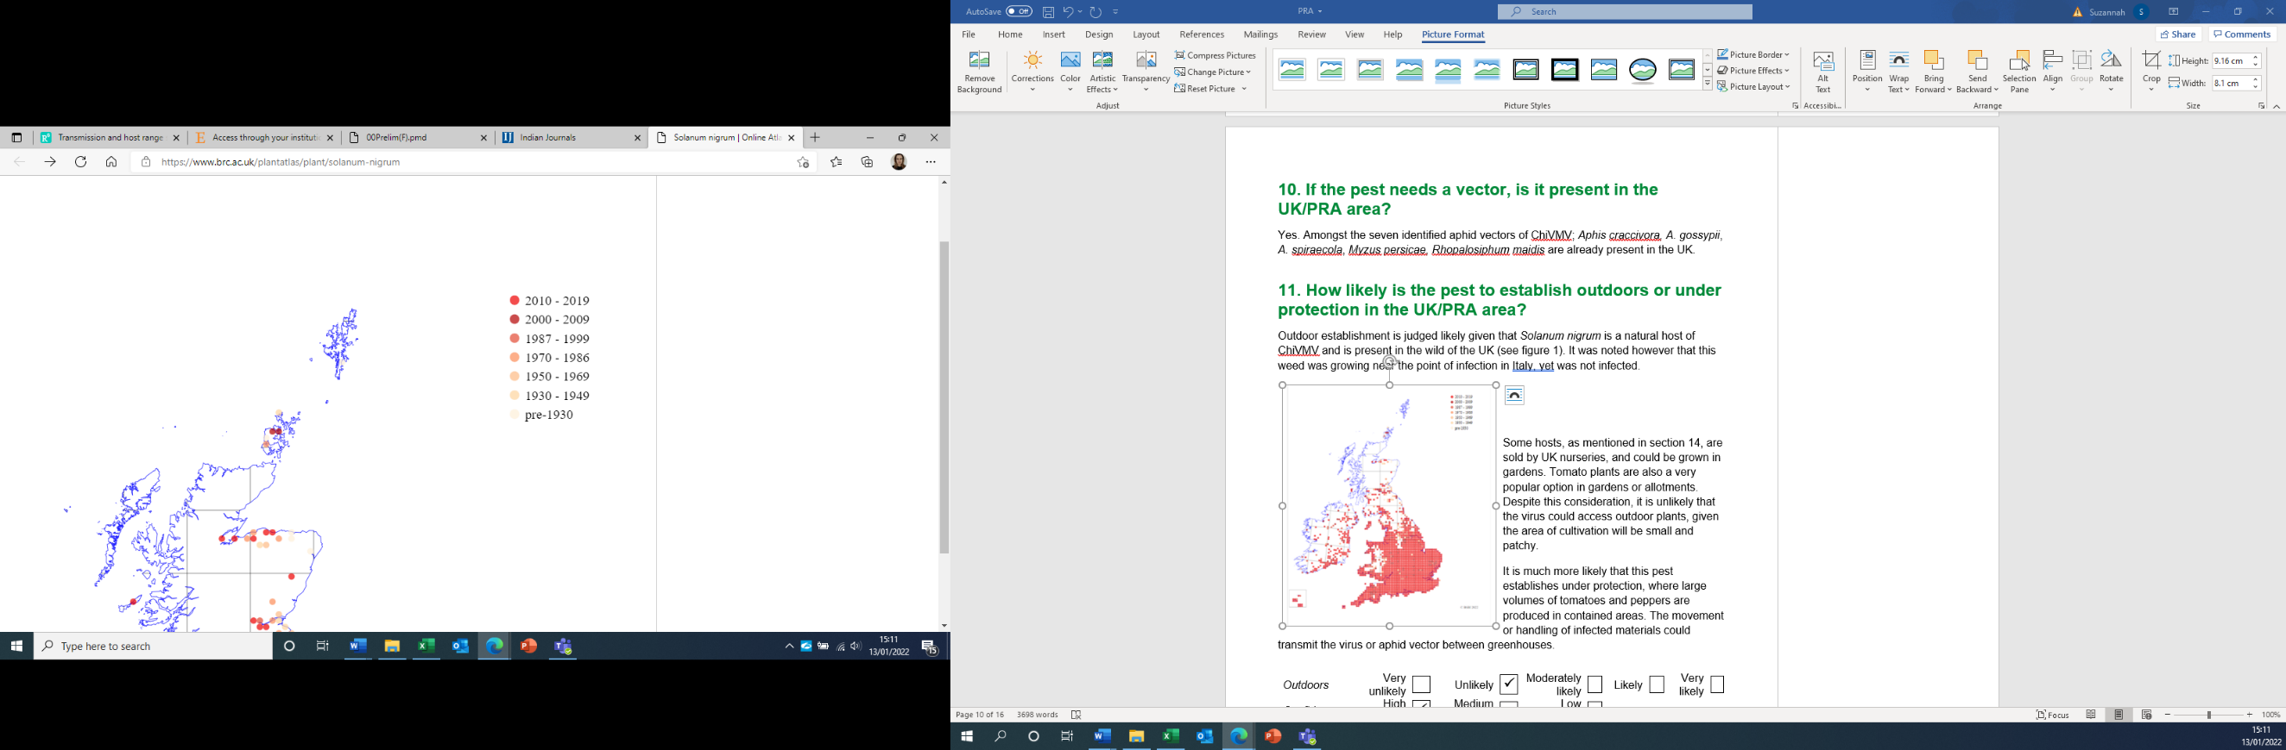
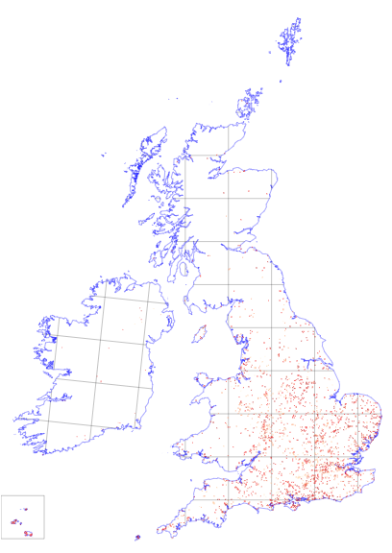
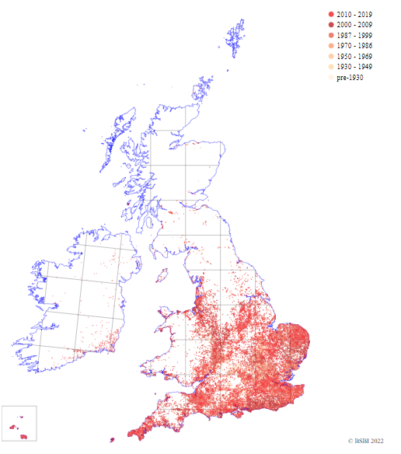
This pest is unlikely to be affected by the UK climate. A previous study has suggested that the infectivity of ChiVMV is not impacted by temperature, though symptoms on the host plant could vary (Cho et al., 2004).
Figure 1: Distribution of hosts (a) Solanum nigrum and (b) Datura stramonium in Great Britain (Online Atlas of the British and Irish Flora, 2022)
(a)
(b)
Outdoors | Very  unlikely |  | Unlikely |  | Moderately likely | P | Likely |  | Very  likely
Confidence | High Confidence |  | Medium Confidence | P | Low Confidence
Under protection
It was considered more likely that this pest establishes under protection, as large volumes of tomatoes and peppers are imported in as plants and cultivated in contained areas. The movement or handling of infected materials could then transmit the virus or aphid vector between greenhouses. If infected plants were imported, then establishment would be considered likely with high confidence.

Under Protection | Very  unlikely |  | Unlikely |  | Moderately likely |  | Likely | P | Very  likely
Confidence | High Confidence | P | Medium Confidence |  | Low Confidence

12. How quickly could the pest spread in the UK/PRA area?

Natural spread
Several of the aphid vectors, such as Myzus persicae, are present in the UK, in both protected conditions and outdoors, migrate seasonally, and are capable of overwintering in Great Britain (Taylor, 1977). Given that ChiVMV is transmitted non-persistently by its vectors, and relies upon a host plant being present and fed on by a viruliferous aphid, the natural spread of ChiVMV across the UK is expected to be at a moderate pace.
Natural spread | Very  slowly |  | Slowly |  | Moderate pace | P | Quickly |  | Very  quickly
Confidence | High Confidence | P | Medium Confidence |  | Low Confidence

Spread with trade
As mentioned previously, the spread of the virus in other countries has been attributed to the movement of plants for planting (Shah et al., 2009). ChiVMV is also mechanically transmissible, so trade could also enable the spread of the pest via physical contact or the movement of equipment. The virus could then spread quickly from a singular infected plant to plants across the greenhouse and, as a result of more inoculum being present, would then be likely to reach neighbouring greenhouses.

This spread with trade is likely to enable outbreaks at disparate sites from which natural spread, via the vector, would then continue. These pathways would explain the significant jumps of ChiVMV from Asia to Europe and Africa, therefore spread with trade is rated as quickly, to new areas, with a high confidence.

Spread with trade | Very  slowly |  | Slowly |  | Moderate pace |  | Quickly | P | Very  quickly
Confidence | High Confidence | P | Medium Confidence |  | Low Confidence

13. What is the pest’s economic, environmental and social impact within its existing distribution?
ChiVMV causes significant economic losses to chilli cultivation in its current distribution in Asia and is suspected of contributing to the decline in production of chilli pepper in certain Asian countries (Shah et al., 2009). Infection drastically reduces the quality and yield of the infected chilli plants, especially when the plant is infected at an early growth stage, as only a few mottled, distorted fruits may be produced (Vandakudari, 2017). Chilli yields can be reduced by over 50% (Ong et al., 1980). Disease incidence occurs at around 45%, though can be as high as 90% (Shah et al., 2009).
Figures on the impact on yield from this virus have not been reported on other host plants. However, a large impact is to be expected, given that symptoms include systematic mottling and leaf distortion in tobacco and tomato and stunting in African eggplant. ChiVMV has been highly problematic to the production of tobacco in China with disease incidence being recorded as 0.5-3%. Infection on other crops has been even higher at 90% on tomato, and 50-90% on African eggplant (Nono-Womdim et al., 2001; Yang et al., 2013; Zhao et al., 2014).
No social or environmental impacts of this virus have been reported, though this virus has been identified in the wild in India and Pakistan.
Impacts | Very  small |  | Small |  | Medium |  | Large | P | Very  large
Confidence | High Confidence |  | Medium Confidence | P | Low Confidence

14. What is the pest’s potential to cause economic, environmental and social impacts in the UK/PRA area?
This pest could have an economic impact on the horticultural industry. Sweet pepper (a cultivar of C. annuum) and tomato are both high-value protected crops in the UK. In 2020, sweet peppers grown in the UK were valued at around £21 million (20 thousand tonnes produced) and tomatoes valued at around £90 million (65 thousand tonnes produced). However, these crops are mostly imported in from other countries. A much greater concern to the UK would be if ChiVMV infected another member of the Solanaceae family, Solanum tuberosum, as potato production is significant in the UK. Fortunately, potato is suggested to be a non-host in the existing literature (Nandappa et al., 2020; Shah et al., 2008; Vandakudari, 2017). Given some of the infected countries are large producers of potatoes (for example, India and China), it is likely that an infection would be recorded by now.
In addition, many of the natural host species (including ornamental species such as Buddleja crispa and Commelina species) are sold by plant nurseries in the UK. Therefore, this pest could cause further economic damage, as well as carry some social impact through damage to gardens or allotments that grow host plants (such as tomatoes or peppers).
Economic impacts | Very  small |  | Small |  | Medium | P | Large |  | Very  large
Confidence | High Confidence |  | Medium Confidence | P | Low Confidence

Social impacts | Very  small |  | Small | P | Medium |  | Large |  | Very  large
Confidence | High Confidence | P | Medium Confidence |  | Low Confidence

The natural host, Solanum nigrum, grows wild in parts of the UK. Solanum nigrum is a native annual weed of cultivated and waste land and was first recorded in the UK in the 1500s (Online Atlas of the British and Irish Flora, 2022). The extent of damage on this species is unclear and although seen as an agricultural pest, a depletion could have unforeseen impacts on the environment.
The common Buddleja weed in the UK (Buddleja davidii) has not been recorded as a host of this virus, though present in a number of countries affected by ChiVMV, therefore this is not of concern.

Environmental impacts | Very  small |  | Small | P | Medium |  | Large |  | Very  large
Confidence | High Confidence |  | Medium Confidence |  | Low Confidence | P

15. What is the pest’s potential as a vector of plant pathogens?
ChiVMV has no apparent ability to act as a vector for other pathogens.

16. What is the area endangered by the pest?
Protected cultivation of solanaceous crops especially tomatoes and sweet peppers.

Stage 3: Pest Risk Management

17. What are the risk management options for the UK/PRA area?

Exclusion
Exclusion of this pest from the UK is an option, as currently ChiVMV is not known to be present. As this virus is highly transmissible, reservoir hosts are present, and infected plants cannot be treated, exclusion measures should be implemented.
The import of Solanaceae plants from third countries outside of the Euro-Mediterranean area is prohibited in the retained Implementing Regulation (EU) 2019/2072². This prohibition covers all countries with ChiVMV, other than Italy where it appears to be eradicated (Tomassoli, personal communication, 2022). The impact of this prohibition may be indicated by the fact that no UK interceptions of this pest have been found on plants for planting.
If ChiVMV successfully established in countries within the Euro-Mediterranean region, statutory controls used for other viruses from the Potyviridae family could be utilised. For example, there could be an import requirement for host plants for planting from a country with ChiVMV to have exhibited no symptoms during their complete cycle of vegetation, including laboratory testing of any suspicious symptoms, and that the plants would also need to come from an area free from the aphid vectors or a place of production free from the aphid vectors.

Eradication
Eradication would be extremely difficult, considering the high transmissibility of this virus and the presence of reservoir hosts. Eradication may be possible if infection is caught at an early stage. All host plants should be destroyed and the site re-inspected for ChiVMV over time. This was the strategy taken in Italy on chilli plants. Pesticides could also be sprayed on the site to eliminate viruliferous aphids. In addition, removing reservoir hosts and practicing crop rotation on this site should prevent any further virus spread.

Non-statutory controls
Infection could be suppressed on a site with the removal of host plants (as described above) and by the control of the aphid vectors. Ong (1984) demonstrates that it is possible to diminish the incidence of ChiVMV in the field by reducing the aphid population. This could be carried out by chemical, biological, or cultural control (for example, by using reflective surfaces to repel the aphids). Tomato and pepper crops in the UK are mainly treated with biological controls, though can also be treated with pesticides to control the aphid population (Fera Science Ltd, 2019). Alternatively, infection could be suppressed with the use of resistant varieties, with work ongoing to develop broad resistance against ChiVMV (Lee et al., 2017).

18. References
Ali, A., Zeshan, M.A., Iftikhar, Y., Abid, M., Ehsan, S.F., Ghani, M.U. and Khan, A.A., 2020. Role of Plant Extracts and Salicylic Acid for the Management of Chilli Veinal Mottle Virus Disease. Pakistan Journal of Phytopathology, 32(2), pp.147-157.
Anindya, R., Joseph, J., Gowri, T.D.S. and Savithri, H.S., 2004. Complete genomic sequence of Pepper vein banding virus (PVBV): a distinct member of the genus Potyvirus. Archives of virology, 149(3), pp.625-632.
Banerjee, A., Dutta, R., Roy, S. and Ngachan, S.V., 2014. First report of Chilli veinal mottle virus in Naga chilli (Capsicum chinense) in Meghalaya, India. Virus Disease, 25(1), pp.142-143.
CABI (2022a). Aphis craccivora (groundnut aphid). Available at: https://www.cabi.org/isc/datasheet/6192#DistributionMap (Accessed: January 2022).
CABI (2022b). Aphis gossypii (cotton aphid). Available at: https://www.cabi.org/isc/datasheet/6204#DistributionMaps (Accessed: January 2022).
CABI (2022c). Aphis spiraecola (Spirea aphid). Available at: https://www.cabi.org/isc/datasheet/6221#DistributionMap (Accessed: January 2022).
CABI (2022d). Myzus persicae (green peach aphid). Available at: https://www.cabi.org/isc/datasheet/35642#DistributionMap (Accessed: January 2022).
CABI (2022e). Rhopalosiphum maidis (green corn aphid)). Available at: https://www.cabi.org/isc/datasheet/47318#DistributionMap (Accessed: January 2022).
CABI CPC datasheet on Chilli veinal mottle virus (2021). Available at https://www.cabi.org/cpc/datasheetreport?dsid=12898 (Accessed: December 2021).
Cho, M.C., Shieh, S.C., Gniffke, P.A., Green, S.K. and Pae, D.H., 2004, May. Infection of Chili Veinal Mottle Virus (ChiVMV) is not affected by temperature. In XII th Meeting on Genetics and Breeding of Capsicum and Eggplant, p. 179.
Davis, R.I., Thomas, J.E., McMichae, L.A., Dietzgen, R.G., Callaghan, B., James, A.P., Gumia, T.G. and Rahamma, S., 2002. Plant virus surveys on the island of New Guinea and adjacent regions of northern Australia. Australasian Plant Pathology, 31(4), pp.385-390.
Department for Environment, Food and Rural Affairs, 2020. Horticulture statistics – dataset. Available at: Latest horticulture statistics - GOV.UK (www.gov.uk) (Accessed December 2021).
Ding, M., Yang, C., Zhang, L., Jiang, Z.L., Fang, Q., Qin, X.Y. and Zhang, Z.K., 2011. Occurrence of Chilli veinal mottle virus in Nicotiana tabacum in Yunnan, China. Plant disease, 95(3), pp.357-357.
Fera Science Ltd, 2019. Pesticide usage survey report: edible protected crops in the United Kingdom. Available at Pesticide usage survey report: edible protected crops in the United Kingdom, 2019 - GOV.UK (www.gov.uk) (Accessed March 2022).
Gao, F., Jin, J., Zou, W., Liao, F. and Shen, J., 2016. Geographically driven adaptation of chilli veinal mottle virus revealed by genetic diversity analysis of the coat protein gene. Archives of virology, 161(5), pp.1329-1333.
Green, S.K., 1993. Pepper virus research in Taiwan and other Asian countries. In Symposium on plant virus and virus-like diseases; Proceedings of the (No. RESEARCH). COA.
IPM CRSP, 2008. Annual report, Integrated Pest Management Collaborative Research Support Program. USAID, Virginia Tech, pp 190.
Kaur, C., Kumar, S. and Krishna Raj, S., 2015. Association of a distinct strain of Chilli veinal mottle virus with mottling and distortion disease of Datura inoxia in India. Archives of Phytopathology and Plant Protection, 48(6), pp.545-554.
Lee, J.H., An, J.T., Siddique, M.I., Han, K., Choi, S., Kwon, J.K. and Kang, B.C., 2017. Identification and molecular genetic mapping of Chili veinal mottle virus (ChiVMV) resistance genes in pepper (Capsicum annuum). Molecular Breeding, 37(10), pp.1-10.
Mehra, A., Hallan, V., Lal, B. and Zaidi, A.A., 2006. Occurrence of Chilli veinal mottle virus in Himalayan butterfly bush (Buddleja crispa). Plant Pathology, 55(2).
Nandappa, C., Ganesha N., Renuka HM., 2020. Host range studies of Chilli veinal mottle virus (ChiVMV) in chilli (Capsicum annuum L.). Int J Chem Stud 2020, 8(1), pp.1558-1560.
Nono-Womdim, R., Swai, I.S., Chadha, M.L., Gebre-Selassie, K. and Marchoux, G., 2001. Occurrence of Chilli veinal mottle virus in Solanum aethiopicum in Tanzania. Plant disease, 85(7), pp.801-801.
Ong, C. A., 1984. Reducing the spread of chilli veinal mottle virus using reflective surfaces. Differences, 52, pp.86-69.
Ong, C.A., Varghese, G. and Ting, W.P., 1979. Aetiological investigation on a veinal mottle virus of chilli (Capsicum annuum L.) newly recorded from Peninsular Malaysia. MARDI Res. Bull, 7(2), pp.78-88.
Ong, C.A., Varghese, G. and Ting, W.P., 1980. The effect of chilli veinal mottle virus on yield of chilli (Capsicum annuum L.). MARDI Research Bulletin, 8(1), pp.74-78.
Online Atlas of the British and Irish Flora, Available at: Online Atlas of the British and Irish Flora (brc.ac.uk) (Accessed: January 2022).
Prakash, S., Singh, S.J., Singh, R.K., Upadhyaya, P.P. and Prakash, S., 2002. Distribution, incidence and detection of a Potyvirus on chilli from eastern Uttar Pradesh. Indian Phytopathology, 55(3), pp.294-298.
Sahu, A.K., Nehra, C., Mishra, R., Verma, R. and Gaur, R.K., 2016. Molecular evidence of Chili vein mottle virus and Chilli leaf curl virus simultaneously from naturally infected chilli plants (Capsicum annuum L.). Indian Journal of Biotechnology, 15, pp.266-268.
Shah, H., Fahim, M., Hameed, S. and Haque, M., 2009. Prevalence, occurrence and distribution of Chili veinal mottle virus in Pakistan. Pakistan journal of Botany, 41, pp.955-965.
Shah, H., Yasmin, T., Fahim, M., Hameed, S. and Haque, M.I., 2008. Transmission and host range studies of Pakistani isolate of chilli veinal mottle virus. Pakistan Journal of Botany, 40, pp.2669-2681.
Siriwong, P., Kittipakorn, K. and Ikegami, M., 1995. Characterization of chilli vein‐banding mottle virus isolated from pepper in Thailand. Plant Pathology, 44(4), pp.718-727.
Subekti, D., Hidayat, S.H., Nurhayati, E. and Sujiprihati, S., 2006. Cucumber Mosaic Virus and Chili Veinal Mottle Virus Infection on Growth and Yield Component of Chilli. HAYATI Journal of Biosciences, 13(2), pp.53-53.
Sulaiman, I.N.O.N. and Gim, W.N., 1981. Symptomatology of Tobacco Mosaic Virus (TMV) and Chilli Veinal Mottle Virus (CVMV) on Six Local Chilli. Pertanika., 4(1), pp.10-15.
Taylor, L.R., 1977. Migration and the spatial dynamics of an aphid, Myzus persicae. The Journal of Animal Ecology, pp.411-423.
Tiberini, A., Manglli, A., Ahmad, A., Cassia, U., & Tomassoli, L. (2017). First report and molecular identification of Chilli Veinal Mottle Virus in Italy. Journal of Plant Pathology, 99(2), pp.523–526.
Tsai, W.S., Huang, Y.C., Zhang, D.Y., Reddy, K., Hidayat, S.H., Srithongchai, W., Green, S.K. and Jan, F.J., 2008. Molecular characterization of the CP gene and 3′ UTR of Chilli veinal mottle virus from South and Southeast Asia. Plant Pathology, 57(3), pp.408-416.
Vandakudari, P. Diagnosis and identification of virus causing mosaic disease in Capsicum (Capsicum annum var. grossum sendt), MSc Thesis. University of Horticultural Sciences, Bagalkot.
Veniari, N.K., Yuliadhi, K.A., Nyana, I.D.N. and Suastika, G.E.D.E., Deteksi Cucumber Mosaic Virus (CMV) dan Chili Veinal Mottle Virus (ChiVMV) pada gulma Commelina spp. di pertanaman cabai (Capsicum spp.) melalui teknik uji serologi dan molekuler. Agroekoteknologi Tropika, 4(1), pp.45-52.
Yang, J., Dong, J. H., Zhang, T. J., Wang, R., Luo, Z. P., Luo, H. Y., & Zhang, Z. K. (2013). A new isolate of Chilli Veinal Mottle Virus that infects tobacco in China. Journal of Plant Pathology, 95(1), pp.187–190.

Zhao, F.F., Xi, D.H., Liu, J., Deng, X.G. and Lin, H.H., 2014. First report of Chilli veinal mottle virus infecting tomato (Solanum lycopersicum) in China. Plant Disease, 98(11), pp.1589-1589.

Name of Pest Risk Analysts(s)
Suzannah Pearce

© Crown copyright 2022
You may re-use this information (excluding logos) free of charge in any format or medium, under the terms of the Open Government Licence v.2. To view this licence visit www.nationalarchives.gov.uk/doc/open-government-licence/version/2/ or email PSI@nationalarchives.gov.uk
This publication is available via the UK Plant Health Information portal https://planthealthportal.defra.gov.uk/
This PRA has been undertaken following IPPC International Standards for Phytosanitary Measures (ISPMs 2 and 11) and it provides technical evidence relating to the risk assessment and risk management of this pest.
Any enquiries regarding this publication should be sent to us at
The Chief Plant Health Officer
Department for Environment, Food and Rural Affairs
Room 11G32
Sand Hutton
York
YO41 1LZ
Email: plantpestsrisks@defra.gov.uk

https://www.eppo.int/ACTIVITIES/quarantine_activities
Commission Implementing Regulation (EU) 2019/2072 of 28 November 2019 establishing uniform conditions for the implementation of Regulation (EU) 2016/2031 of the European Parliament and the Council, as regards protective measures against pests of plants, and repealing Commission Regulation (EC) No 690/2008 and amending Commission Implementing Regulation (EU) 2018/2019 (legislation.gov.uk)
The Phytosanitary Conditions (Amendment) Regulations 2022 (legislation.gov.uk)
The latest consolidated versions can be accessed via a search on https://eur-lex.europa.eu/
This figure was indicated from the number of PEACH applications submitted with the relevant genus/species.
Figure taken from the marketable home production for the calendar year. Department for Environment, Food and Rural Affairs, 2020.

